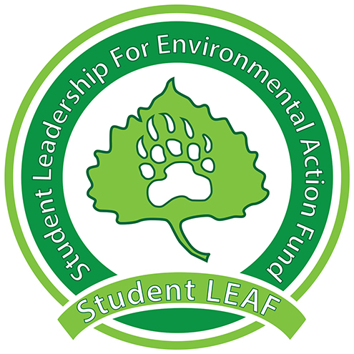
Board Minutes
Student LEAF
Date|9/17/2018 4:00 PM | Meeting called by Z. King
Z. King, President | M. Wike, Vice President | E. Scott, Grant Coordinator | T. Rapport , Treasurer | L. Van Es, Secretary | T. Boen, Public Relations| J. Jenkins, Green Team | K. Leichliter , Advisor | C. Romulo, Advisor
Time | Item | Owner
4:00 | Call to Order
4:00 | Presidential Updates:  - Switch Club- focus on energy – unbiased look at sustainability  - Byron Straw and President of Switch coming on October 1  - Swag is in Chelsie’s office  - IDs for access to Bishop Lehr (Kirk) | Z. King
[Time] | Vice President:  - In talks with video club and script for Sprinkler Video | M. Wike
[Time] | Grant Coordinator:  - PVA Breakdown – costs of lights retrofit  - Phases instead of all at once  - Printed forms (with environmental return)  - Future Project Proposals  - Breaking down and write up for each one before voting | E. Scott
[Time] | Green Team:  - Dining Services Update  - Holmes now need 3 water bottle fillers (one for staff)  - Need more info on how to submit proposal (better)  - Where are the remaining fillers going to be?  - Already funded to finish campus- would this be covered | J. Jenkins
[Time] | Treasurer: | T. Rapport
[Time] | Public Relations:  - Send volunteer schedules  - Swag on the way  - Name tags on the way  - Early October for event | T. Boen
[Time] | Secretary: | L. Van Es
[Time] | Advisor:  - Checking on projects/proposals from last year  - PVA lights  - Frolf Discs  - Solar Flower – contact Cesar Chavez about interest  - Gardens at APASS and WGEC are approved and funded | C. Romulo
[Time] | Public Comment:  - Interest in doing a Story on Student LEAF  - We exist  - Funded by Students  - Anyone can propose projects  - Bear in Mind – Podcast  - We’d like to be involved  - Calendar.unco.edu – adding events to university calendar | Nate Haas
[Time] | Vote:  Called to a vote by:  Seconded by:  For:  Against:  Unsure:  Notes:
4:35 | Adjournment | Z. King
General Notes:

