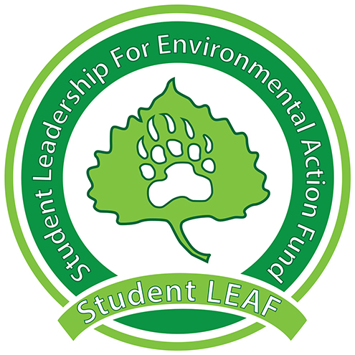
Board Minutes
Student LEAF
Date|9/10/2018 4:00 PM | Meeting called by Z. King
Z. King, President | M. Wike, Vice President | E. Scott, Grant Coordinator | T. Rapport , Treasurer | L. Van Es, Secretary | T. Boen, Public Relations| J. Jenkins, Green Team | K. Leichliter , Advisor | C. Romulo, Advisor
Time | Item | Owner
4:00 | Call to Order
4:00 | Presidential Updates: | Z. King
[Time] | Vice President: | M. Wike
[Time] | Grant Coordinator: | E. Scott
[Time] | Green Team: | J. Jenkins
[Time] | Treasurer: | T. Rapport
[Time] | Public Relations: | T. Boen
[Time] | Secretary: | L. Van Es
[Time] | Vote:  Called to a vote by:  Seconded by:  For:  Against:  Unsure:  Notes:
 | Adjournment | [Owner]
General Notes:

