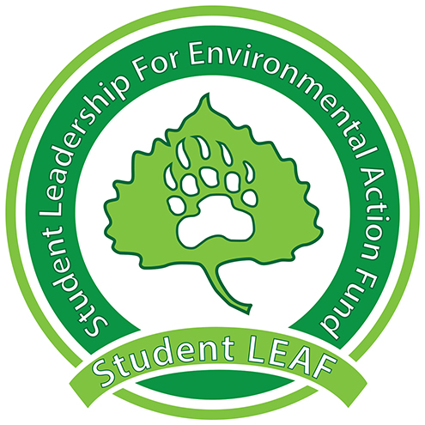
Board Minutes
Student LEAF
Date|10/1/2018 4:00 PM | Meeting called by Z. King
Z. King, President | M. Wike, Vice President | E. Scott, Grant Coordinator | T. Rapport , Treasurer | L. Van Es, Secretary | T. Boen, Public Relations| J. Jenkins, Green Team | K. Leichliter , Advisor | C. Romulo, Advisor
Time | Item | Owner
4:00 | Call to Order
4:00 | Presidential Updates: | Z. King
ABSENT | Vice President: | M. Wike
ABSENT | Grant Coordinator: | E. Scott
ABSENT | Green Team: | J. Jenkins
ABSENT | Treasurer: | T. Rapport
4:05 | Public Relations:  - Painting leaves event October 8th and 9th  - Lookout for update on time  - Including an information card  - Swag is in!  - In Chelsie’s office Michener L100 | T. Boen
4:10 | Secretary:  - Guest speaking at RHA  - Who and what? | L. Van Es
4:15 | Advisor:  - McKinstry has offered to help us with social media presence  - Individually think about goals for social media  - Student interested in making Greek Life more sustainable  - “Parking Lot” – things outstanding from previous meetings | C. Romulo
 | Adjournment | Z. King
Parking Lot:
- Allocation of time and tasks
- Professional Headshots
- Contact in Greek Life on Sustainability

