SOCIETY FOR THE ACADEMIC STUDY OF SOCIAL IMAGERY (SASSI)

CONFERENCE REGISTRATION FORM

THE IMAGE OF REBIRTH
in Literature, Media, and Society

SATURDAY, MARCH 18, 2017
UNIVERSITY OF NORTHERN COLORADO, GREELEY, CO

Please complete and return this form via mail/fax/email to:

SASSI Fax: (970) 351-2336
c/o Thomas Endres
CAND 1265, Box 155 Email: SASSI@unco.edu
University of Northern Colorado
Greeley, CO 80639

NAME: ___________________________________________________________________________________

Title of presentation: ________________________________________________________________________

Telephone: ( )_______________________________ Is this?: ___ Cell ___ Office ___ Home

E-mail: _________________________________________ FAX (optional) _(____)___________________

Affiliation/Institution: _______________________________________________________________________

Department/Program: ________________________________________________________________________

Mailing Address: ___________________________________________________________________________

City, State, Zip: ________________________________________________________________________

REGISTRATION: (Circle or place X in box of choice)

Type of Registration | Prior to 3/3/17 | After 3/3/17
Conference Presenter Only (includes a copy of Proceedings) | $95 | $115
Conference Presenter + Inclusion in (and a copy of) Proceedings | $140 | $160
Conference Non-Presenter Only (does not include a copy of Proceedings) | $45 | $45

METHOD OF PAYMENT: (Select one)
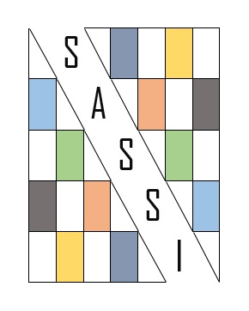
_____ Check (made payable to SASSI) enclosed with this form

_____ Payment will be made via PayPal on SASSI website

_____ Check (made payable to SASSI) or cash at registration desk

SASSI 2017 is sponsored by the UNC School of Communication

