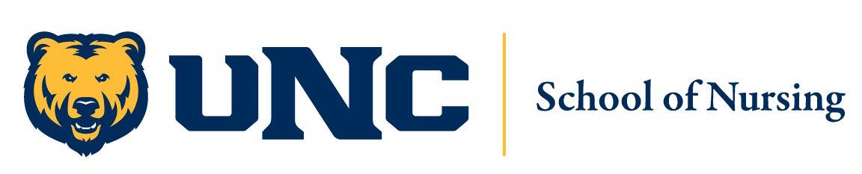

Open Admission Q&A Sessions

2021-2022

Please plan to attend one of the following **Zoom** sessions:

Tuesday, November 9th: 12-1pm

<https://unco.zoom.us/j/94030248996>

Wednesday, November 10th: 12-1pm <https://unco.zoom.us/j/91640171190>

Tuesday, November 16th: 12-1pm

<https://unco.zoom.us/j/97253384795>