University of Northern Colorado  School of Nursing  Nursing Faculty – Student Organization  Sponsored by:  Human Resources | Original Policy Date:  9/25/2007  Updates:  - 5/92; 8/91; 2/96  - 11/01 Human Resources/SB  - 4/16/07 lc; 3/25/08 DWL  - 11/14/17 Human Resources / FH  - 9-27-19 Human Resources/FH

Title of Policy: Workers’ Compensation
Policy:
When UNC places a student in a cooperative education or student internship program without pay from the employer, UNC shall insure such a student under UNC's worker's compensation insurance.
Procedure:
If a UNC student is injured at an affiliated agency during student clinical experiences, the student must complete any health care agency report forms as required by the agency policies. If the injury or illness requires immediate attention, the student should be sent directly to the nearest emergency room. If the injury does not require immediate attention, the student must notify faculty of record and contact the Human Resources within 24 hours post injury (970-351-2718). A Human Resources representative will schedule an appointment for the employee with UNC's designated medical provider. Please review the Health/Safety website for the most current information, provider letter, and the up to date “First Report of Injury Form”.(https://www.unco.edu/human-resources/employee-resources/health-safety.aspx).
In addition, in order to be covered under UNC’s worker’s compensation:

- The student and faculty of record must complete and submit the "Injury/Illness Report" form within 24 hours of injury to:
  - the UNC School of Nursing, Gunter Hall 3080, Greeley, CO, 80639; or
  - via email to nursing@unco.edu; or
  - via fax 970-351-1707.
  - This policy) is available from the School of Nursing main office or at http://www.unco.edu/nhs/nursing/pdf/workers-compensation-policy.pdf.
- The student must sign the form, as well as the Director or Assistant Director (there is no specific signature line so below the student signature is fine).
- The form must be submitted by the School of Nursing within four (4) working days to:
Human Resources, via email at human.resources@unco.edu or via fax: 970-351-1386.
- Copies must also be sent to the NHS Dean’s Office, put in the student’s file, and put in the SON’s main office Worker’s Comp file.
- If the injury/incident occurs within a clinical agency and is deemed an emergency or the injury needs immediate attention, the student should be taken care of by the nearest Emergency room. (Upon discharge the student should notify the hospital that their visit is a UNC Workers’ Compensation claim, this will help to prevent the student from receiving bills for the care provided.) After emergency care has been provided and the student is discharged, the student must contact Human Resources as soon as possible to schedule follow-up care with a worker's compensation physician.

*Please follow the below link for the most current and updated information!!!
https://www.unco.edu/human-resources/employee-resources/health-safety.aspx

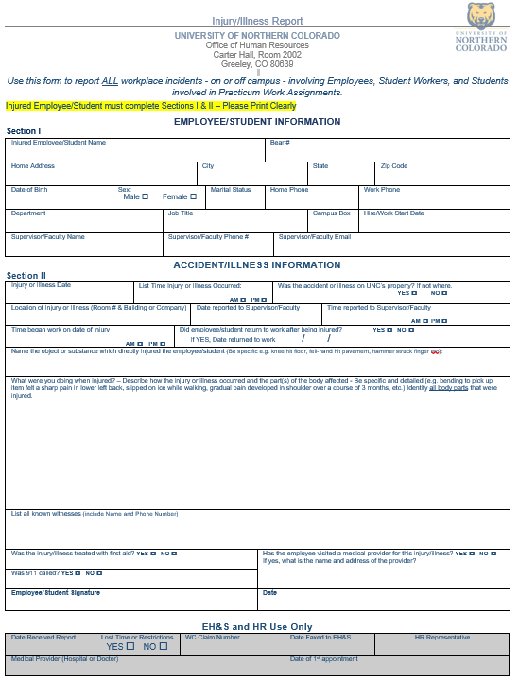
*SAMPLE FORM
*Please follow the below link for the most current and updated information!!!
https://www.unco.edu/human-resources/employee-resources/health-safety.aspx
*Please follow the below link for the most current and updated information!!!

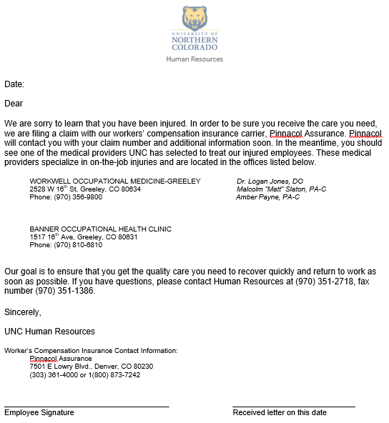
*SAMPLE LETTER

