ABC Intrinsic Scheduling WORKSHEET

Our energy, motivation, and high impact ‘work’ times fluctuate throughout the day. Use this worksheet to develop an intrinsic productivity schedule to help you work efficiently and protect your self-care time. Contact us at HSS.StudentSuccess@unco.edu or Call 970-351-3140 with questions, resources, and support.

The Heatmap | Productive Capacity reflects your intrinsic ability to produce at various times throughout the day. Reflect on the times of the day you feel able to accomplish more. EX. I start strong in the morning, fade in the afternoon, and resurge at night. Flip this sheet over for a Clock to track your days over the course of a week.
When are you at capacity? | Started strong most mornings--- with high creativity and motivation from wake up (6:30) through the mid morning (11:30ish). I tended to fade a bit after lunch but really crash in the early evening from 5:00-7:00ish.
A Time  The Core | When do you tend to produce higher quality outcomes with the most efficiency? Find the 2-3 hour windows from your Heat Map that reflect your highest times. EX. 7:30-11:30 am and 8-10pm—things are just easier, faster, and better for me. *NOTE* We typically sustain peak focus for a few hours at a time: breaks and burn-out happen!
 | 6:30 to 11 and again from 2 to 4 pm are the peak times that I feel the most productive in the day.
 | What activities are best to complete during your A Time? Write 1-2 types of assignments, projects, and tasks that require higher cognitive and creative energy. EX. Writing paper drafts, completing practice exams, studying for your more challenging courses, organizing the house/workspace.
 | I should wake up and clean, do the dishes, and other house chores to start my day really strong. Then I need to get to my reading in the morning before I fade at noon. I can also take my practice exams in the early afternoon—I can study my materials in the morning and then quiz myself after lunch.
C Time  The Self-Care | When do you tend to focus the least? Write the 1-3-hour window when you tend to spend more energy staying motivated than completing tasks. EX: 5-7pm, I just don’t focus very well and feel drained. *NOTE* Self-care is essential to maintaining and balancing a workload. Because C Time is your least efficient time to work, use these hours to recharge yourself without guilt! Treat yourself!
 | Every day the early evening from 5 to 7ish were red for me. I don’t feel motivated at all until I eat dinner—but I don’t even WANT to cook dinner until 6:30 or 7.
 | What do you enjoy for self-care and to recharge your batteries? EX: Long showers, listening to podcasts, watching shows/movies, playing video games, talking with friends/family.
 | Listening to podcasts about film reviews and coloring are all the things I can stand to do before dinner. I also like to walk the dog since he stops and sniffs so much.
B Time  The Baseline | When do you tend to cruise along with your work and tasks? Note the baseline windows from your Heat Map that are neither your high productivity nor your low productivity times. EX. Noon to 5pm. *Note* Baseline also serves as ‘spill over’ if a key task needs longer to finish.
 | The mid morning and a small peak before I go to bed are my orange times. I feel myself getting tired after being motivated all morning. Then I feel a bit refreshed after chilling out in the early evening.
 | What activities will help you maximize your A Time windows? Write the type of prep items and tasks that don’t require high cognitive or creative energy. EX: Create study materials, outline papers, develop to-do lists for A Time, grocery shopping, meal prepping.
 | Because A time is first thing in the morning, I need to create my To-Do lists during B time before I go to bed. I can also set out the house tasks I want to complete in the morning. I can outline my papers the evening before and get to writing in the morning or early afternoon.

Read More about Energy Mapping and Intrinsic Productivity: Gilkey, C (2017), Heat Map Your Schedule

Over the next 7 days (including weekends!), note when you intrinsically feel more and less productive. If you are watching TV, notice how you feel while watching. If you are reading, note how long it takes and the level you understand the work. The goal is to establish when your energy levels allow for higher and lower productive capacities. Once you know your energy map, you can start to plan your schedule and workflow around your rhythms.

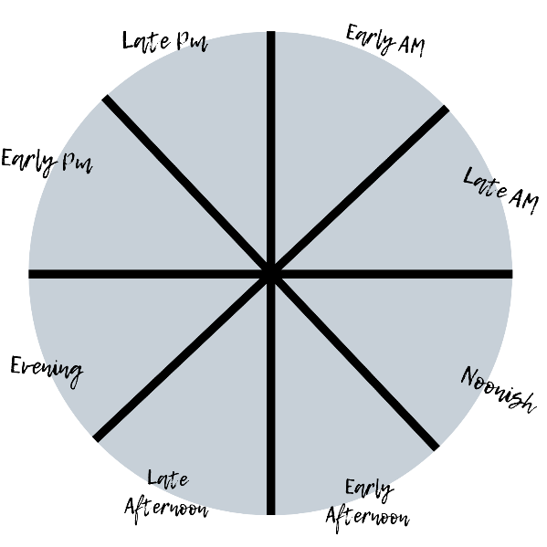
Notes:

Color Key:
Green- High Outcomes (feel creative, productive, motivated)
Yellow- Mid Outcomes
Red- Low Outcomes

