ABC Intrinsic Scheduling WORKSHEET

Our energy, motivation, and high impact ‘work’ times fluctuate throughout the day. Use this worksheet to develop an intrinsic productivity schedule to help you work efficiently and protect your self-care time. Contact us at HSS.StudentSuccess@unco.edu or Call 970-351-3140 with questions, resources, and support.

The Heatmap | Productive Capacity reflects your intrinsic ability to produce at various times throughout the day. Reflect on the times of the day you feel able to accomplish more. EX. I start strong in the morning, fade in the afternoon, and resurge at night. Flip this sheet over for a Clock to track your days over the course of a week.
When are you at capacity?
A Time  The Core | When do you tend to produce higher quality outcomes with the most efficiency? Find the 2-3 hour windows from your Heat Map that reflect your highest times. EX. 7:30-11:30 am and 8-10pm—things are just easier, faster, and better for me. *NOTE* We typically sustain peak focus for a few hours at a time: breaks and burn-out happen!
 | What activities are best to complete during your A Time? Write 1-2 types of assignments, projects, and tasks that require higher cognitive and creative energy. EX. Writing paper drafts, completing practice exams, studying for your more challenging courses, organizing the house/workspace.
C Time  The Self-Care | When do you tend to focus the least? Write the 1-3-hour window when you tend to spend more energy staying motivated than completing tasks. EX: 5-7pm, I just don’t focus very well and feel drained. *NOTE* Self-care is essential to maintaining and balancing a workload. Because C Time is your least efficient time to work, use these hours to recharge yourself without guilt! Treat yourself!
 | What do you enjoy for self-care and to recharge your batteries? EX: Long showers, listening to podcasts, watching shows/movies, playing video games, talking with friends/family.
B Time  The Baseline | When do you tend to cruise along with your work and tasks? Note the baseline windows from your Heat Map that are neither your high productivity nor your low productivity times. EX. Noon to 5pm. *Note* Baseline also serves as ‘spill over’ if a key task needs longer to finish.
 | What activities will help you maximize your A Time windows? Write the type of prep items and tasks that don’t require high cognitive or creative energy. EX: Create study materials, outline papers, develop to-do lists for A Time, grocery shopping, meal prepping.
Read More about Energy Mapping and Intrinsic Productivity: Gilkey, C (2017), Heat Map Your Schedule

Over the next 7 days (including weekends!), note when you intrinsically feel more and less productive. If you are watching TV, notice how you feel while watching. If you are reading, note how long it takes and the level you understand the work. The goal is to establish when your energy levels allow for higher and lower productive capacities. Once you know your energy map, you can start to plan your schedule and workflow around your rhythms.

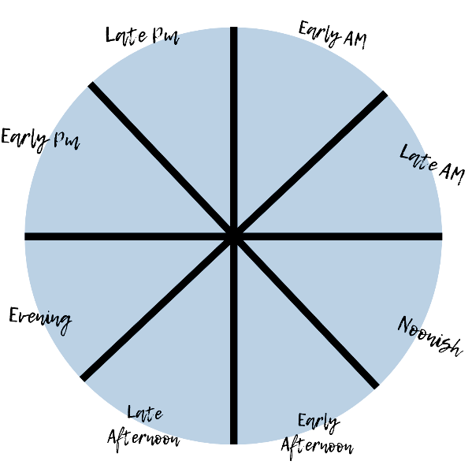
Color Key:
Green- High Outcomes (feel creative, productive, motivated)
Yellow- Mid Outcomes
Red- Low Outcomes
Notes:

