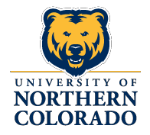

CANDIDATE EXIT INTERVIEW INFORMATION

The University of Northern Colorado is an Affirmative Action/Equal Opportunity employer and does not discriminate on the basis of race, color, religion, national origin, gender or disability. In order to insure that we do follow a policy of non-discrimination, we ask for your cooperation in completing this form:

TO EQUAL OPPORTUNITY COORDINATOR: This form is to be completed while candidate is on campus and forwarded to Human Resource Services immediately after the interview.

- Do you believe the interview(s) you have completed has/have been fair?
_Yes _No
If no, please explain:

- At any time during the interview(s), did you feel you were being judged on criteria other than professional qualifications? _Yes _No
If yes, please explain:

- Were you made to feel uncomfortable or encouraged not to pursue employment at the University because of your race, color, religion, national origin, sex or handicap? _Yes _No
If yes, please explain: _

- How could the interview have been improved?

CANDIDATE
Name (Please Print): Signed: Address:

Date of Interview
Today’s Date

Position Name, Number and Department for which you are a candidate

Date AA/EO COORDINATOR

Revised 3/2017

