Activity T1. Transportation T1
Activity 1: Early Transportation in Colorado

Background Information can be found at:
http://www.unco.edu/hewit/doing-history/20th-century-colorado/transportation/

Step 1 | Your Task
Open Activity One: Early Transportation in Colorado (click on link).  You should see a map similar the one below. You may want to zoom out some. Predict on the map below where you think the route of the earliest trails came from the East to Colorado, and then how they might have continued to the West Coast. As you make your prediction, think about the topography (landforms) and the population living in Colorado in the early 1800’s.  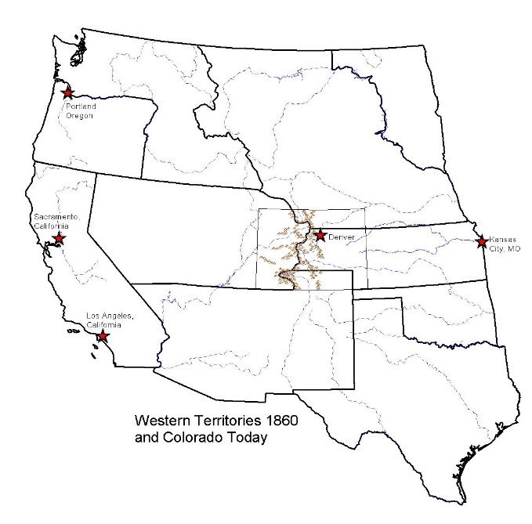 | Why do you predict these locations? (Be sure to support your prediction with evidence from the map)
Step 2 | Your Task
Use the Layer List button to Check On (make visible) the Early Trails (Expand Transportation1 to see individual layers). By clicking on the trails, | Locate two trails that run through Colorado. What are their names?  Why do you think those trails are there?  Who do you think used them and how?  What do you notice about their locations?
Step 3 | Your Task
Check OFF the Western Territories 1860 and Western Rivers layers (towards the bottom of the list), Go to your Bookmarks and select the Colorado bookmark. This should zoom you to roughly the area of Colorado. If you need to you can zoom back out slightly (manually). Check ON the Colorado Rivers layer. Locate the Arkansas and Purgatoire Rivers. Notice where the two rivers meet in southeastern Colorado.  Now, Check ON the Forts layer. Go to your Bookmarks and select the Arkansas--Purgatory bookmark. This should zoom you in to the confluence of these two rives.  One of these forts became quite famous! By 1820, St. Louis, Missouri had become a trading center in the United States. Merchants were interested in expanding this trade to Santa Fe and Mexico. They thought it could be a good market for their goods and perhaps a source of gold and silver. In 1821 William Becknell arrived in Santa Fe. He found a trail that had been used by the Indians and Spanish for years. This trail became known as the Santa Fe Trail. Bent’s Fort was built near the mountain branch of the Santa Fe Trail. It was the largest trading post in the southwest. | What are the names of the three forts located where the Arkansas River and Purgatoire Rivers meet (you may need to Zoom In more to that one area)?
Step 4 | Your Task
Go to the Doing History website: http://hewit.unco.edu/dohist/trappers/traders/santafe/intro.htm  Look through the pictures and read the information about each image. Most, but not all of the images will have About This Image information. Below, answer each question about traveling on the Santa Fe Trail.  Return to the interactive map. If necessary zoom back out to the entire state of Colorado (hint: use the Colorado Bookmark). Check ON the 1873 Railroads layer.  Click on the various railroad lines  The Union Pacific was laying railroad tracks on their way to California. In 1867 the Union Pacific laid those railroad tracks across the Wyoming prairie, avoiding Colorado.  Interesting Websites:  http://www.sfmuseum.org/hist1/rail.html  http://www.cprr.org/  This was serious. A town without a railroad line had very little chance of growing. | Who used the trail?  How did people travel?  What supplies did they need for the journey?  What do you notice about the location of the first railroads as compared to the early trails in Colorado?  Where were the first railroad lines built?  Name the first two railroad lines built into Colorado from another state.  1.  2.  Why do you think they decided against building new railroad tracks directly across Colorado?  Why do you think a railroad would be so important for growth?
Step 5 | Your Task
The railroad was the cheapest, fastest, most comfortable, and the only dependable, year-round means of transportation at the time. The Denver Pacific decided to build “feeder tracks” from the Union Pacific tracks in Wyoming south into Colorado. In 1870 another railroad line was completed in Kansas to go west to Colorado.  The Denver Pacific Railroad line continues west of Denver.  Denver was a “supply town” because the smaller mining towns needed supplies from Denver. These mining communities were difficult to access until the 1860’s when the railroad lines were built. | Locate where these first two Railroad lines meet. What community do you think this is?  What do you think was going on in the towns west of Denver in the late 1800’s? Why would this area need a railroad (hint: check on and off the Mineralbelt layer!)?  How do you think supplies were brought to towns in the mountains before the railroad was available?
Step 6 | Your Task
Now go to the Doing History website at: http://hewit.unco.edu/dohist/mining/transprt/submenu.htm to check your answer.  Before the railroad, large wagons transported goods to Denver. It took four to six weeks to reach Colorado by wagon. Once in Denver, supplies were put into smaller wagons that were then hauled up to the mountain communities. Mules and burros also carried supplies to the most isolated areas. This kind of transportation was expensive so the cost was added on to the price of goods.  The fastest way to reach Colorado before the railroad was by stagecoach. It took ten to twelve days to cross the plains by stagecoach. So it was much faster than traveling by wagon but the price was high. It cost $100 - $125 to travel one-way in 1859. | How were supplies brought to the mining region of Colorado?
Step 7 | Your Task
Check OFF all layers and then Check ON the 1879 Railroads, Colorado Rivers, Colorado Mountains, and Colorado layers.  Check ON the 1895 Railroads layer.  Before 1895, the railroads were concentrated along the front range of Colorado. Now the western portion of our state is included. | What do you notice about how the railroads have changed?  What changes do you notice?  Who do you think was living and working in the western half of our state at the turn of the century?

