Physical Geography – Activity 3 (PG-3)

Open Activity 3: Colorado’s Life Zones (web map is for Activities PG-1, PG-2, PG-3, and PG-4). Colorado can be divided into five “life zones” going from lowest to highest elevation: Plains, Foothills, Montane, Subalpine, and Alpine. Boundaries of the life zones are defined by elevation: how high the land is above sea level.

Step 1 | Your Task
Using Layer List button , CHECK ON the following layers: Major Cities, Continental Divide, Mountains, Colorado Rivers, Colorado (other layers Checked OFF). On the map at right, try to predict where each life zone is. | Double click on the image below. Use Shapes tools to draw a region (area) showing where you predict each zone will be located. Color the Plains yellow, the Foothills orange, the Montane brown, the Subalpine dark red, and the Alpine gray or white.  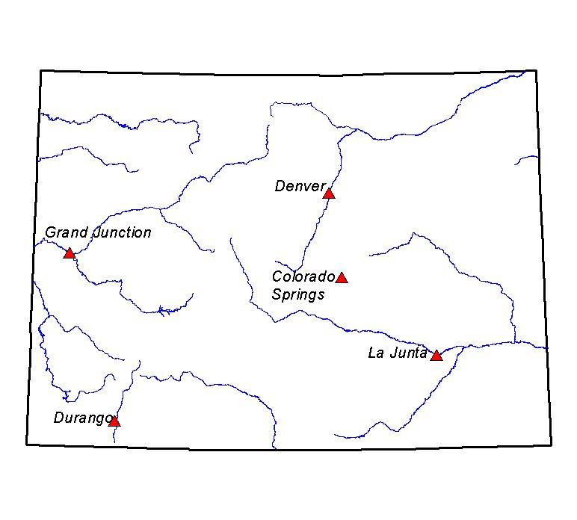
Step 2 | Your Task
Check ON the Life Zones layer. Click Legend button to see which color is used to show each different Life Zone. | Which life zones did you predict correctly?  Which ones did you not predict correctly?  Which life zone appears to occupy the MOST land in Colorado?  Which life zone appears to occupy the LEAST land in Colorado?  What do you notice about where the each life zone is located, in relation to the mountains?  Predict the life zone that you would expect to see in the states that neighbor Colorado on the east.
Step 3 | Your Task
Explore ThingLink of Colorado Life Zones or Colorado VR (or any other image bank on the web) to gain understanding of the characteristics of each zone. | Guiding questions for discussion:  - What are common characteristics of several adjacent life zones?  - How do elevation, landforms, and precipitation affect the plants and animals that are found in each life zone?

