Physical Geography – Activity 2 (PG-2)

Open Activity 2: Precipitation in Colorado (web map for Activities PG-1, PG-2, PG-3, and PG-4).

Step 1 | Your Task
Using Layer List button, make sure the following layers are CHECKED ON: Major Cities, Continental Divide, Mountains, Colorado Rivers (all other layers OFF). Looking at the continental divide, mountains, and rivers in Colorado, where do you predict our state gets the most precipitation (rain and snow)? Where does it get the least precipitation? | On the map below, shade the areas you think are the wettest in blue and the areas you think are the driest in yellow. You don’t need to shade the entire map. Remember: wet means a lot of rain AND snow!  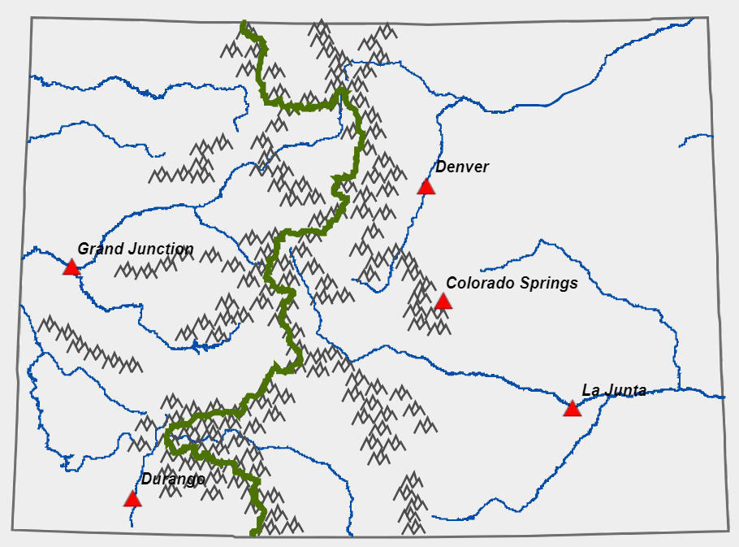  How did you decide which areas would be wet?  How did you decide which areas would be dry?
Step 2 | Your Task
Check ON the Precipitation Zones layer to check your prediction. Click Legend button to see what the different colors mean for Precipitation Zones. (Arid means dry; semi-arid is not as dry – the category in the middle.) | Which areas of Colorado receive the most precipitation (classified as “wet”)?  Which areas of Colorado receive the least precipitation (classified as “arid”)?

Step 3 | Your Task
Check ON Communities layer, then Refresh Map. Click on the communities to find your hometown or a nearby town or city. | Do you live in a wet, semi-arid, or arid region?
Reflection | Your Task
Read about rain shadows. | Use what you noticed from the maps and information from the National Geographic article to write a paragraph explaining why some regions of Colorado receive less precipitation than others.

