Physical Geography - Activity 1 (PG-1)

Open Activity 1: The Continental Divide (web map for Activities PG-1, PG-2, PG-3, and PG-4). You should see a map of the major rivers in Colorado with a few of the major cities in the state.

Step 1 | Your Task
A continental divide is a naturally occurring boundary or ridge separating a continent’s river systems. In Colorado, the Continental Divide separates the rivers that drain west into the Pacific Ocean from the river systems that drain east toward the Atlantic Ocean.  Looking at this map of Colorado’s rivers, where do you predict the continental divide is? | Double click on the image below. Use the scribble tool to draw a red dotted line to show your prediction on the map below.  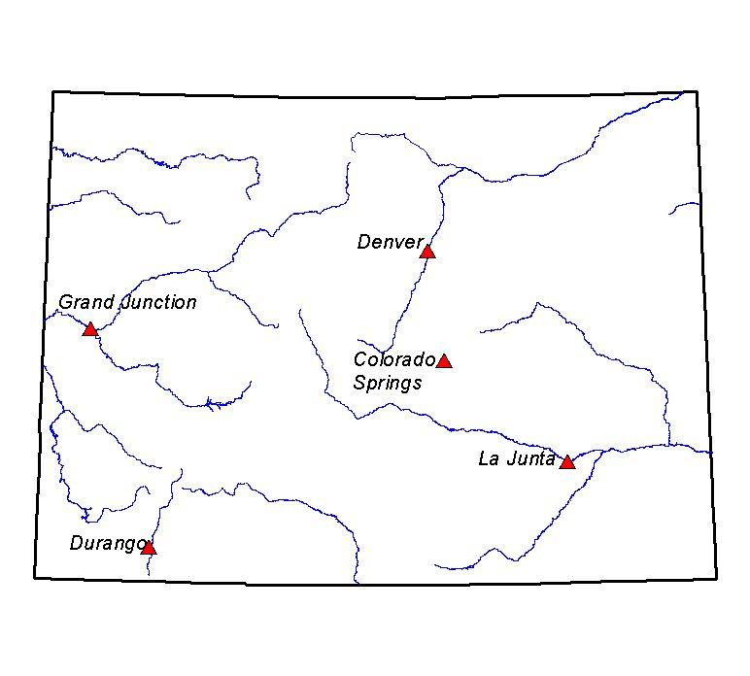  Why do you predict this location?
Step 2 | Your Task
Use Layer List button to CHECK ON the Mountains layer. | Does this information change your prediction?  If so, double click on the image below. Draw a new red dotted line on the map below.  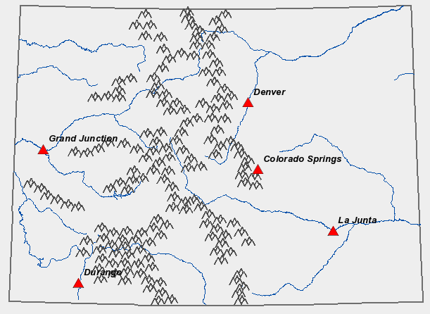  Did your prediction change?  Why do you predict this location?
Step 3 | Your Task
CHECK ON the Continental Divide layer to see if your prediction was accurate. | Double click on the map below. Use the shape tool to put a yellow rectangle on the eastern slope and a green rectangle on the western slope.

Step 4 | Your Task
CHECK ON the Communities layer. Try to find your community (or one nearby) by clicking on the communities. A popup box should appear. You may need to click a number of times to find your community or a nearby one. | Do you live on the eastern or western slope of Colorado?
Step 5 | Your Task
Check OFF ALL layers. Then Check ON the Western States, Continental Divide, and Western Rivers layers.  Use your zoom in/out tools so you can see the Western US (similar to the one here). Colorado is just one state in the Rocky Mountain region. The continental divide runs north all the way into Canada and south into Mexico, though the map shows only the part in Colorado. | On the map below, predict where the full continental divide should go. Use the scribble tool to draw the line in red.  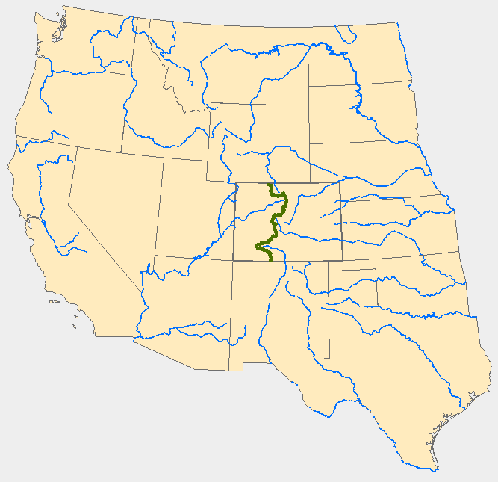
Extension | Your Task
Use Stream Tracer Tool  https://txpub.usgs.gov/DSS/streamer/web/  Locate these four rivers in Colorado and trace their flow downstream. | To where does each river flow?  - South Platte River  - Colorado River  - Rio Grande  - Arkansas River

