“Understanding by Design” Unit Guide

Title of Unit | Colorado Physical Geography |  | Grade Level | upper elementary
Curriculum Areas | technology, science, geography |  | Time Frame | 45 minutes per activity
Developed By | Michelle Eckstein
Identify Desired Results (Stage 1)
Content Standards
Geography
- 3rd - Use various types of geographic tools to develop spatial thinking.
- 4th - Use several types of geographic tools to answer questions about the geography of Colorado.
- The concept of regions is developed through an understanding of similarities and differences in places.
- Use maps and other geographic representations, geospatial technologies, and spatial thinking to understand and communicate information.
Life Science
- There is interaction and interdependence between and among living and nonliving components of systems.
Math
- CCSS.MATH.PRACTICE.MP5 Use appropriate tools strategically
- CCSS.MATH.CONTENT.MD.B Solve problems involving measurement and estimation

CCSS.MATH.CONTENT.MD.B Represent and interpret data
- CCSS.MATH.CONTENT.MD.C. Measure area
Digital Communications
- With guidance and support from adults, use technology to produce and publish writing (using keyboarding skills) as well as to interact and collaborate with others.
- Communicate clearly and creatively for a variety of purposes using the platforms, tools, styles, formats and digital media appropriate to goals and intended audience.
- Use public domain or creative commons media, and refrain from copying or using material created by others without permission.
Digital Literacy
- CCSS.ELA-LITERACY.RI.3.5 Use text features and search tools (e.g., key words, sidebars, hyperlinks) to locate information relevant to a given topic efficiently.
- Conduct basic keyword searches to gather information.
- Cite websites using modified MLA citation
- Provide basic source information (e.g., name of source or URL) for non-text-based sources (e.g., images, audio, video).

Understandings |  |  | Essential Questions
- Continental divide is an imaginary line -- all rivers to the west flow to the Pacific Ocean and all rivers to the east flow to the Atlantic Ocean.  - Mountains affect precipitation patterns.  - The mountains on the western slope get a lot more precipitation than the eastern plains because the clouds are stopped as they head west over the mountains. As they rise the moisture gets cooler and drops out of the clouds. By the time they get over the mountains and onto the plains, they have lost most of their moisture.  - Colorado’s five life zones are defined mostly by elevation and determine which plants and animals can survive in each zone.  - The elevation of an area affects its climate, which affects the plants and animals that live in that area.  - Humans make decisions that contribute to the protection or endangerment of environmental systems.  - External influences such as climate, physical geography, and available resources determine how humans and organisms adapt to their environment.  - The interdependent nature of environmental systems reflects the connections among habitats, organisms, cultures and technologies. |  |  | - How do the major landforms of Colorado affect the climate in different areas?  - How do physical features provide opportunities and challenges to regions?  - What are geographic characteristics of regions in Colorado?  - How do non-living components of an ecosystem influence living components?  - How are resources shared between humans and organisms within a specific environment?  - What human activities can affect the habitats in each life zone?
Knowledge  Students will know…… |  |  | Skills  Students will be able to……
Major habitats or life zones:  - prairie or grasslands  - semi-desert shrublands  - foothills or woodlands  - montane  - subalpine  - alpine  - riparian  Major landforms of Colorado:  - Great Plains  - Rocky Mountains  - Colorado Plateau  - lakes, rivers, streams  Vocabulary:  - elevation  - precipitation  - coniferous  - deciduous  - tundra |  |  | - Read and interpret information from geographic tools and formulate geographic questions  - Find oceans and continents, major countries, bodies of water, mountains, and urban areas, the state of Colorado, and neighboring states on maps  - Locate the community on a map and describe its natural and human features  - Identify geography-based problems and examine the ways that people have tried to solve them  - Identify Colorado’s five life zones  - Understand how life zones are determined  - Use map skills to locate these zones on a map of Colorado  - Compare the plants and animals common to these zones  - Summarize the characteristic life forms of each zone  - Compare and contrast different habitat types
Assessment Evidence (Stage 2)
Performance Tasks |  |  | Other Evidence
MapCO Physical Geography Activity 1
MapCO Physical Geography Activity 2
MapCO Physical Geography Activity 3
Create Google MyMap
Create VR Tour of one Colorado Life Zone (ThingLink, YouTube 360 or Google Expeditions)
Activities
Lesson 1: Continental Divide |  | MapCO Physical Geography Activity 1
Lesson 2: Precipitation in Colorado |  | MapCO Physical Geography Activity 2
Lesson 3: Colorado Life Zones |  | MapCO Physical Geography Activity 3  Explore ThingLink of Colorado Life Zones or Colorado VR or other web-based image banks to gain understanding of the characteristics of each zone. Discuss:  - What are common characteristics of several adjacent life zones?  - How does elevation, landforms, and precipitation affect the plants and animals that are found in each life zone?
Lesson 4: Map Measurements |  | MapCO Physical Geography Activity 4
Extension |  | - Investigate a specific zone using assigned websites  - http://shelledy.mesa.k12.co.us/staff/computerlab/ColoradoLifeZonesInformation.htm  - https://www.nps.gov/romo/learn/nature/naturalfeaturesandecosystems.htm  - http://coloradobirdingtrail.com/birding-basics/habitats/grasslands/  - http://www.landscope.org/colorado/ecosystems/featured_ecosystems/iconic_ecosystems/  Create ThingLink  - Include major components of an ecosystem and examples of each component Example

Template from G. Wiggins and J. McTighe (1998), Understanding by Design, Association for Supervision and Curriculum Development.

Physical Geography - Activity 1 (PG-1) Answer Key

Open Activity 1: The Continental Divide (web map for Activities PG-1, PG-2, PG-3, and PG-4). You should see a map of the major rivers in Colorado with a few of the major cities in the state.

Step 1 | Your Task
A continental divide is a naturally occurring boundary or ridge separating a continent’s river systems. In Colorado, the Continental Divide separates the rivers that drain west into the Pacific Ocean from the river systems that drain east toward the Atlantic Ocean.  Looking at this map of Colorado’s rivers, where do you predict the continental divide is? | Double click on the image below. Use the scribble tool to draw a red dotted line to show your prediction on the map below.  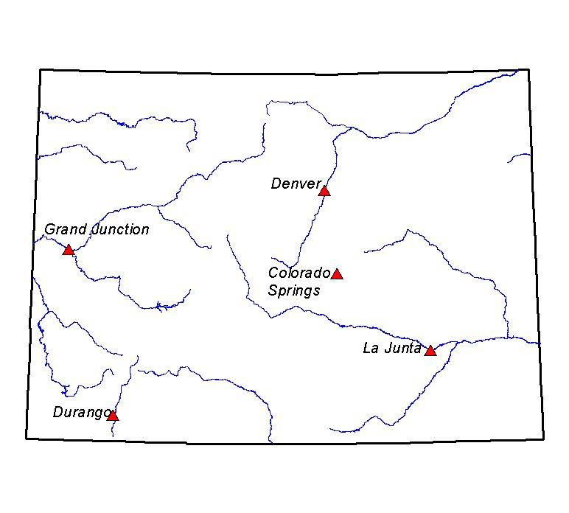  Why do you predict this location?  The scribble tool in Microsoft Word is Insert Tab, then Shapes, then in the Lines category. Students need to click and hold in order to draw. Students should try to think in terms of mostly east flowing rivers end up in the Atlantic and mostly west flowing end up in the Pacific.
Step 2 | Your Task
Use Layer List button to CHECK ON the Mountains layer. | Does this information change your prediction?  If so, double click on the image below. Draw a new red dotted line on the map below. Knowing where the mountains are can help in understanding water movement—which is, of course, downhill!  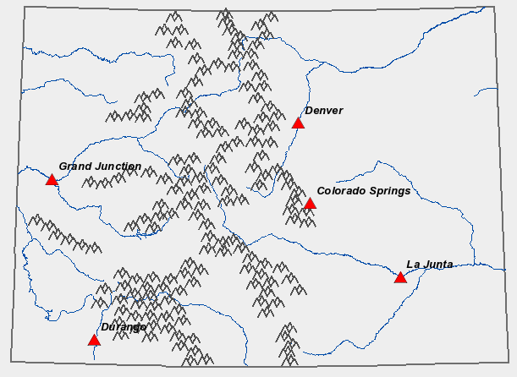  Did your prediction change?  Why do you predict this location?  Obviously water flows downhill. Most Rivers start at the “Headwaters”. Colorado is the “Headwaters” of many rivers.
Step 3 | Your Task
CHECK ON the Continental Divide layer to see if your prediction was accurate. | Double click on the map below. Use the shape tool to put a yellow rectangle on the eastern slope and a green rectangle on the western slope.  Insert Tab, Shapes, and then rectangle tool. You can right-click on the new polygon and change the outline color and make it no-fill, as was done above.

Step 4 | Your Task
CHECK ON the Communities layer. Try to find your community (or one nearby) by clicking on the communities. A popup box should appear. You may need to click a number of times to find your community or a nearby one. | Do you live on the eastern or western slope of Colorado? Generally the term “Eastern Slope” means those areas that drain to the Atlantic Ocean; and the term “Western Slope” are those that drain to the Pacific Ocean.
Step 5 | Your Task
Check OFF ALL layers. Then Check ON the Western States, Continental Divide, and Western Rivers layers.  Use your zoom in/out tools so you can see the Western US (similar to the one here). Colorado is just one state in the Rocky Mountain region. The continental divide runs north all the way into Canada and south into Mexico, though the map shows only the part in Colorado. | On the map below, predict where the full continental divide should go. Use the scribble tool to draw the line in red.  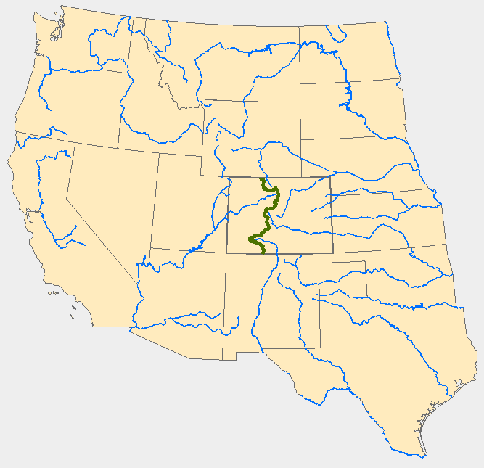Try to have students follow the divides between major rivers. See above. In Microsoft Word the Scribble Tool is under the Insert Tab, then Shapes, and in the Lines category.
Extension | Your Task
Use Stream Tracer Tool  https://txpub.usgs.gov/DSS/streamer/web/  Locate these four rivers in  Colorado and trace their flow downstream. | To where does each river flow?  - South Platte River  - Colorado River  - Rio Grande  - Arkansas River  If you use Stream Tracer correctly (Use Trace Downstream button) the South Platte ends up in the Gulf of Mexico/Atlantic Ocean. The Colorado River terminates in the Gulf of California/Pacific Ocean. Note that Stream Tracer doesn’t show the last little part of the Colorado River going through Mexico. Both the Rio Grande and Arkansas Rivers end in the Gulf of Mexico, albeit by different routes.

Physical Geography – Activity 2 (PG-2) Answer Key
Open Activity 2: Precipitation in Colorado (web map for Activities PG-1, PG-2, PG-3, and PG-4).
Step 1 | Your Task
Using Layer List button, make sure the following layers are CHECKED ON: Major Cities, Continental Divide, Mountains, Colorado Rivers (all other layers OFF). Looking at the continental divide, mountains, and rivers in Colorado, where do you predict our state gets the most precipitation (rain and snow)? Where does it get the least precipitation? | On the map below, shade the areas you think are the wettest in blue and the areas you think are the driest in yellow. You don’t need to shade the entire map. Remember: wet means a lot of rain AND snow!  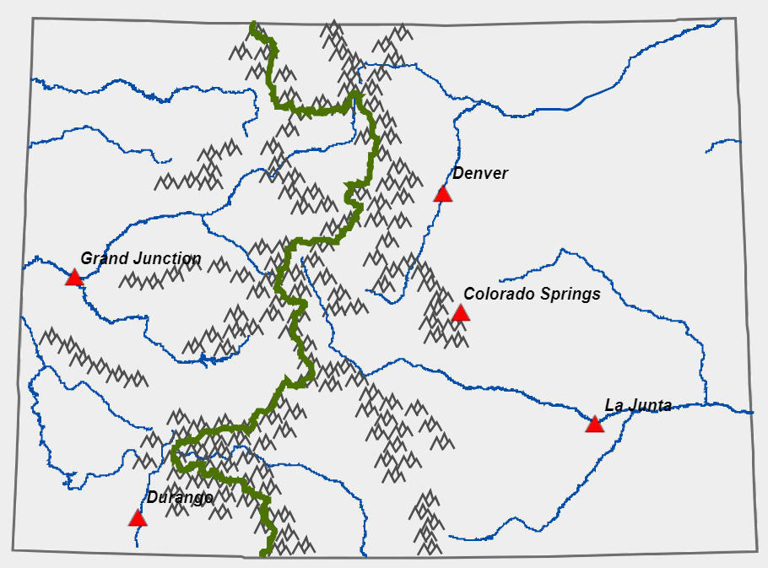  How did you decide which areas would be wet? Students could “guess” anything. But—maybe that mountains will be wet (thinking skiing).  How did you decide which areas would be dry? Again—answer could be anything.
Step 2 | Your Task
Check ON the Precipitation Zones layer to check your prediction. Click Legend button to see what the different colors mean for Precipitation Zones. (Arid means dry; semi-arid is not as dry – the category in the middle.) | Which areas of Colorado receive the most precipitation (classified as “wet”)? Have students click the Precipitation Zones layer off and on several times. It should be apparent the “Wet” areas are in the mountains.  Which areas of Colorado receive the least precipitation (classified as “arid”)? The driest areas are scattered in the western ½ of the state.
Step 3 | Your Task
Check ON Communities layer, then Refresh Map. Click on the communities to find your hometown or a nearby town or city. | Do you live in a wet, semi-arid, or arid region?
Reflection | Your Task
Read about rain shadows. | Use what you noticed from the maps and information from the National Geographic article to write a paragraph explaining why some regions of Colorado receive less precipitation than others.  Teachers probably need to read the article to the left and discuss the idea of mountain precipitation AS IT RELATES TO COLORADO. Dominant weather comes from west to east in Colorado. These air masses are relatively dry. However, as they move over the mountains of Colorado (average elevation higher than any other state) it can rain or snow. As the air mass moves down the slopes of the mountain ranges (like into the Front Range of Colorado) the air warms and becomes drier. Several of the “splotchs” of arid climate between mountain ranges in Colorado are basins that affected by this “rain shadow effect”. San Luis Valley is a great example of this.

Physical Geography – Activity 3 (PG-3) Answer Key

Open Activity 3: Colorado’s Life Zones (web map is for Activities PG-1, PG-2, PG-3, and PG-4). Colorado can be divided into five “life zones” going from lowest to highest elevation: Plains, Foothills, Montane, Subalpine, and Alpine. Boundaries of the life zones are defined by elevation: how high the land is above sea level.

Step 1 | Your Task
Using Layer List button , CHECK ON the following layers: Major Cities, Continental Divide, Mountains, Colorado Rivers, Colorado (other layers Checked OFF). On the map at right, try to predict where each life zone is. | Double click on the image below. In Microsoft Word use the Insert Tab, then Shapes pull-down tools to draw a region (use freeform/area tool) showing where you predict each zone will be located. Color the Plains yellow, the Foothills orange, the Montane brown, the Subalpine dark red, and the Alpine gray or white.  Student could also just use colored pen/pencil for this section. Regions could be all over the place. Teachers need to briefly explain Plains, Foothills, Montane, Subalpine, and Alpine.
Step 2 | Your Task
Check ON the Life Zones layer. Click Legend button to see which color is used to show each different Life Zone. | Which life zones did you predict correctly? Varies  Which ones did you not predict correctly? Varies  Which life zone appears to occupy the MOST land in Colorado?  Clearly Plains and Foothills zones.  Which life zone appears to occupy the LEAST land in Colorado? Harder to tell. Alpine, or Subalpine.  What do you notice about where the each life zone is located, in relation to the mountains?  Noticeably an order of zones. As you get closer to mountains. Plains, then foothills, then Montane, then Subalpine, and Alpine is the top of the highest mountains in Colorado.  Predict the life zone that you would expect to see in the states that neighbor Colorado on the east. Probably Plains. There are not any mountains in Kansas or Nebraska!
Step 3 | Your Task
Explore ThingLink of Colorado Life Zones or Colorado VR (or any other image bank on the web) to gain understanding of the characteristics of each zone. Portions of this website can be slow to load. | Guiding questions for discussion:  - What are common characteristics of several adjacent life zones? You’ll need to think of examples. Example: Alpine and Sub-Alpine are both pretty high in elevation. Both would be cold in the winter and mild/cool in the summer. Both are probably pretty wet. Etc.  - How do elevation, landforms, and precipitation affect the plants and animals that are found in each life zone? The two most important here would be elevation (affecting temperature), which in terms affect precipitation. More precipitation the higher you go. With the BIG exception of landforms (like large mountain ranges) creating a rain shadow affect.

Physical Geography - Activity 1 (PG-4) Answer Key

Open Activity 4: Map Measurement (web map for Activities PG-1, PG-2, PG-3, and PG-4). You should see a map of the major rivers in Colorado with a few of the major cities in the state. In this activity, you will be using the map measurement tools.

Step 1 | Your Task
Click on Ruler to open measurement tools.  Then click on the second (middle) icon to measure distance in miles. | Estimate the distance between Grand Junction and Denver. Tell students to estimate by air. Obviously driving would be longer (about 240 miles)!  Click on Grand Junction to open your first point. Then click on Denver to measure the distance from Grand Junction to Denver.  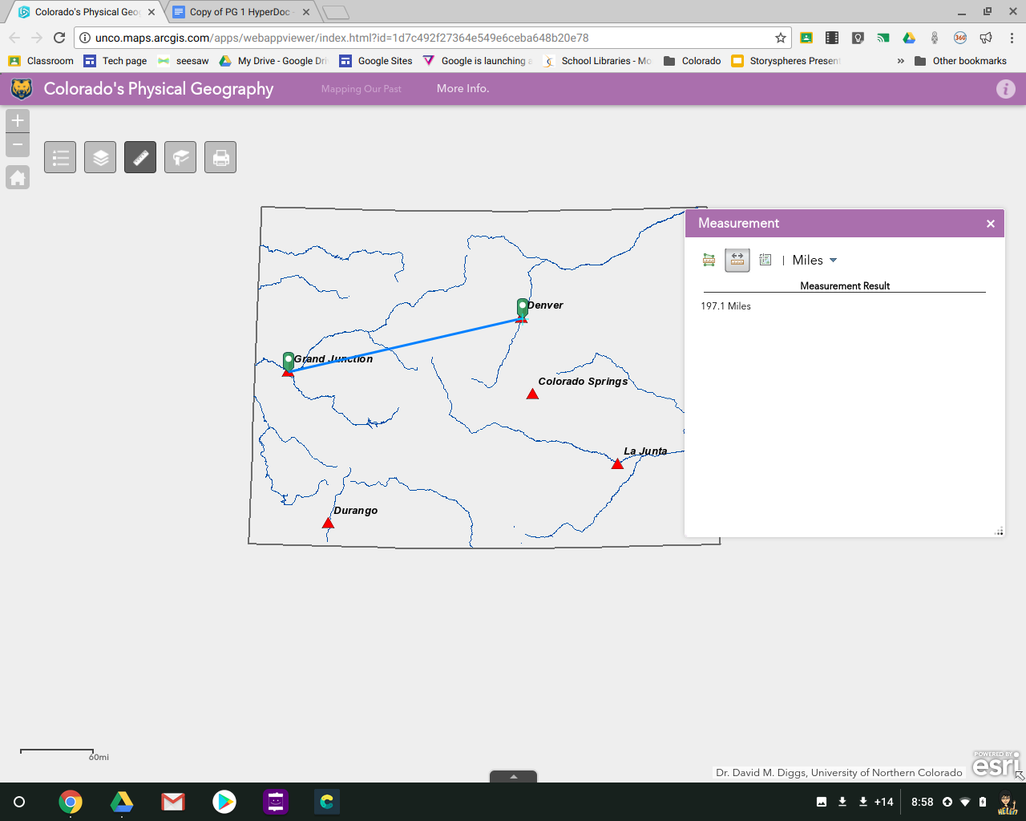  What is the approximate distance between Grand Junction and Denver?  About 197 miles by air  How close was your estimate?
Step 2 | Your Task
Click Clear or the second icon again to reset the measurement tool. | Estimate the distance between La Junta and Durango.  Now use the measurement tool to find the actual distance. What is the approximate distance between La Junta and Durango?  About 242 miles by air  Measure distance of La Junta and Durango to Continental Divide. Which city is farther?  La Junta
Step 3 | Your Task
Click Clear or the second icon again to reset the measurement tool.  Check on Continental Divide Layer. | Estimate the distance between Colorado Springs and Denver.  Use measurement tool to calculate the actual distance. What is the approximate distance between Colorado Springs and Denver?  About 63 miles by air  Estimate which city, Colorado Springs or Grand Junction, is closer to the Continental Divide. Use measure tool to check your guess.  It’s Colorado Springs (about 74 miles vs. Grand Junction 105 miles).
Step 4 | Your Task
Click on first icon (far left) to measure area. Note that you can change the units by clicking on the unit name. Switch between square miles and square kilometers. Make sure to hit the CLEAR button when done measuring.  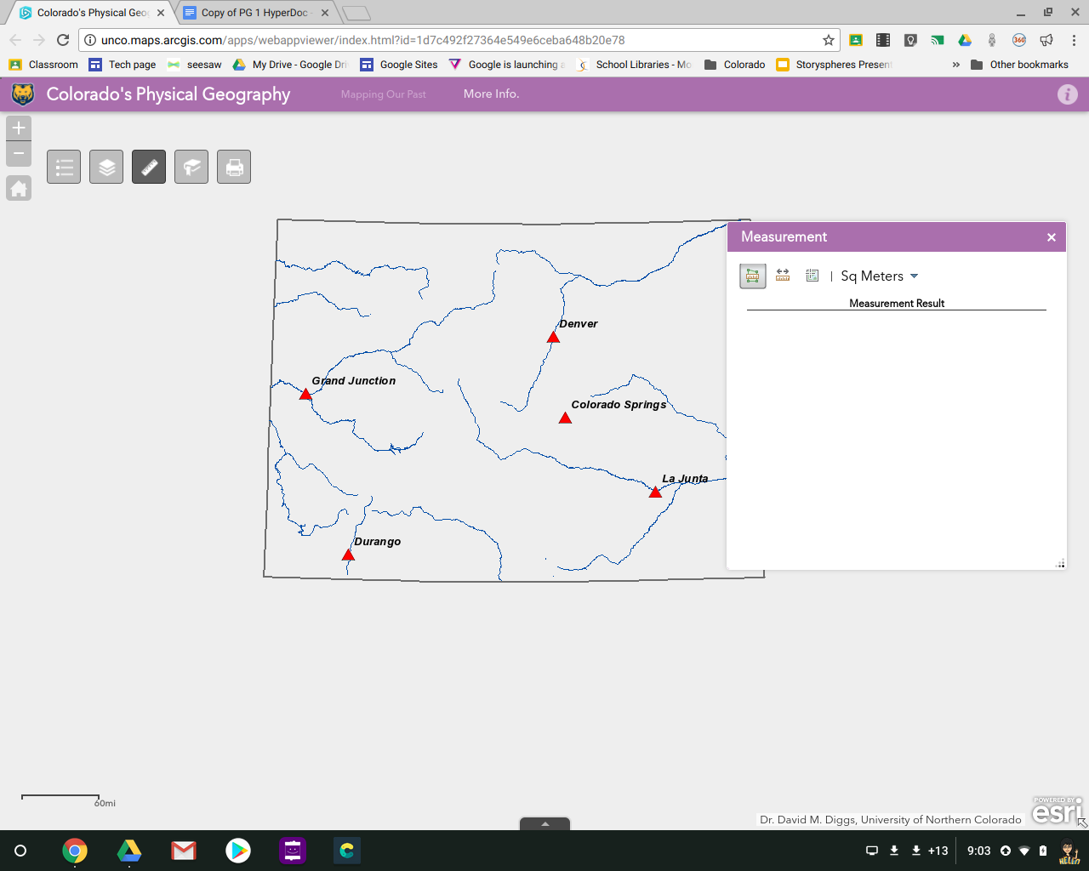 | Measure the area of Colorado by clicking on each corner of the state. As you do so, the area being measured will increase until you cover the whole state. Double-click on the fourth corner to finish.  What is the approximate area of Colorado in square kilometers? Actual is 269,837 sq. km. Students should get within 5,000  What is the approximate area of Colorado in square miles? Actual is 104,185 sq. miles. Students should get within 2,000.
Step 5 | Your Task
You can also measure the distance rivers travel, by clicking several times to follow the river’s path. As you do so, the total distance will keep adding up. | Find the Gunnison River in western Colorado. It flows into the Colorado River at Grand Junction.  What is the approximate distance from there to the point in the mountains where the Gunnison River begins? Answers could vary considerable here—depending on how closely they measured. Somewhere in the vicinity of 125 miles?
Step 6 | Your Task
Check ON the Communities layer and find the community you live or go to school in. | What is the closest major city to your community?  What is the distance between your community and that major city?

