Worksheet MP-3 Population Changes in a Colorado Supply Town
MP-3 Interactive Map
Directions: Do the Step and then the Task for that Step before moving on
to the next Step and Task
Step 1 | Your Task
A. Click on the link (below) or copy and paste the link into your browser to see more detail of the picture of the inside of a miner’s log cabin to the right:  http://www.unco.edu/hewit/doing-history/colorado-miners/food-clothing-shelter/interiors.aspx  B. Open the online Map.  In a browser go to (or click link):  http://unco.maps.arcgis.com/apps/webappviewer/index.html?id=aeed10c185bd4dfcb11570d2da24cc28 | 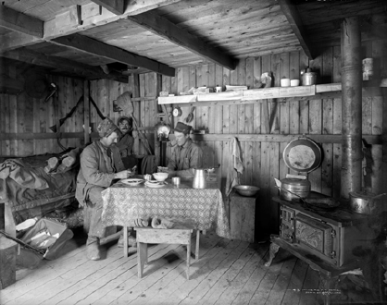  Photo: Denver Public Library, Western Historical Collection  1. Examine the photo above of the inside of a miner’s cabin to help you make a list of supplies that miner’s needed every day. Think about which items they could make on their own and which items they would need to get from a supply town. Think also about what tools they would need in order to mine.  2. Go to Step B when list completed  Supplies  Made on their own: Buy from Supply Town:
Step 2 | Your Task
C. On the online map, use the Layer List button (insert icon of layer list button here) to CHECK ON only the following layers:  -City Pop. 1900  -1895 Railroad  -Major Mountain Ranges  -Mining Camps and Ghost Towns | 3. After you have Checked on the layers, click on some of the red circles and explore towns that you think might have been a supply town for a mining camp. You will see drop downs for railroad lines and population totals when doing this.  4. Discuss with your partner the reasons a supply town would be located where they are and the difference between a supply town and a mining town/camp.  Write those reasons here:
Step 3 | Your Task
D. Keep the same layers on your map and answer the questions for Task #5. | 5. Choose a Colorado Supply Town on the map and fill in the information below:  Name of Supply town:__________________________  Population in 1900:____________________________  Population in 1910:____________________________  Population Difference:__________________________  Why do you think the population changed in these 10 years?  Why do you think your Supply Town was located where it was?  Write your answers here:
Step 4 | Your Task
E. Use the Measurement button and its Ruler tool to determine the distance from your Supply Town to the Mining Camp.  -Click this button once on the Supply Town and then once on the Mining Camp.  -Then read the “Measurement Result in the pop up box.”  -When done, close the Measurement pop up box.  -You can also use the Zoom in/out tools to help get a more accurate measurement.  F. Do Task #9, 10, & 11. | 6. What kind of people and businesses do you think you would see in a Supply Town? Write your answer below:  7. Choose a Mining Camp/Ghost Town in the mountains and find its’ Supply Town.  The name of the Mining Camp is:  _____________________________________  The name of the Supply Town is:  _____________________________________  8. Read directions in Step E.  9. What is the distance between your Mining Camp and the Supply Town?  ______________________________________  10. How do you think the supplies were transported from your Supply Town to your Mining Town?  11. Estimate how long the trip would take from the Supply Town to the Mining Town?  Walking/hiking:___________________________ hours/days  Mule/horse:_______________________________ hours/days  Wagon:___________________________________ hours/days  Narrow gauge railroad_______________________ hours/days
Step 5 | Your Task
12. Would you rather have lived in a Supply Town or a Mining Town? Give your reasons why:

13. If you could own a business in a Supply Town, what would it be and why?

14. Make a sketch/design of a sign you would have to advertise your business in a Supply Town having business name with catchy slogan and/or design:

