Worksheet CB3. Activity County Boundaries CB3
Open County Boundaries Activity CB3: 20th Century County Changes.

Step 1 | Your Task

From the middle bottom of the map bring up the table for your map; click on the 1890 County Boudaries tab, and then click on the “Name” field to get it in alphabetical order.

Then click on “ARAPAHOE” in the table. This should “select” the record and turn the county cyan on the map.
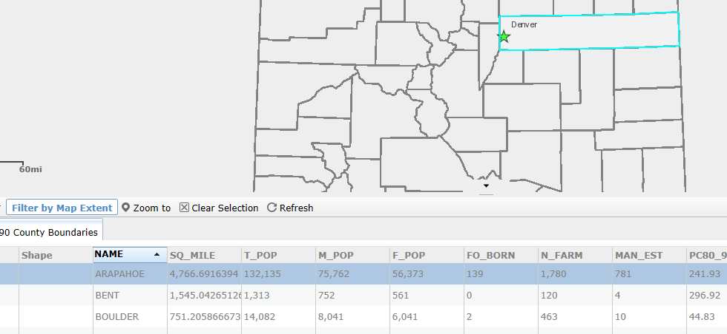

Now you know what Arapahoe County looked like in 1890—it stretched all the way from Denver to the Kansas border!

On the table click the Clear Selection button . You can also collapse the table (click on the small arrow). You now know the location of the old Arapahoe County.

Step 2 | Your Task
Check ON the 1920 County Boundaries layer (also—the 1890 County Boundaries layer should still be checked on). Go to the Bookmark “Northeastern Colorado”. If you want you can manually zoom in more/less to the area (depends on your monitor size). | From 1890 to 1920 Arapahoe County is split into 5 counties. What are they?
Step 3 | Your Task
Check OFF all layers then Check On the 1910-1920 Pop. Change layer. Go to the Bookmark “Colorado”. Make sure you look at the legend for this layer. | In terms of population growth, what happened in northwest and northeast Colorado from 1890 to 1920?  Why do you think Arapahoe County was split up into 5 different counties?
Step 4 | Your Task
Check OFF all layers. Then Check ON the following layers: 1920 County Boundaries, Communities, 1895 Railroads, and 1913 Railroads.  (you may want to zoom in a bit to Eastern Colorado) | How do you think railroads helped these new Plains counties (Eastern Colorado)?
Step 5 | Your Task
Go to the Bookmark “Kit Carson County”. If you want you can manually zoom in more/less to the area (depends on your monitor size).  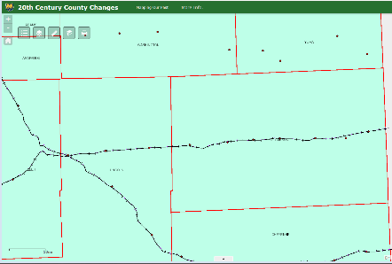  Click on the Measure tool, then select the distance tool, and measure the distance from town to town. Click once on the first town, a second click on the second town, then read the measurement.  Before starting the next pair of towns you’ll have to close the Measurement box and reopen it. | Flagler to Seibert _______miles  Seibert to Vona _______miles  Vona to Stratton _______miles  Stratton to Bethune _______miles  Bethune to Burlington _______miles  Burlington to Peconic _______miles  What pattern do you notice about the distance between these towns? Why do you think towns were regularly spaced along the railroads?  During the period 1890 to 1920 try to describe how Colorado’s economy was changing? (extended response)

