Worksheet CB1. Activity County Boundaries CB1

Open County Boundaries Activity CB1:

Step 1 | Your Task
Colorado’s Border and Early County Boundaries. A map of Denver, 1880 Counties, and Early Trails is displayed.  These are the major trails in Colorado before the gold rush. Click precisely on the trails to get a popup box with the trail’s name (Not the 1880 county information). Zooming in can help you be more precise on where you are clicking!  Use the Layer List button to Check On (make visible) the Major Mountain Ranges layer. | What are the 3 main trails that existed prior to the Colorado Gold Rush?  Why didn’t these trails just head straight across the state from east to west?
Step 2 | Your Task
Use the Layer List button to Check Off the 1880 Counties layer. Then Check On the 1876 Counties layer. At the bottom of the map you’ll see a small arrow. Click on this and you should see an attribute table of data. 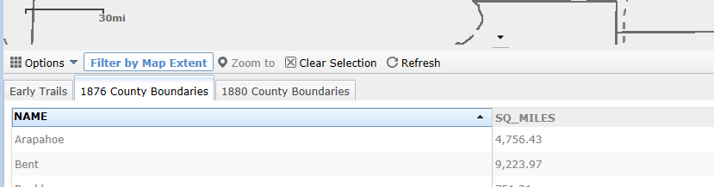  Click On the 1876 County Boundaries tab. Then Click On the Sq_Miles field heading. This should sort the table lowest to highest or highest to lowest. Get the table so it shows LOWEST to HIGHEST. Then hold down the Ctrl key and Click on the two counties that are UNDER 500 square miles in size. This should turn the outlines of the counties cyan in color. On the map it should look like:  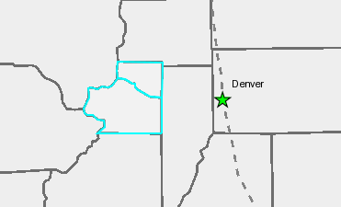  Turn on the Mineral Belt layer.  Turn on the Mountain layer. | What two counties were chosen and what were their sizes?  Name Size in Sq. Miles  Why do you think Colorado’s counties were such different sizes in 1876?
Step 3 | Your Task
On the table click the Clear Selection button . You can also collapse the table (click on the small arrow). Check OFF ALL layers. Then Check On only the Major Rivers, Gold Rush Trails, 1876 Counties, 1879 Railroads, and Mineral Belt layers. | How did people reach these important mining counties?
Step 4 | Your Task
Try turning on some of the other layers.  Check ON the Continental Divide layer. | Can you think of other factors that influenced the placement of county boundaries in 1876?
Step 5 | Your Task
From the previous question you may have different layers on. So let’s get everyone back on the same page! Check OFF ALL layers, then Check On 1876 Counties. Look at this map for a second.  Now Check On the 1880 Counties layer. The Red lines indicate county boundary changes or the splitting of one county into two counties from 1876 to 1880.  Click on the Mineral Belt layer for additional help. | How many “more” counties were created by 1880?  Using the layers available on your map (and any other sources), try and form a “hypothesis” on WHY one of the counties was split into two or more counties.

