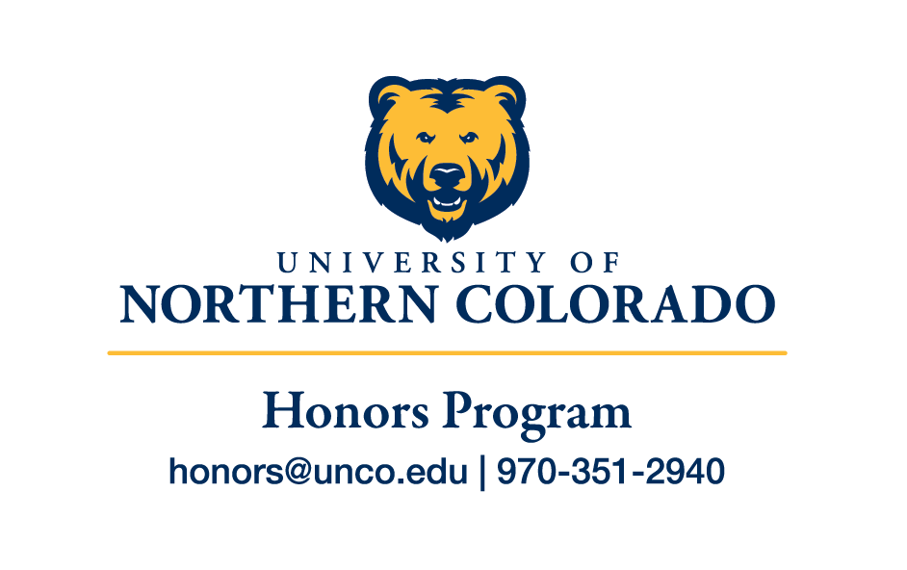

Mission and Vision

Center for Honors, Scholars and Leadership Mission
Through innovative programs and initiatives in the areas of curriculum development, undergraduate research, leadership studies, student development, and global and community engagement, The Center for Honors, Scholars and Leadership fosters a community of UNC students as they become socially responsible citizen scholars and leaders.

Honors Program Vision
University of Northern Colorado’s Honors Program vision is to build a community of intellectually engaged, students and innovative scholars who enrich the world as responsible global citizens.

Honors Program Mission
The mission of the University of Northern Colorado (UNC) Honors Program is two-fold:

Honors Interdisciplinary Program:
The University of Northern Colorado Honors Interdisciplinary Program develops a community of creative problem solvers in order to cultivate responsible citizen scholars, through an enriched curriculum that promotes critical thinking and self-driven integrative, inquiry-based learning.

Upper Division Honors Program:
The University of Northern Colorado Upper Division Honors Program develops a scholarly community of creative problem solvers in order to cultivate responsible citizen scholars through an enriched curriculum that supports self-driven, independent learners and promotes contributions to the disciplinary discourse.

