Giant Traveling Map Lesson

TITLE / AUTHOR:
Reading Maps Together / Lauren Lehmann

COLORADO ACADEMIC STANDARDS / SUITABLE DISCIPLINES:
- Social Studies, Geography: Fourth Grade Standard 2, Grade Level Expectation 1: Use several types of geographic tools to answer questions about the geography of Colorado, Evidence Outcome a: Answer questions about Colorado regions using maps and other geographic tools (DOK 1-2).
- Visual Arts: Fourth Grade Standard 1: Observe and Learn to Comprehend, Grade Level Expectation 2: Works of art articulate and express different points of view, Evidence Outcome a: Discuss how characteristics of art are used in specific ways to create meaning (DOK 1-3).

OBJECTIVES:
Students will:
- interpret visual cues on a globe, a hand-held map of the United States, and a giant floor map of Colorado.
- use manipulative items to represent features of the geography of Colorado such as mountains, rivers, grassland, towns, cities, and forest.
- recognize patterns and relationships found on the maps by interpreting the symbols found on the map’s legend.
- collect information and data from a secondary source by analyzing a map.
- collaborate with their teammates to make choices and share tasks.

RECOMMENDED GRADES: Third and younger, although older students and adults enjoy making their own maps as well.

TIME NEEDED: 45 minutes

MATERIALS:
- Globe of any kind, 1
- Laminated map keys or legends for the Giant Map of Colorado, 4
- Laminated maps of the world and the United States, 20
- Stacks of green plastic drink cups, 96
- Tub of small glass droplets
- Green squares of cloth, 12
- Green and white squares of cloth, 24
- Black plastic portion cups, 80
- Ice cube trays, 18
- Small, flattened brown paper bags, 24
- Cardstock strips with features written on them (6 of each): mountain, river, grassland, small town, city, forest
- 6 “shoebox” tubs

PREPARATION:
- In advance, prepare the students to work with the Giant Map by reviewing the rules.
- Have students remove their shoes and put on socks.
- Divide the materials into the 6 “shoebox” tubs. Each team will get one tub to work with. Each tub should have sufficient manipulatives and six word cards.
  - 12 green cups
  - 10 small black cups
  - 3 paper bags
  - 3 ice cube trays
  - 2 green squares of cloth
  - 4 green and white squares of cloth
  - 2 small black cups full of stones
- The laminated United States maps will be used at the beginning of the lesson; students may share or have their own.
- The globe will be used in a group activity.
- Open and lay out the giant map. Check to be sure there are no writing tools near the map.
- Prepare a song, poem, or game for remembering the names of continents.
- Seat small groups of students around the giant map, with some teams at the corners, and some on the sides.

RULES:
- Shoes are not allowed on the map. Please have students remove shoes before walking on the map.
- No writing utensils on the map.
- No sliding on the map.

DIRECTIONS:

Before you go to the giant state map: (optional segmenting of the lesson)
- Using any globe, review the names of the continents (sing a continent song, say a poem, make associations to remember their names, play a game, or some other appropriate activity). Ask students what a continent is.
- Have a quick discussion about how continents may be divided into countries. Some of the questions that you might ask include: What is the name of our continent?
What continent is our country part of?
- Give out the laminated maps of the United States. State that the United States has fifty different states that are united into one country. One of the states is Colorado. Can you find Colorado on the map? What do you notice about Colorado? This may include the shape, size or location of Colorado.

On the map: (optional segmenting of the lesson)
- Please look at the map key/legend with your team. What do the symbols stand for?
- Have each person on a team choose one symbol and find it on the giant map. That person should stand on a place where that symbol is used.
- Everyone returns to their groups. Ask the students what they found out about Colorado.
- Demonstrate how one can put a hand inside a brown paper bag to open it and then “scrunch it up” and shape the bag to make a pointed top to represent a mountain (This can be one of the objects used in the next step).
- Each group will be asked to use the word cards in their tub and select an object from the tub that represents each of the terms on the word cards and put that object on the giant map where the item on the word card is located.
- You may limit the number of groups on the map by selecting a subset of the group to go on the map while the other groups observe.
- After the students have put the objects on the map ask them a series of questions. What do you notice about Colorado? This will produce a variety of responses. Follow up the initial responses by asking them why they came up with the observations they did. How did you know where to put the objects you chose? This questions should elicit answers related to the correlation of places on the Earth’s surface with symbols. Where is our school on the map? How can a person make a map of such a big place? This may be a difficult for the students to answer if they haven’t had some background.
- Following the last lesson, stack all the tubs and materials together.

MODIFICATIONS:

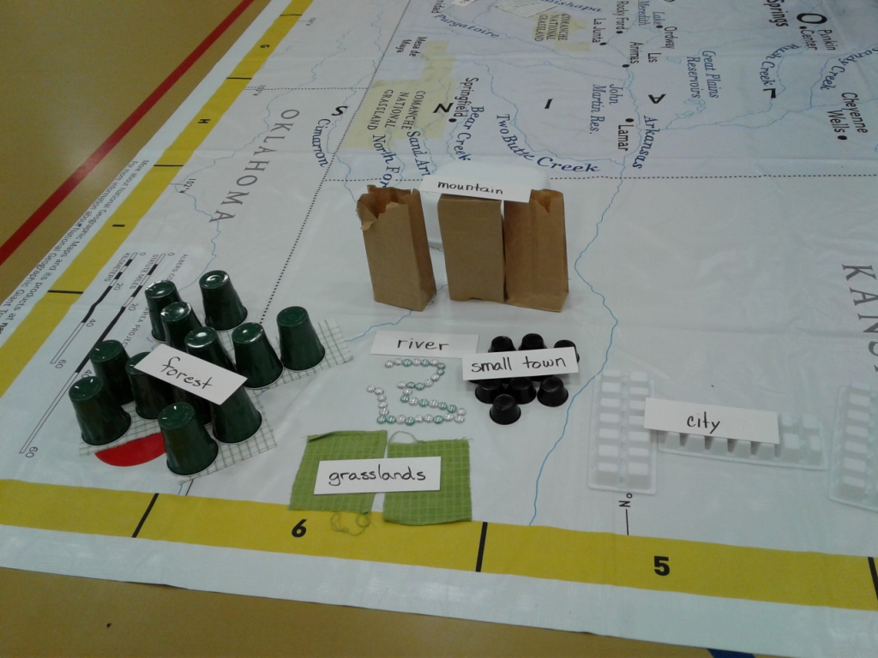
Alternatively, after step 4 above, divide students into six groups. Seat them around the map: one group each on the red, yellow, blue, and green dots in the corners and the remaining two groups on the red Xs in the center at the north and the south ends of the map. Give each of the groups one of the six tubs. If the students are old enough to read the cards, ask them to take out the cards, identify what types of items in the tubs might be used to represent the different features. For students who are not yet reading (preschoolers or kindergarteners), they may use the materials to make whatever they would like on the map. Invite them to dump everything in the tub out on to the map. Ask them to cooperate to build a map with the materials. This will take five to seven minutes, depending on the age of the students. When everyone is done, ask all students to step away from the map. Have everyone walk around the map (on the floor or carpet –off the map) and take a look at what other groups used to represent the features as part of a gallery walk. Ask a representative from each group to explain how they decided to use their materials. After everyone has had a chance to present their maps, ask the students to put everything back in the individual tubs to be prepared for the next class.

Sight-impaired students can access information about Colorado geographic features on their tablet or computer and coach their group members on what to look for and where to place representations of features. Have them make Braille signs for each type of feature so their teammates can place them accordingly.

Students in wheelchairs can be in charge of deciding which items to use for which features and they can give them out to their teammates. Make sure they have a good view of the map so they can direct their teammates effectively.

For ELL students, make word cards in the language for each type of feature. The choosing and building aspects of the task are done with the universal language of spatial understanding and the elements of design. Much of their success with this lesson may be nonverbal. The focus of this class is on non-linguistic representations.

Students with autism or social/emotional diagnoses may enjoy doing the tasks alone or with one trusted student. Let them complete the population of the entire map with objects of their choosing. Give them plenty of time.

EXTENSIONS:

In the computer lab, examine satellite images of Colorado [http://libguides.colostate.edu/c.php?g=64730&p=417271]. Have each student choose a section of particular interest to them and ask them to draw it on a piece of paper resting on a clipboard, using the whole space to the edges. Later, use colored pencils to create color and texture in the various geographic areas. Then, using student watercolor sets, paint over the entire picture with watercolors.

Invite students to create a story based on the map they created.

