Pika
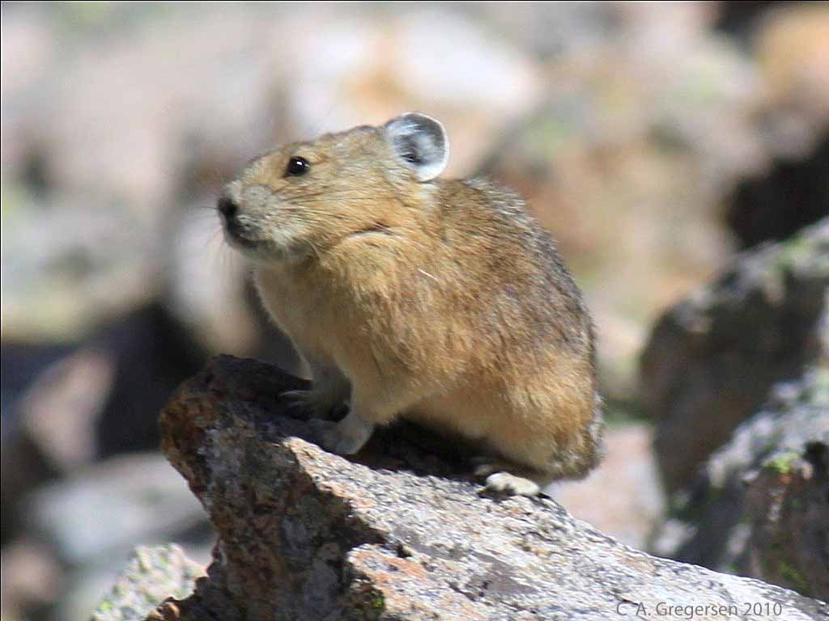
Pika in its Summer Habitat

- This animal lives among the rocks in this cold, treeless habitat in the summer.
- They eat the small plants that grow in this zone in the summer.

Marmot

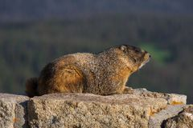

Marmot in its Summer Habitat

- This animal likes to sun itself on the rocks in this treeless habitat in the summer.
- This animal eats small plants, flowers, and berries.
- These animals hibernate through the winter.

Black Bear

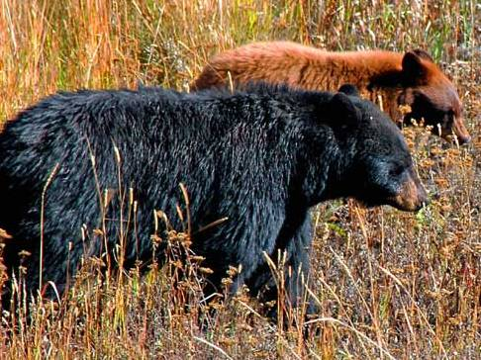

Black Bear in its Summer Habitat

- This animal rubs its back on pine trees.
- It mostly eats the seeds from pine cones, plants, and berries.
- It can also climb the trees in its habitat.
- The bear hibernates in the winter.

Mountain Lion

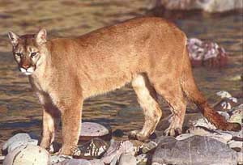

Mountain Lion

- This predator hunts animals in the forest but may also live in the foothills.
- This cat is a great jumper and will jump up on boulders and into trees.

White-Tailed Jackrabbit

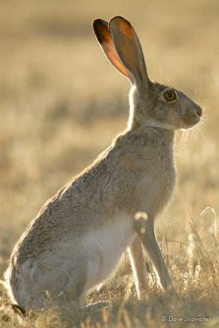

White-Tailed Jackrabbit

- This rabbit lives in several habitats, but it thrives in the hills in front of the mountains. It likes the grasses, small bushes, and rocky land.
- It eats grasses, bark, and twigs.
- It is a larger rabbit with long legs and long ears. This rabbit turns white in the winter.

Mule Deer
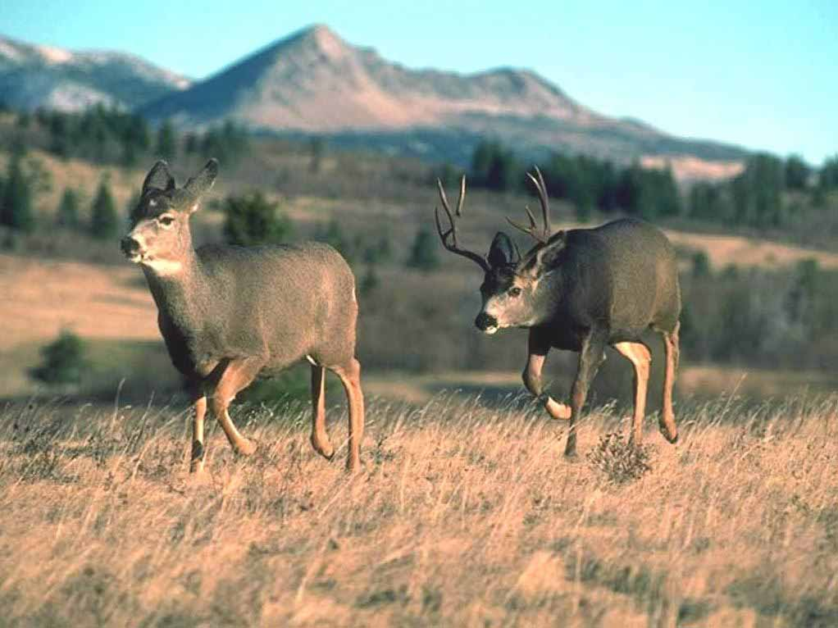

Mule Deer in its Winter Habitat
- These deer have large ears that look like the ears of a mule.
- They eat mostly shrubs.
- They like to go into the mountains in the summer, but are normally in this lower, hilly area in the winter. They also live in the semi-desert area of western Colorado.

Black-Tailed Prairie Dog

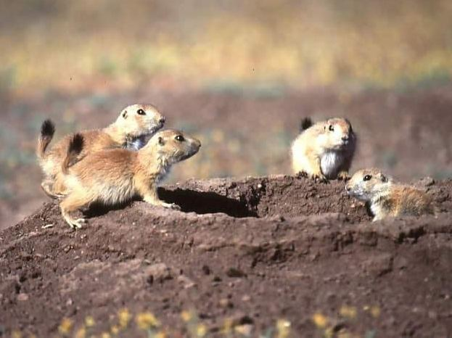
Black-Tailed Prairie Dog

- This small animal lives in burrows in the ground in grassy areas.
- They eat seed stems, roots, leaves, and grasses.
- They live in neighborhoods of prairie dogs, enjoying the company and safety of many animals.

Mice

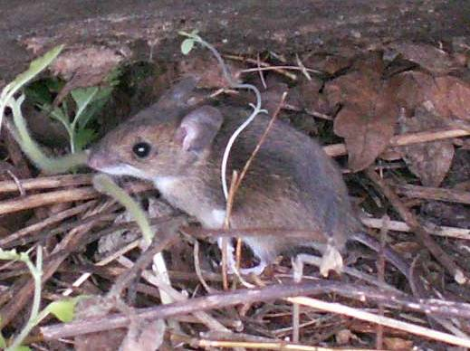

Mice

- Though they can live in other habitats, mice like to live in this grassy area.
- These critters eat insects, spiders, and smaller mammals.
- Mice are nocturnal.

Desert Shrew

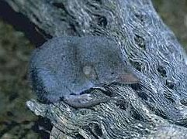

Desert Shrew

- The shrew prefers this desert area but also likes grasslands.
- The desert shrew eats insects and spiders found in this habitat.
- Like a bat, the shrew relies on its large ears and echolocation.
- The desert shrew has adapted to having no water source. It gets water from the plants it eats.

Rainbow Trout

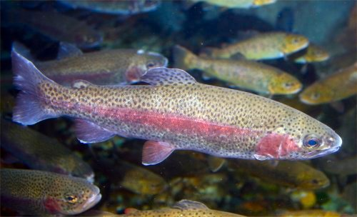

Rainbow Trout

- This fish lives in moving, cold waters of Colorado.
- The rainbow trout eats insects, fish eggs, and small fish.

Great Blue Heron

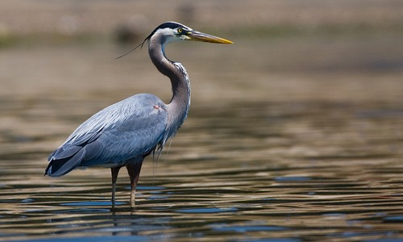

Great Blue Heron

- The Great Blue Heron migrates to Colorado waterways in the spring and leaves in the fall.
- They nest in trees that are 40-70 feet tall. That’s as tall as a 4-7 story building.
- These birds eat mostly fish, which they grab out of the water with their long beaks.

