Colorado Indians Topic
STUDENT INVESTIGATIONS

- Set up the following “resource stations” in the classroom:
  - Computer station for CD0ROM disk or Internet website.
  - Reference and textbook station.
  - Hard copy photograph station (illustrated history or picture books on Colorado Indians).
  - VCR for quiet viewing of a video on Colorado Indians.
  - (The graphic on the next page shows additional possibilities for stations.)
- Post a schedule to rotate students through the computer station.
- Write the following synthesis question on the chalkboard:
  - What was it like to live as Colorado Indians did?
- Divide the students into work groups (no more than three students per group) and give each group one of the five Colorado Indians Investigation Sheets (see below).
- Explain to students that each group will become expert on one of the following themes:
  - Food, Clothing, and Shelter
  - Families, Children, and Infants
  - Work and Tools
  - Community Life
  - Reservation Life
The groups will gather information at the resource stations to answer the questions on their Investigation Sheet.
- Each group will be responsible for teaching the rest of the class about its theme. They must decide how best to teach this material. Some possibilities:
  - An oral report.
  - A poster.
  - A skit.
  - A mock press conference.
- The students in each group must take notes about the themes that they have not investigated.
- Finally, each student must submit a written piece that integrates the information by responding to the synthesis questions. Some possibilities include an essay, a short story or poem, a series of mock diary entries, a written dialogue between two historical characters.

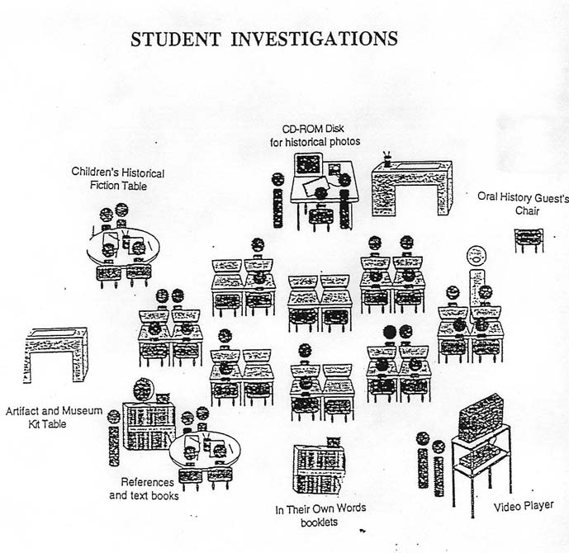

The figure above illustrates some of the possibilities for
stations that students might use during their investigations.
FOOD, CLOTHING, AND SHELTER

INVESTIGATION SHEET

The task of your group is to find out all you can about the kind of FOOD the Colorado Indians ate, the CLOTHES they wore, and what kinds of SHELTER they lived in. Use the Doing History/Keeping the Past CD-ROM disk or Internet site and as many other sources as you can find.
The questions below will help you get started. Add to this list any other questions that you can think of.

- What kind of food did Colorado Indians eat? __________________________________________________________________________________________________________________________________________________________________________________________________________________________________________________________________________________________________________________________________________
- What kind of clothes did Colorado Indian women and girls wear? ________________________________________________________________________________________________________________________________________________________________________________________________________________________________________________________________________
- What kind of clothes did Colorado Indian men and boys wear? __________________________________________________________________________________________________________________________________________________________________________________________________________________________________________________________________________________________________________________________________________
- What kind of shelters did Colorado Indians use? __________________________________________________________________________________________________________________________________________________________________________________________________________________________________________________________________________________________________________________________________________
- Who set up tepees and how did they do it? __________________________________________________________________________________________________________________________________________________________________________________________________________________________________________________________________________________________________________________________________________

Write on the back of this sheet if you need more space.
FAMILIES, CHILDREN, AND INFANTS

INVESTIGATION SHEET

The task of your group is to find out all you can about Indian FAMILIES, CHILDREN, and INFANTS in Colorado. Use the Doing History/Keeping the Past CD-ROM disk or Internet site and as many other sources as you can find.
The questions below will help you get started. Add to this list any other questions that you can think of.

- What was it like to live in an Colorado Indian family? __________________________________________________________________________________________________________________________________________________________________________________________________________________________________________________________________________________________________________________________________________
- What kind of toys did Indian children have? ________________________________________________________________________________________________________________________________________________________________________________________________________________________________________________________________________
- How did Indian children learn skills they would need as adults? __________________________________________________________________________________________________________________________________________________________________________________________________________________________________________________________________________________________________________________________________________
- What kind of chores did Indian children have to do? __________________________________________________________________________________________________________________________________________________________________________________________________________________________________________________________________________________________________________________________________________
- What were cradle boards and why did Indian mothers use them? ________________________________________________________________________________________________________________________________________________________________________________________________________________________________________________________________________________________________________________________________________

Write on the back of this sheet if you need more space.

INDIAN WORK AND TOOLS

INVESTIGATION SHEET

The task of your group is to find out all you can about the kind of WORK Colorado Indians did and the kind of TOOLS they used. Use the Doing History/Keeping the Past CD-ROM disk or Internet site and as many other sources as you can find.
The questions below will help you get started. Add to this list any other questions that you can think of.

- How did Indians hunt when they did not have horses? __________________________________________________________________________________________________________________________________________________________________________________________________________________________________________________________________________________________________________________________________________
- How did Indians use horses to hunt buffalo? ________________________________________________________________________________________________________________________________________________________________________________________________________________________________________________________________________
- What weapons did Indians use to hunt buffalo? __________________________________________________________________________________________________________________________________________________________________________________________________________________________________________________________________________________________________________________________________________
- What kind of work did Indian men do? __________________________________________________________________________________________________________________________________________________________________________________________________________________________________________________________________________________________________________________________________________
- What kind of work did Indian women do? ________________________________________________________________________________________________________________________________________________________________________________________________________________________________________________________________________________________________________________________________________

Write on the back of this sheet if you need more space.

COMMUNITY LIFE

INVESTIGATION SHEET

The task of your group is to find out all you can about Colorado Indian COMMUNITY LIFE. Use the Doing History/Keeping the Past CD-ROM disk or Internet site and as many other sources as you can find.
The questions below will help you get started. Add to this list any other questions that you can think of.

- How large were Colorado Indian villages? __________________________________________________________________________________________________________________________________________________________________________________________________________________________________________________________________________________________________________________________________________
- How were Indian villages laid out? ________________________________________________________________________________________________________________________________________________________________________________________________________________________________________________________________________
- Why did Indians meet in a Camp Circle once each year? __________________________________________________________________________________________________________________________________________________________________________________________________________________________________________________________________________________________________________________________________________
- What kind of religious ceremonies did Colorado Indians have? __________________________________________________________________________________________________________________________________________________________________________________________________________________________________________________________________________________________________________________________________________
- What kind of games and sport did Colorado Indians play?
__________________________________________________________________________________________________________________________________________________________________________________________________________________________________________________________________________________________________________________________________________

Write on the back of this sheet if you need more space.

RESERVATION LIFE

INVESTIGATION SHEET

The task of your group is to find out all you can about why Colorado Indians moved to reservations and what RESERVATION LIFE was like. Use the Doing History/Keeping the Past CD-ROM disk or Internet site and as many other sources as you can find.
The questions below will help you get started. Add to this list any other questions that you can think of.

- Why did Indians and Whites go to war against each other? __________________________________________________________________________________________________________________________________________________________________________________________________________________________________________________________________________________________________________________________________________
- Why did Indians move to reservations? ________________________________________________________________________________________________________________________________________________________________________________________________________________________________________________________________________
- How did Indians make a living on reservations? __________________________________________________________________________________________________________________________________________________________________________________________________________________________________________________________________________________________________________________________________________
- What kind of shelters did Indians live in on their reservations? __________________________________________________________________________________________________________________________________________________________________________________________________________________________________________________________________________________________________________________________________________
- What new skills did reservation children learn to play and how did they learn them? __________________________________________________________________________________________________________________________________________________________________________________________________________________________________________________________________________________________________________________________________________

Write on the back of this sheet if you need more space.

