COLORADO CITIES
STUDENT INVESTIGATIONS

- Set up the following “resource stations” in the classroom:
  - Computer station for CD0ROM disk or Internet website.
  - Reference and textbook station.
  - Hard copy photograph station (illustrated history book on Colorado cities).
  - VCR for quiet video viewing.
  - (The graphic on the next page shows additional possibilities for stations.)
- Post a schedule to rotate students through the computer station.
- Write the following synthesis question on the chalkboard: What was it like to live and work in a 19th century Colorado city?
- Divide the students into work groups (no more than three students per group) and give each group a Colorado Cities Investigation Sheet.
- Explain to students that each group will become expert on one of the following themes:
  - Food, Clothing, and Shelter
  - Families, Children, and Schools
  - Work Places
  - Large Cities
  - Community Life
  - Transportation
The groups will gather information at the four resource stations to answer the questions on their Investigation Sheet.
- Each group will then gather information at the four resource stations to answer the questions on their Investigation Sheet.
- Finally, each student must write a 1-2 page essay that responds to the synthesis question.

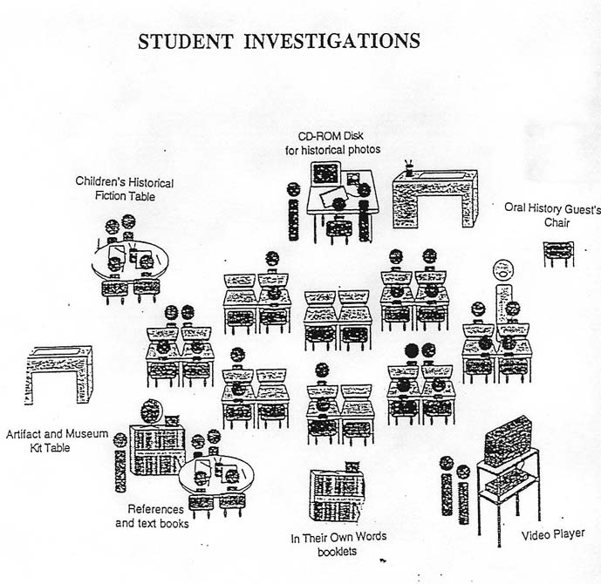

The graphic above suggests several additional work stations
for students to use as they investigate their topics.
COLORADO CITIES INVESTIGATION SHEET

FOOD, CLOTHING, AND SHELTER

The task of your group is to find out all you can about the kind of FOOD city people ate, the CLOTHES they wore, and what kind of SHELTER they lived in. Use the Doing History/Keeping the Past CD-ROM disk or Internet site and as many other sources as you can find.
The questions below will help you get started. Add to this list any other questions that you can think of.

- What kind of food did people eat? ____________________________________________________________________________________________________________________________________________________________________________________________________________________
- Where did they get this food? _____________________________________________________________________________________________________________________________________________________________________________________________________________
- What kind of clothes did men and women wear? ____________________________________________________________________________________________________________________________________________________________________________________________________________________
- What kind of clothes did children wear? ____________________________________________________________________________________________________________________________________________________________________________________________________________________
- What kind of houses did people in cities live in? ____________________________________________________________________________________________________________________________________________________________________________________________________________________
- What were the houses like on the inside? What kind of furniture did people have? ____________________________________________________________________________________________________________________________________________________________________________________________________________________

Write on the back of this sheet if you need more space.
COLORADO CITIES INVESTIGATION SHEET

FAMILIES, CHILDREN, AND SCHOOLS

The task of your group is to find out all you can about FAMILIES and CHILDREN in Colorado cities and the kind of SCHOOLS children attended. Use the Doing History/Keeping the Past CD-ROM disk or Internet site and as many other sources as you can find.
The questions below will help you get started. Add to this list any other questions that you can think of.

- What evidence can you find about the size of families? ____________________________________________________________________________________________________________________________________________________________________________________________________________________
- How did families dress when their photos were taken? _____________________________________________________________________________________________________________________________________________________________________________________________________________
- What did children do to have fun? ____________________________________________________________________________________________________________________________________________________________________________________________________________________
- How tall were school buildings? ____________________________________________________________________________________________________________________________________________________________________________________________________________________
- What kind of desks did children have at school? __________________________________________________________________________________________________________________________________________________________________________________________________________________
- How did teachers dress? __________________________________________________________________________________________________________________________________________________________________________________________________________________

Write on the back of this sheet if you need more space.

COLORADO CITIES INVESTIGATION SHEET

WORK PLACES

The task of your group is to find out all you can about the kind of WORK people did in Colorado cities in the 19th century. Use the Doing History/Keeping the Past CD-ROM disk or Internet site and as many other sources as you can find.
The questions below will help you get started. Add to this list any other questions that you can think of.

- What kind of shops and factories did people work in? ____________________________________________________________________________________________________________________________________________________________________________________________________________________
- What kind of tools and machines did they use? _____________________________________________________________________________________________________________________________________________________________________________________________________________
- What kind of goods did they sell in stores? ____________________________________________________________________________________________________________________________________________________________________________________________________________________
- What did people do who worked in banks? ____________________________________________________________________________________________________________________________________________________________________________________________________________________
- What kind of services did workers provide? __________________________________________________________________________________________________________________________________________________________________________________________________________________
- What were hospitals like? ____________________________________________________________________________________________________________________________________________________________________________________________________________________

Write on the back of this sheet if you need more space.

COLORADO CITIES INVESTIGATION SHEET

LARGE CITIES

The task of your group is to find out all you can about the larger cities of Colorado in the 19th century. Use the Doing History/Keeping the Past CD-ROM disk or Internet site and as many other sources as you can find.
The questions below will help you get started. Add to this list any other questions that you can think of.

- What were the earliest buildings made of? ____________________________________________________________________________________________________________________________________________________________________________________________________________________
- What were later buildings made of? _____________________________________________________________________________________________________________________________________________________________________________________________________________
- How were the main streets surfaced? ____________________________________________________________________________________________________________________________________________________________________________________________________________________
- How crowded were city streets? ____________________________________________________________________________________________________________________________________________________________________________________________________________________
- How clean was the air in large cities? __________________________________________________________________________________________________________________________________________________________________________________________________________________
- What kinds of businesses were located down town? __________________________________________________________________________________________________________________________________________________________________________________________________________________

Write on the back of this sheet if you need more space.

COLORADO CITIES INVESTIGATION SHEET

COMMUNITY LIFE

The task of your group is to find out all you can about COMMUNITY LIFE in Colorado cities in the 19th century. Use the Doing History/Keeping the Past CD-ROM disk or Internet site and as many other sources as you can find.
The questions below will help you get started. Add to this list any other questions that you can think of.

- What were churches like in 19th century cities? ____________________________________________________________________________________________________________________________________________________________________________________________________________________
- What holidays did people celebrate? _____________________________________________________________________________________________________________________________________________________________________________________________________________
- What festivals and other special events did they attend? ____________________________________________________________________________________________________________________________________________________________________________________________________________________
- What did city people do for entertainment? ____________________________________________________________________________________________________________________________________________________________________________________________________________________
- What did city people do for recreation? __________________________________________________________________________________________________________________________________________________________________________________________________________________
- What kinds of sports did city people play? __________________________________________________________________________________________________________________________________________________________________________________________________________________

Write on the back of this sheet if you need more space.

COLORADO CITIES INVESTIGATION SHEET

TRANSPORTATION

The task of your group is to find out all you can about TRANSPORTATION in Colorado cities in the 19th century. Use the Doing History/Keeping the Past CD-ROM disk or Internet site and as many other sources as you can find.
The questions below will help you get started. Add to this list any other questions that you can think of.

- How were streetcars powered in 19th century Colorado? ____________________________________________________________________________________________________________________________________________________________________________________________________________________
- Why were streetcars important? _____________________________________________________________________________________________________________________________________________________________________________________________________________
- What were horse-drawn wagons used for? ____________________________________________________________________________________________________________________________________________________________________________________________________________________
- What kind of carriages did people ride in? ____________________________________________________________________________________________________________________________________________________________________________________________________________________
- How important were railroad stations in large cities? ____________________________________________________________________________________________________________________________________________________________________________________________________________________
- What were early autos like? _______________________________________________________________________________________________________________________________________________________________________________________________________________________________________________________________________________

Write on the back of this sheet if you need more space.

