GSA Grant Cycle 04
Research Project Grant Application
(save MS Word file as "Firstname Lastname Research")

WARNING:
Due to the increased volume of grant applications, all application submissions are final. The GSA will no longer be accepting corrections, additions, revisions, etc. prior to initial review Errors, omissions, mistakes, insufficient documentation, etc. may result in application dismissal. See the current GSA Grant Handbook for more information. Contact the Grant Review Committee at gsa@unco.edu with any questions before submitting an application that is incomplete in any way. It may be up to two business days before you receive a response to any questions, so please plan accordingly.

Enter your information into the following document. Follow the example formats provided EXACTLY. Remove the example and input your own information. Do not change the formatting, font (Calibri 11pt), and/or line spacing. Send the completed Microsoft Word file to gsa@unco.edu before the application deadline. No corrections, revisions, additions, etc. will be accepted once your application is submitted.

Applicant First & Last Name:

Bear Number:
xxxxx6789

UNC Bear Mail (do not use your first.last@unco.edu email):
last1234@bears.unco.edu

U.S. Phone Number:
555-555-5555

U.S. Mailing Address:
1234 Street, City, State, Zip Code

College:
EBS, HSS, NHS, MCB, or PVA

Program (use the official program name from this list):
Your academic program (including post-nominals: Ph.D., M.S., D.A., etc.)

Primary Campus Location:
Greeley, Denver, Loveland, or Online

[continue]
Project Title:
Name of your research project. Do not list more than one project per application.

Has this project been funded previously by the GSA?
Yes or No; if yes, provide grant cycle and academic year (e.g., Cycle 2 of 2020-2021)

Principal Investigator:
Firstname Lastname
If you are not the principal investigator, include a statement here as to why you are applying for GSA funding instead of the principal investigator.

Additional Contributors:
Name all others that are contributing to this research. Enter N/A if not applicable.
Research Advisor for this Project:
Firstname Lastname
Research Dates (Enter start-end dates using numerical format below):
MM/DD/YYYY-MM/DD/YYYY
If you are applying for continuing research funding, the start date should be when the research first began.

Anticipated submissions for publication and/or presentation (list all journals / conferences):
Journal #1, anticipated submission date
Conference A, anticipated submission date
Conference B, anticipated submission date

NOTICE:
If your project is funded, you must disclose that the “University of Northern Colorado Graduate Student Association” contributed funding towards your research in all publications and/or presentations of your research. Failure to do so may result in suspension of your privileges to participate in the GSA grant process.

[continue]

Written Responses
Answer the following questions. You may add additional lines as necessary. Given the limited funds available and the high degree of competition from fellow graduate students, the Review Committee is prioritizing applications with detailed, thoughtful, and useful information. Please be truthful in your answers. The Review Committee wants to know about your research, but they also want to know about your experiences as a UNC graduate student. Provide specifics, not generalizations, whenever possible.
Keep in mind that the GSA may choose to publish any/all responses. Do not plagiarize. You may include citations and a reference list if necessary.

Note:
If you are submitting this application for research that began during the last grant cycle, answer all questions with detailed information about what you did and what happened. Lack of details may cause the reviewers to doubt your work/attendance.

Student Name: Firstname Lastname
Program: fullnameofprogram, Ph.D.
College: EBS, HSS, MCB, NHS, PVA
Research Project Title: TitleOfResearchProject

Tell us about your research. What is the objective? What is your methodology? (300 words max)

What are the historical/theoretical/societal/etc. underpinnings of your research? (300 words max)

What makes your research project special/difficult/innovative? (300 words max)

Why should anyone care about this research? (300 words max)

Why do you need funding for this research? What will the money be used for? Will you perform this research even if you do not receive funding from the GSA? (300 words max)

[continue]

Copy of IRB/IACUC Approval:
Delete the example below and enter a photo, screenshot, or scan of your current IRB/IACUC approval letter (not your IRB/IACUC application). Must be large enough to read clearly. IRB/IACUC approval letter must be addressed to you and/or easily allow the Review Committee to determine that the research has been approved and that you are part of that research team. If the IRB/IACUC approval letter is not addressed to you, include a copy of that letter here and also enter your information into the next question on this application. If you are conducting research under another person’s IRB / IACUC protocol, their IRB / IACUC letter must be current.

If your IRB/IACUC application is still pending, write a 1 or 2 sentence statement explaining your situation in the space below. Include when you submitted your IRB / IACUC application and when you anticipate hearing back from the IRB / IACUC committee.

If your project does not require IRB/IACUC approval, write a 1 or 2 sentence statement of exemption in the space below.

Example:
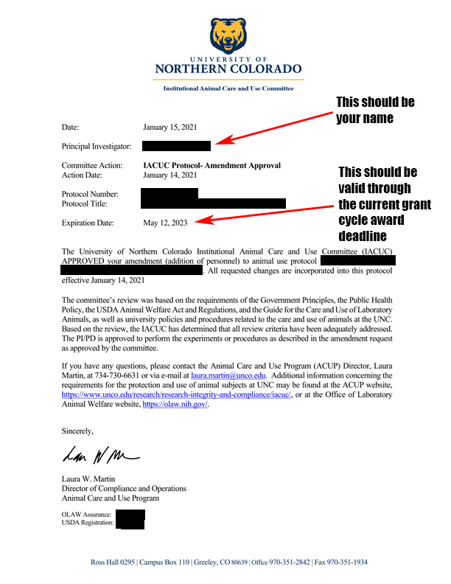
[continue]

Copy of IRB/IACUC Supplemental Statement Form:
If the IRB/IACUC letter in the previous question is not addressed to you, delete the example below and enter a photo, screenshot, or scan of a completed IRB/IACUC Supplemental Statement Form, from the letter addressee, here. The Supplemental Statement form asserts that your research is covered under their protocol. If you are conducting research under another person’s IRB / IACUC protocol, their IRB / IACUC letter must be current.

If your project does not require an IRB/IACUC Supplemental Statement form, leave this question blank.

Example:
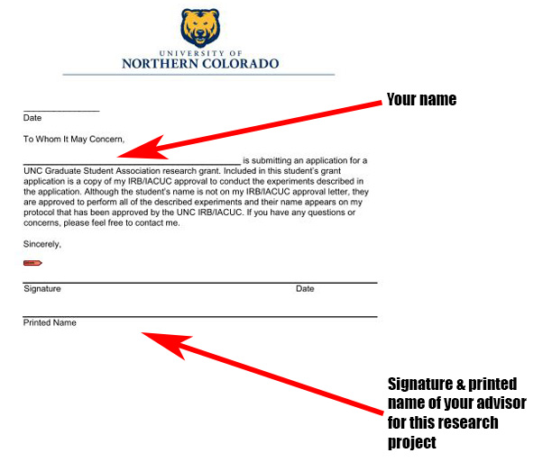

[continue]

Copy of Course Schedule:
Copy of Course Schedule:
If you are starting or continuing a research project between May 1, 2023 – June 30, 2023, delete the example below and enter a photo, screenshot, or scan of your:
- Summer 2023 or Fall 2023 course schedule, or
- Proof of continuous graduate enrollment for Summer 2023 or Fall 2023.

If you started a research project between January 1, 2023 – April 30, 2023, delete the example below and enter photos, screenshots, or scans of your:
- Summer or Fall 2023 course schedule, or proof of continuous graduate enrollment AND
- Spring 2023 course schedule or proof of continuous graduate enrollment.

Correct name and semester must be visible. If either are cropped out of the image, the Grant Review Committee will not be able to verify your enrollment and your application may be dismissed.

Example:
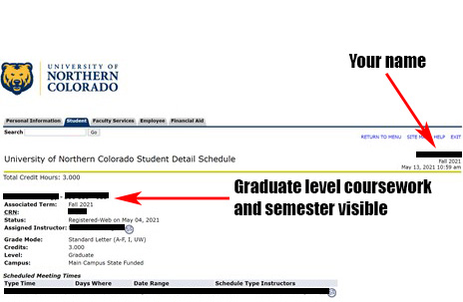

[continue]

Financial Aid Impact

Download a copy of the Student Gifts, Prizes, or Awards Recipient Information Form. Fill out the following:
- Name
- Bear ID #
- Address
- City, State, Zip Code
- Purpose/Description: Write a brief description about the project/travel/publication/professional development this grant request is for.
- Was this required for a course/program at UNC?

Save this PDF form as Firstname_Lastname_giftform. Submit this completed PDF form along with your GSA grant application.

[continue]

Was This Research Required?

Download a copy of this Advisor Statement Form and have your advisor fill it out.

Save this PDF form as Firstname_Lastname_advisor-statement-form. Submit this completed PDF form along with your GSA grant application.

[continue]

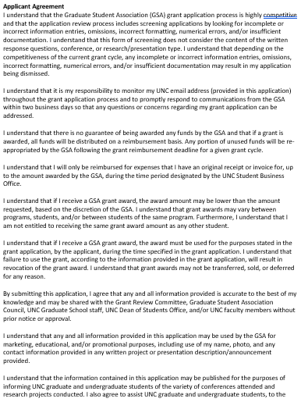

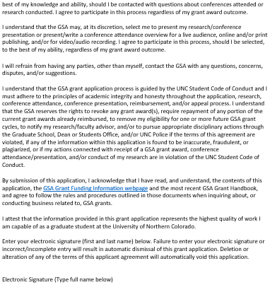

YOURELECTRONICSIGNATUREHERE

[last page]

Save document as a MS Word file as "Firstname Lastname Research"). Send the completed Microsoft Word file to gsa@unco.edu before the application deadline.

