GSA Grant Cycle 04
Professional Development Grant Application
(save MS Word file as "Firstname Lastname Professional Development")

WARNING:
Due to the increased volume of grant applications, all application submissions are final. The GSA will no longer be accepting corrections, additions, revisions, etc. prior to initial review Errors, omissions, mistakes, insufficient documentation, etc. may result in application dismissal. See the current GSA Grant Handbook for more information. Contact the Grant Review Committee at gsa@unco.edu with any questions before submitting an application that is incomplete in any way. It may be up to two business days before you receive a response to any questions, so please plan accordingly.

Enter your information into the following document. Follow the example formats provided EXACTLY. Remove the example and input your own information. Do not change the formatting, font (Calibri 11pt), and/or line spacing. Send the completed Microsoft Word file to gsa@unco.edu before the application deadline. No corrections, revisions, additions, etc. will be accepted once your application is submitted.

Applicant First & Last Name:

Bear Number:
xxxxx6789

UNC Bear Mail (do not use your first.last@unco.edu email):
last1234@bears.unco.edu

U.S. Phone Number:
555-555-5555

U.S. Mailing Address:
1234 Street, City, State, Zip Code

College:
EBS, HSS, NHS, MCB, or PVA

Program (use the official program name from this list):
Your academic program (including post-nominals: Ph.D., M.S., D.A., etc.)

Primary Campus Location:
Greeley, Denver, Loveland, or Online

[continue]
Professional Development Training Title:
Name of professional development class / experience. If you are attending a conference, you should fill out a GSA Conference Application instead.

Training Organization Name:
Full name of organization, no acronyms

Training Organization Website:
Full, working web address

Training Dates (Enter start-end dates using numerical format below):
MM/DD/YYYY-MM/DD/YYYY

Training Location:
City, State, Country

Faculty Advisor:

[continue]

Written Responses
Answer the following questions. You may add additional lines as necessary. Given the limited funds available and the high degree of competition from fellow graduate students, the Review Committee is prioritizing applications with detailed, thoughtful, and useful information. Please be truthful in your answers. The Review Committee wants to know about your professional development, but they also want to know about your experiences as a UNC graduate student. Provide specifics, not generalizations, whenever possible.
Keep in mind that the GSA may choose to publish any/all responses. Do not plagiarize. You may include citations and a reference list if necessary.

Note:
If you are submitting this application for professional development that occurred during the last grant cycle, answer all questions with detailed information about what you did and what happened. Lack of details may cause the reviewers to doubt your work/attendance.

Student Name: Firstname Lastname
Program: fullnameofprogram, Ph.D.
College: EBS, HSS, MCB, NHS, PVA
Professional Development Opportunity: TitleOfCourse

Tell us about this professional development opportunity. (300 words max)

How does this professional development opportunity impact your academic/professional career? How will this knowledge be applied to your education, work, research, etc. (300 words max)

What additional opportunities will be available because of completing this professional development? (300 words max)

[continue]

Copy of Course Schedule:
If you are attending professional development that takes place between May 1, 2023 – June 30, 2023, delete the example below and enter a photo, screenshot, or scan of your:
- Summer 2023 or Fall 2023 course schedule, or
- Proof of continuous graduate enrollment for Summer 2023 or Fall 2023.

If you attended professional development that took place between January 1, 2023 – April 30, 2023, delete the example below and enter photos, screenshots, or scans of your:
- Summer or Fall 2023 course schedule, or proof of continuous graduate enrollment AND
- Spring 2023 course schedule or proof of continuous graduate enrollment.

Correct name and semester must be visible. If either are cropped out of the image, the Grant Review Committee will not be able to verify your enrollment and your application may be dismissed.

Example:
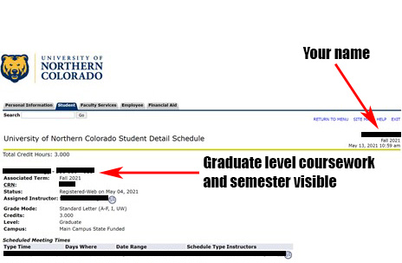

[continue]

Financial Aid Impact

Download a copy of the Student Gifts, Prizes, or Awards Recipient Information Form. Fill out the following:
- Name
- Bear ID #
- Address
- City, State, Zip Code
- Purpose/Description: Write a brief description about the project/travel/publication/professional development this grant request is for.
- Was this required for a course/program at UNC?

Save this PDF form as Firstname_Lastname_giftform. Submit this completed PDF form along with your GSA grant application.

[continue]

Was This Professional Development Required?

Download a copy of this Advisor Statement Form and have your advisor fill it out.

Save this PDF form as Firstname_Lastname_advisor-statement-form. Submit this completed PDF form along with your GSA grant application.

[continue]

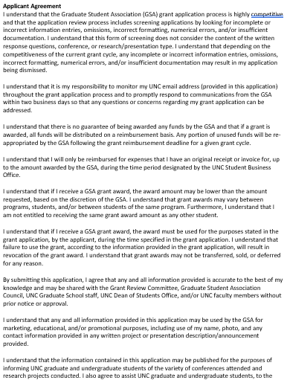

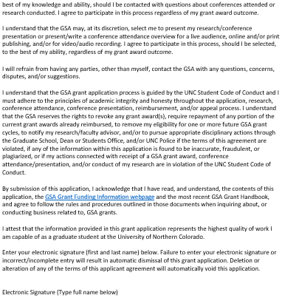

YOURELECTRONICSIGNATUREHERE

[last page]

Save document as a MS Word file as "Firstname Lastname Professional Development"). Send the completed Microsoft Word file to gsa@unco.edu before the application deadline.

