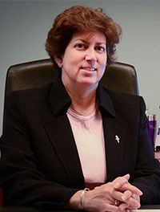
Alissa Craft, DO, MBA

Since 2017, Dr. Craft has served as a consultant in areas of accreditation and curriculum development. She has assisted osteopathic medical schools with both the documentation and site visit preparation, as well as working on new school and campus development.

From 2015 – 2017, Dr. Craft served as the Vice President of Accreditation at the American Osteopathic Association. In this role, she served as Secretary for the Commission on Osteopathic College Accreditation (COCA), the only accrediting agency for the 50 plus training locations for doctors of osteopathic medicine in the United States.
Prior to joining the American Osteopathic Association, Dr. Craft served as Associate Dean for Academic Affairs at the New York Institute of Technology College of Osteopathic Medicine. She has also served as the Director of Medical Education for a new GME program at Samaritan Health Services in Corvallis, OR and as Medical Director for an integrated health network at Samaritan Health Plans.
She completed her osteopathic medicine degree at the Kirksville College of Osteopathic Medicine (now ATSU-KCOM) and her MBA at the University of Phoenix. She completed residency training at Phoenix Children’s Hospital and fellowship in Neonatal and Pediatric Intensive Care at the University of California, San Diego and Rady Children’s Hospital.

