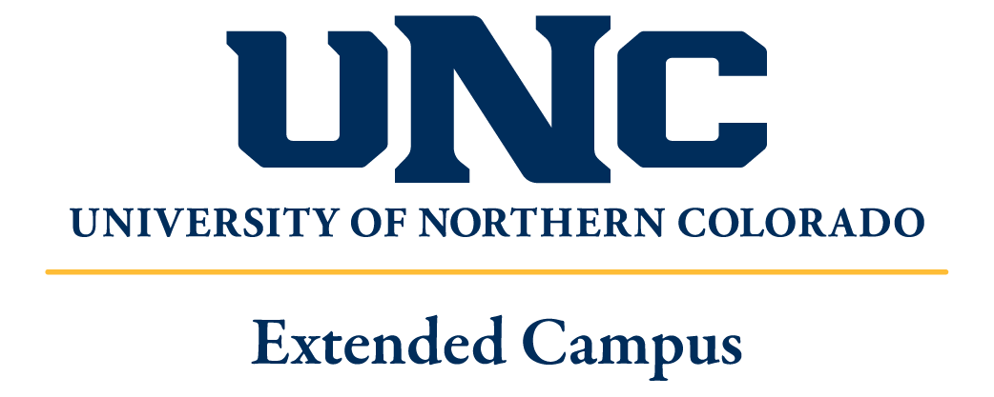

College of Humanities & Social Sciences
Department of World Languages & Cultures

GER 411-614 Germany Then & Now
On the Threshold of Modernity: The Legacy of the German Hansa

Faculty-Led Study Abroad: Germany
Summer 2019

Instructor: Dr. Don Holman
Email: Donald.holman@unco.edu
Telephone: 970-351-3698

Course Description
On the German Autobahn you will see license plates starting with “F” on cars that hale from Frankfurt. It’s not hard to guess that a driver with a “B” on his plate lives in or around Berlin. Midsize and smaller administrative regions have two or three letters, including Tübingen (TÜ) and Heide (HEI). But why are plates from Germany’s second largest city, Hamburg, marked “HH” rather than just “H” (Hannover)? For that matter, why is Bremen signified by “HB”, Lübeck by “HL”, and Rostock by “HRO”? It’s because each of these cities proudly proclaims itself to be a Freie und Hansestadt, or Hanseatic City. And by the way, even if you knew that Luft means “air” in German, what about the last five letters in the name of the German airline Lufthansa? What does hansa have to do with safe, affordable travel?
While the ships of Spanish and Italian explorers figure prominently even in U.S. history (e.g. Columbus), relatively few Americans know that the Baltic Sea was another region where vigorous maritime trade brought wealth to Scandinavia and northern Germany starting in the Middle Ages. In order to secure their goods more effectively against stormy weather, as well as from pirates and privateers, merchants from free German cities along the Baltic and North Seas joined together in a hansa, a union or alliance, to reduce the costs and risks associated with shipping their precious cargo over the treacherous northern seas to and from Russian Novgorod: a major trade center for wares produced in lands stretching from Western Europe to Asia.

Course Content and Objectives
Our itinerary will comprise stays of up to a week each in Oldenburg/Bremen, Hamburg, Lübeck and Stralsund/Greifswald, three of which have UNESCO World Cultural Heritage status. Stays will include, too, excursions to other nearby natural, historical and cultural sites of special relevance. Additionally, both our first and final locations will involve visits to two universities, Oldenburg and Greifswald, with whom the University of Northern Colorado either already has an exchange partnership (Oldenburg) or is looking to establish one (Greifswald). Locations and topics of study include the following:
- The North and Baltic Seas as an integrated cultural, historical, economic, and natural region.
- The Nationalpark Niedersächsisches Wattenmeer, or Wadden Sea of Lower Saxony, including the diking and draining of the sea coast in the 18th and 19th centuries, to win new farmlands from the North Sea, as one response to exponential population growth at that time. We will visit a typical Koog or Groden, which serves as a buffer between the North Sea and towns & farmlands, many of which lie well below sea level. We will learn, too, about new threats to these lands posed by global warming and rising sea levels.
- We will visit the historical sectors of Bremen’s old town, including the Rolandsplatz, the Schnoorviertel and the fin de siècle artist sector, the Böttcherstraße. In particular, the history of Bremen will be considered as a model of the “free cities” that succeeded in winning independence from ecclesiastical and secular princes, allowing their bourgeoisie (German: Bürgertum) to practice self-governance, while answering directly only to the Holy Roman Emperor: a freedom commemorated there since 1404 by the 5.5m tall statue of Roland.
- We will learn about the rise of “Hammaburg” – the largest and most populous city today with a Hanseatic history and heritage. This will include a visit to the Hamburg historical museum with its full-size model of a Kogge: the characteristic medieval cargo ship of the Hansa. Of special note will be its vibrant Bürger (bourgeois) cultural life, especially in opera and instrumental music, exemplified by Telemann, Handel, CPE Bach, and the city’s new acoustic wonder: the Elbphilharmonie concert hall. We will look for reasons why Hamburg escaped the general decline of the Hansa at the end of the Middle Ages and succeeded as a modern industrial, economic, and cultural metropolis.
- Apart from its well-preserved Hanseatic architecture, Lübeck merits special attention for its monument to its founder, Henry the Lion, 11th-century Duke of Saxony. The formerly Slavic Liubice became a bulwark in his campaigns to spread Christendom in the North and East. Once the richest and most powerful city of the Hansa, Lübeck will come under consideration as a city whose bourgeoisie declined in power and influence due in part to their stubborn attachment to a patrician way of life and doing business. While there, we will visit the new European Museum of the Hansa.
- With visits to Greifswald and nearby Stralsund, both Hanseatic cities, we will examine two developments associated with the decline and ultimate end of the Hansa: piracy and the Thirty Years War. Tours will include the University of Greifswald, whose status as the “oldest Swedish university” (1456) can be traced to the apex of Swedish power and dominions during, and for a century after, the Thirty Years War. We will also visit the university’s Biological Research Station on the island of Hiddensee, known then as a denizen of pirates and privateers (Störtebeker Festival), who preyed on ships crossing the Baltic.

Required Reading and Viewing
Bertolt Brecht, Mutter Courage und ihre Kinder, Berlin: Suhrkamp, 1999 (ISBN: 9783518100493).
Buddenbrooks. Dir. by Heinrich Breloer. Perf. by Armin Mueller-Stahl, Iris Berben. Warner Brothers, 2008.
Jakob und Wilhelm Grimm, “Die Bremer Stadtmusikanten”, from Kinder und Hausmärchen.
Andreas Gryphius, Selected poems.
Johannes Schildhauer, The Hansa: History and Culture [excerpts], trans. Katherine Vanovitch, Erfurt: Druckerei Fortschritt, 1985.
Theodor Storm, Selected poems.

Written and Other Assignments

Pre-travel 1 research worksheet: What was the Hansa?
1 three-page inquiry paper: What was a -burg (-bourg, -burgh)?
and who were the Bürger (bourgeois, burghers)?
1 three-page response paper on Buddenbrooks film

In Germany 10 German speaking tasks
10 German Tagebuch entries
1 Hansemuseum Worksheet

By Aug 20 1 five to seven-page expository paper: The German Hansa, Dead or Alive?

Final Grade
Final Grade Breakdown: Grading Scale:
2 Worksheets @ 30 pts 10% A ≥ 93% A- ≥ 90%
Inquiry Paper @ 60 pts 10% B+ ≥ 87% B ≥ 83% B- ≥ 80%
Response Paper @ 60 pts 10% C+ ≥ 77% C ≥ 73% C- ≥ 70%
10 Speaking tasks @ 12 pts 20% D+ ≥ 67% D ≥ 63% D- ≥ 60%
10 Tagebuch entries @ 15 pts 25% F < 60%
Expository Paper @ 150 pts 25%

Pre-Travel Meetings (CAND 0280)
Time Date Assignments to be completed by meeting
5:00 pm Monday, January 7th Introduction to course; read through syllabus
5:00 pm Monday, January 21st Grimm, Schildhauer, 7-38; quiz on learning objectives
5:00 pm Monday, February 18th Storm; Schildhauer, 39-64; view Buddenbrooks
5:00 pm Monday, March 11th Gryphius; Schildhauer, 65-100; Response Paper
5:00 pm Monday, April 8th Brecht, Schildhauer, 101-172; Research Worksheet
5:00 pm Monday, April 29th Brecht, Schildhauer, 173-235; Inquiry Paper

German Itinerary
June 2 Travel to Germany
June 3 Travel to Germany, Oldenburg
June 4-7 AM: Instruction at UO; PM: Field activities at coastal towns and Wadden Sea National Park
- Universität Oldenburg: Guest lecture on the Wadden Sea ecosystem and climatology
- Ausflug (excursion) to Nationalpark Wattenmeer
- Visit to Koog/Groden
June 8 Travel to Bremen (World Cultural Heritage)
June 9-10 AM: Instruction at Universität Bremen; PM: Field activities in Bremen
- Guest lecture at UB on Hansa, Bremen as free imperial city
- Rolandsplatz
- Rathaus
- Schnoorviertel
- Böttcherstraße
June 11 Travel to Hamburg; tour of Hamburger Hafen (harbor)
June 12-14 AM: Instruction at Universität Hamburg; PM: Field activities in Hamburg
- Innen-, Außen-Alster, Speicherstadt
- Universität Hamburg: Guest lecture on Hafenstadt Hamburg
- Hamburg Maritime Museum and/or Museum for Hamburg History
- Rathaus
- Churches (e.g. Michaeliskirche)
- Elbphilharmonie
- Planten un Bloomen
June 15 Travel to Lübeck; tour of Old Town (World Cultural Heritage)
June 16-19 AM: Instruction at European Museum of the Hansa; PM: Field activities in Lübeck
- Rathaus (gothic town hall)
- Lübeck Cathedral
- Marienkirche (St. Mary’s)
- Schlosstor (Castle Gate), Schloss
- Holstentor (Holsten Gate)
- Lecture at Musikhochschule Lübeck (University of Music): Legacy of Dieterich Buxtehude
- Buddenbrookhaus
- Ausflug (excursion) to Mölln (Till Eulenspiegel monument)
June 20 Travel to Schwerin; tour of Ducal Palace (Schloss, Pending: World Cultural Heritage)
June 21-24 AM: Instruction at UG; PM: Field Activities
- Travel to Greifswald
- Meeting with Universität Greifswald International Office staff
- Universität Greifswald: Guest lectures on Baltic pirates and privateers, Thirty Years War
- Tour of old and new university campuses
- Pommersches Landesmuseum
- Wieck (fisher village)
- Eldena Cloister ruins
- David-Caspar-Friedrich-Centre
- Insel Rügen: Störtebeker Festival
- Hiddensee Island, UG Biological Research Station: Baltic marine biology
June 25-27 Stralsund/Rügen/Hiddensee
- Tour of city wall and old town
- Rathaus Stralsund (Der Friede von Stralsund, 1370)
- Störtebeker Festival
- Biological Station Hiddensee
June 28 Travel to Hamburg or Berlin
June 29 Return travel to US

UNC Policies

Student Handbook: UNC’s policies and recommendations for academic misconduct will be followed. Consult your student handbook for university policies on student conduct in the classroom, online, cheating, plagiarism, and other academic expectations. (https://www.unco.edu/dean-of-students/).

Disability Resources: It is the policy and practice of the University of Northern Colorado to create inclusive learning environments. If there are aspects of the instruction or design of this course that present barriers to your inclusion or to an accurate assessment of your achievement (e.g. time-limited exams, inaccessible web content, use of videos without captions), please communicate this with your professor and contact Disability Support Services (DSS) to request accommodations. Office: (970) 351-2289, Michener Library L-80. Students can learn more about the accommodation process at http://www.unco.edu/disability-support-services/.

Honor Code: All members of the University of Northern Colorado community are entrusted with the responsibility to uphold and promote five fundamental values: Honesty, Trust, Respect, Fairness, and Responsibility. These core elements foster an atmosphere, inside and outside of the classroom, which serves as a foundation and guides the UNC community’s academic, professional, and personal growth. Endorsement of these core elements by students, faculty, staff, administration, and trustees strengthens the integrity and value of our academic climate.

Special Term Courses: Special Term Courses do not meet during a typical semester (begin or end earlier or later), these courses have different add/drop/withdrawal dates. It is the responsibility of the student to be aware of these dates. Please refer to “special term/short course deadlines” from this link: http://www.unco.edu/registrar/current-students/course-add-drop.aspx, to learn the dates for this course.

