

Electronic Internal Order (EIO) Instructions
_____________________________________________________________________________
Effective March 2018, the Technical Support Center is no longer creating EIOs for departments. When ordering technology items, please initiate an EIO and, provide the requested information and “Route to Supplying”. Once the FOAP is authorized, the IM&T Technology Center will order and deliver the requested technology item.

1. Log onto URSA and click on the Employee Tab

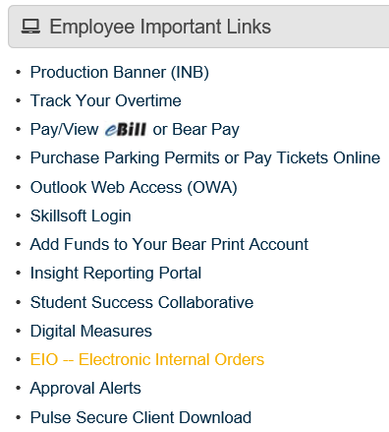
2. Under the Employee Important Links Channel, click on EIO – Electronic Internal Orders

3. To create a new EIO, click on the “Create a New EIO” link.

4. A new window will open with the Electronic Internal Order Form. Here you will fill out the blank fields to begin the ordering process.
- Fill in the Ordering Department information on the left and Supplying department e-mail. You must enter valid contact
e-mails for your form to be routed back and forth between the supplying and ordering departments. The supplying department will complete their information.

- Fill in the ordering department FOAP information you wish to use for this transaction. The Account box is a drop-down menu that lets you choose a valid account number for your purchase. The matching supplying account code will auto populate.

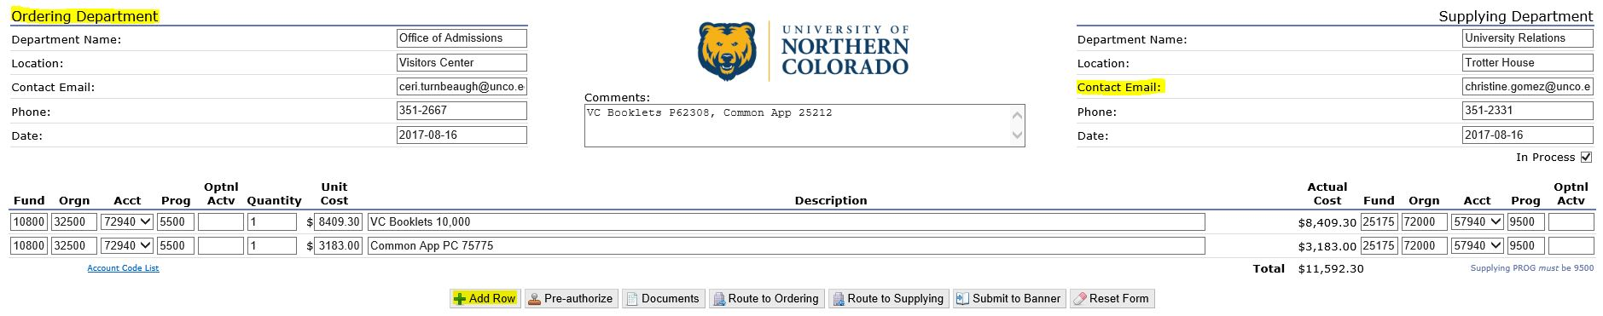
- Enter the quantity and unit cost for each item you are purchasing. Your total cost will be calculated at the bottom of the EIO form. If you need to order multiple items from the department, select Add Row.

- Complete the description field with the product name or number the supplying department requires.

- Click Save and the EIO form will refresh and assign a number in the upper right corner. If information is missing, you will receive an error message. Warnings of missing supplying department information is ok.

- You may now attach any backup documentation by clicking on the Documents button. You must upload the signed Official Function form when using account codes 72910/57910.
5. Once completed, click on Route to Supplying. This will send the EIO to the supplying contact email. The status will change from blank to waiting on supplying. Supplying will now begin the order and fill in their information. By pushing this link, you are committing to this purchase and may be charged a restocking fee for special orders.
6. The EIO form can be routed between supplying and ordering departments until both parties agree that the form is ready to be submitted. If the form requires pre-authorization, you will need to click on the pre-authorize button. You must be an authorized person on the ordering approval queue in order to pre-authorize. This may require another person authorizing the EIO through their URSA.
7. Once all information has been filled in correctly by both parties, the Submit to Banner link will appear at the bottom of the EIO form.
8. All changes made to the EIO form are logged at the bottom of the page.
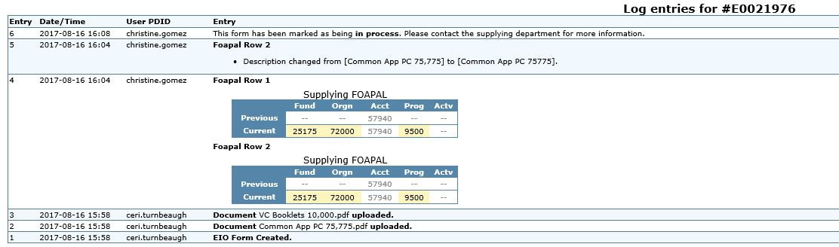

9. You are able to review active EIOs and all EIOs any time using the options in your EIO Channel in URSA.
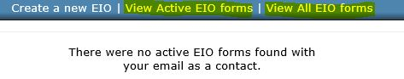
10. To check the status of your EIO, you may run Insight Report, FIN050 – EIO by status.
- Enter Fund/Org/Acct (Optional)
- Select Needs Approval
- Select Fiscal Year
- Choose document number to see who is authorized to approve. If the information is in green, it means that person has approved the document.
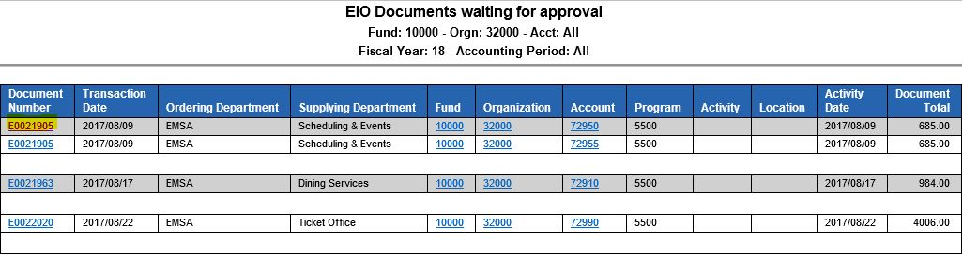
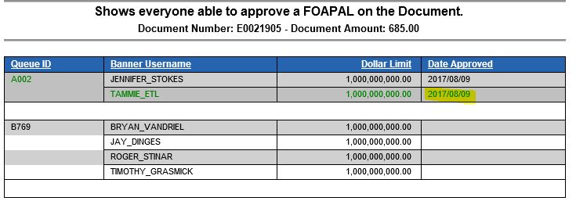

11. You may also check on approval status through URSA. Click on Approval Alerts in the Employee Important Links Channel.
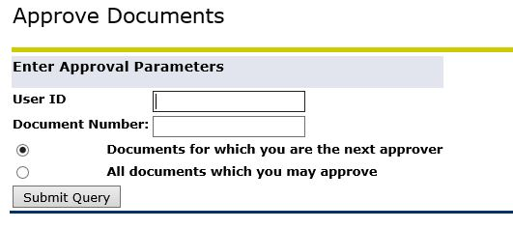
- Remove your name from the User ID and click Query
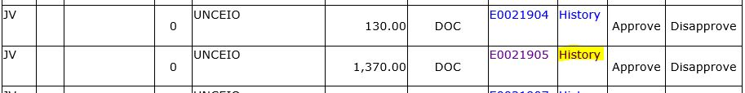
- Find the appropriate EIO and click History

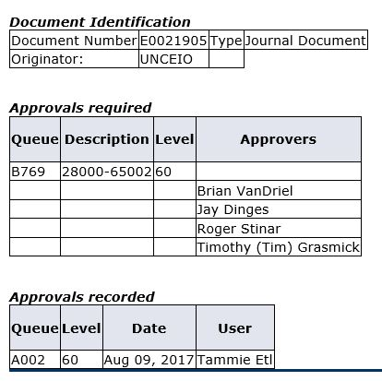
- You can view approvals required and approvals recorded

12. If you need to edit or void an EIO after it has been submitted but before it is posted to Banner, have the EIO disapproved by an approver. Then contact General Accounting to have the Banner records removed and the EIO reopened. Edit the EIO and resubmit or void the EIO. If the order is “in process”, please contact the supplier.
13. If you need to edit or void the EIO after it has been posted in Banner, submit a journal entry with backup for changes and reference the EIO number. Contact the supplier for returns if necessary.

