Introduction:
- Possibly bringing more MGC Delegates as the semester goes on for introductions/discussion
  - @uncomgc on IG
- Mini workshop about our Greek traditions as MGC and D9 organizations

Chapter Reports:
Lambda Theta Alpha: @lta_zetachi on IG
- Spooky Basket Raffle
  - Accepting tickets from October 7th to the 31st
    - $3 for 1, $5 for 2
    - Proceeds go to the LTA Foundation
    - Contact an active sister to purchase, or ask for chapter paypal
- Thanksgiving Event
  - Collaboration between Zeta Phi Beta Sorority Inc. and ourselves
  - Helping give out meals during the week of thanksgiving
  - Food donations from Panhellenic and IFC appreciated
    - More info to come
- Calypso’s Pet Bets Fundraiser
  - Oct. 13th
- 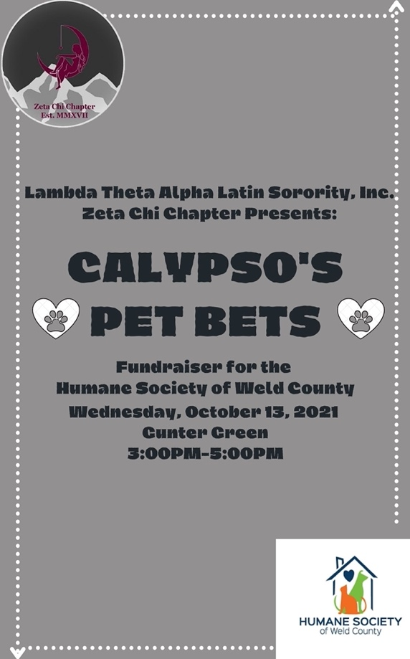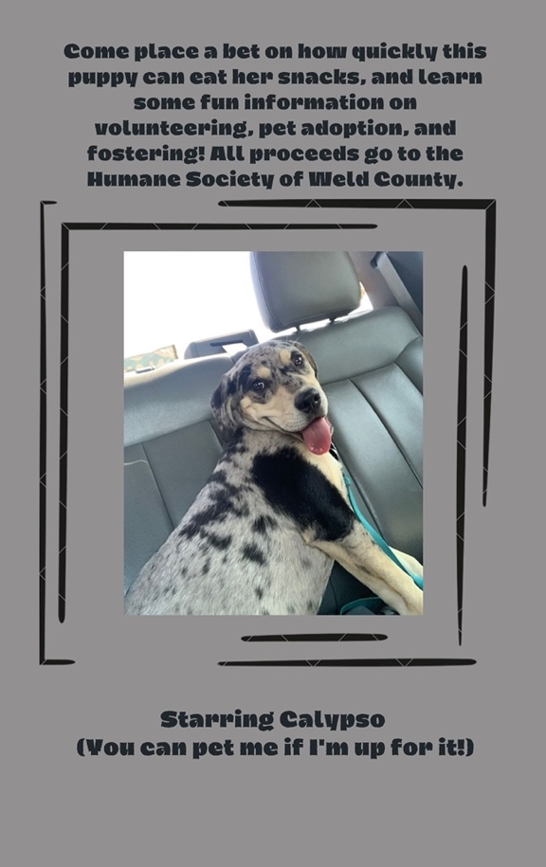
- Also opportunities to sponsor an animal as a chapter, if you are interested please contact me

Lambda Theta Nu: @kapptivatingkappa_lambdas
- Winter Coat Drive
  - Oct 4-28th (Tuesday -Thurs/9am-4pm) @ The Family Center
  - Please exclude RED and BLUE jackets
  - If you have any questions, please email president
  - Flyer attached to email
- If you’d like to donate some winter items, please contact us!
  - Items accepted until Nov. 5th
  - Boxes will be around CCCC & Marcus Garvey Cultural Center
Sigma Lambda Beta @uncobetas
- Cake A Beta fundraiser ends Oct 29th
  - Pay to vote to cake one of them
  - Venmo: upsilon-beta
Pi Lambda Chi @plc_zetachapter
- Annual Pi-A-Chi fundraiser
  - Tickets on sale until the 12th!
    - 1 Pie $3 2 Pies $5
    - 13 dollars to pie all the active sisters
  - CashApp $PLCZeta
Other announcements
- Greeley Multicultural Festival
  - Tabling & booths
  - Sat. Oct 23rd 11-4pm @ UC Ballroom
- Other Orgs with no report today
  - Nu Alpha Kappa @sigmanak
  - Kappa Delta Chi @kdchiunco
  - Sigma Lambda Gamma @deltabetaslg

