Multicultural Greek Council
University of Northern Colorado
Tuesday, January 21, 2020 Meeting Paper Minutes

- Call to Order
- Roll Call:
- Guest Speakers:
- Approval of agenda/minutes:
- Reports
  - FSL Advisor: Lacey Staehs (Lacey.Staehs@unco.edu)

  - Officer Reports
    - President- Anjelica Adan ( Anjelica.Adan@unco.edu )
      - Executive Board Elections
        - We have two spots open (Secretary and Treasurer) that we would like to fill! Applications will be available until January 27th, and elections will take place January 28th! Anyone can run including 1st year actives. Application available on FSL page
    - Vice President- Kimberly Guzman (Kimberly.guzman@unco.edu )
      - Remember reports are due SUNDAY NIGHT! If reports are not in by then they will not be put on the agenda
    - Secretary- Vacant
      - No report
    - Treasurer- Vacant
      - No report
    - Liaison- Vacant
  - Chapter Reports
    - Lambda Theta Nu
      - No report
    - Lambda Theta Alpha
      - Pre- Sales for our annual cake pop sale are happening now! Orders are finalized by Feb 13th and pick up will be Feb 14th at the Marcus Garvey! Contact a lambda lady and place your order! All proceeds go to St. Jude’s Children's hospital
      - We have an informational Jan 23rd at 6pm
    - Sigma Lambda Gamma
      - No report
    - Nu Alpha Kappa
      - No Report
    - Sigma Lambda Beta
      - No report
    - Kappa Delta Chi
      - Rush week
        - Study tables Jan 22rd @ Michener Library 2nd floor 6:30pm
        - Shining through Self Care- January 23th @ CWGE 7pm-8:30pm
        - Service Saturday- Jan 24th meet at UC at 10am
    - Pi Lambda Chi
      - Golden Oreo Fundraiser will be Wednesday, January 29th at the Cesar Chavez Cultural Center from 10am-4pm
      - We will be having the Golden Oreos covered in chocolate and Fried Oreos
      - We will be taking pre-orders as well as selling them the day of the fundraiser.
      - If you have any questions please contact any of us.
      - 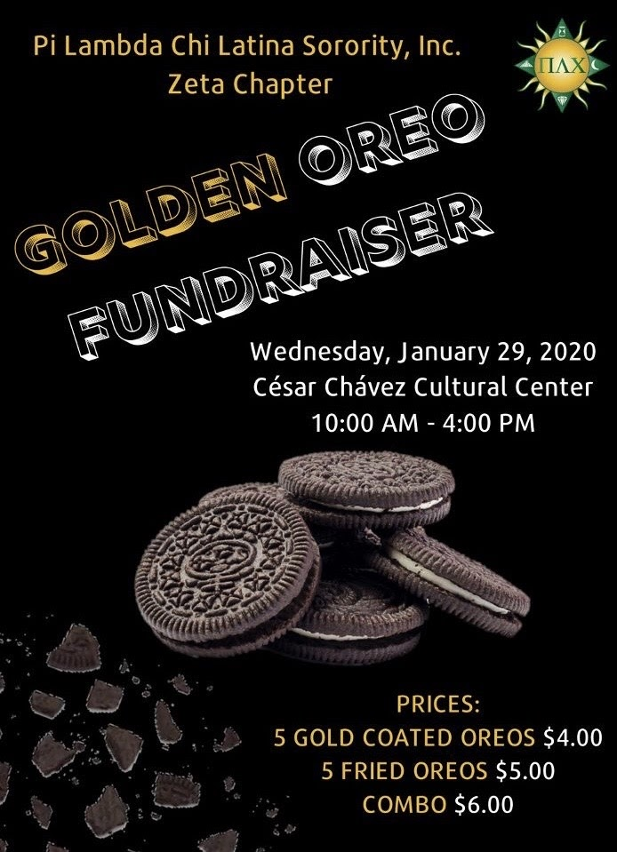
  - Associate Members:
    - Lambda Theta Phi

  - Liaison reports
    - IFC

    - Panhellenic

    - RHA

    - Senate

- Announcements
- Old Business

- New Business

- Adjournment

Future meeting dates:
- Tuesday, January 28th at 5:00 PM
- Tuesday, February 11th at 5:00 PM

