Take a look at what Ed Psych students have been doing this spring!
  - Spring Issue
2016

Educational Psychology Society

Presentation of Research
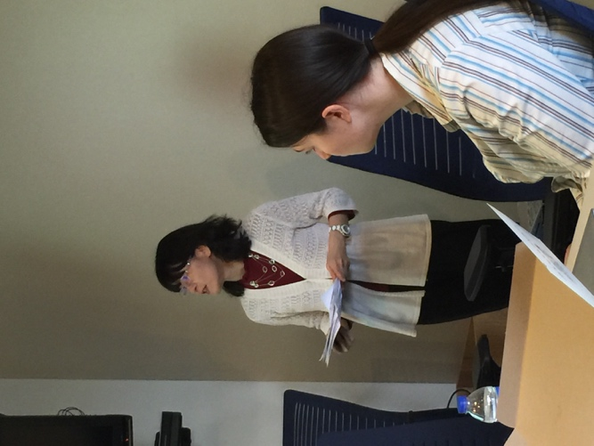
On March 3rd, Dr. Todd Allen, Dr. Cassie Bergstrom, and Grad student Akiko Watabe presented their latest research to a small group of fellow students and faculty in the psychology conference room.
Ed Psych Students have been busy this semester!
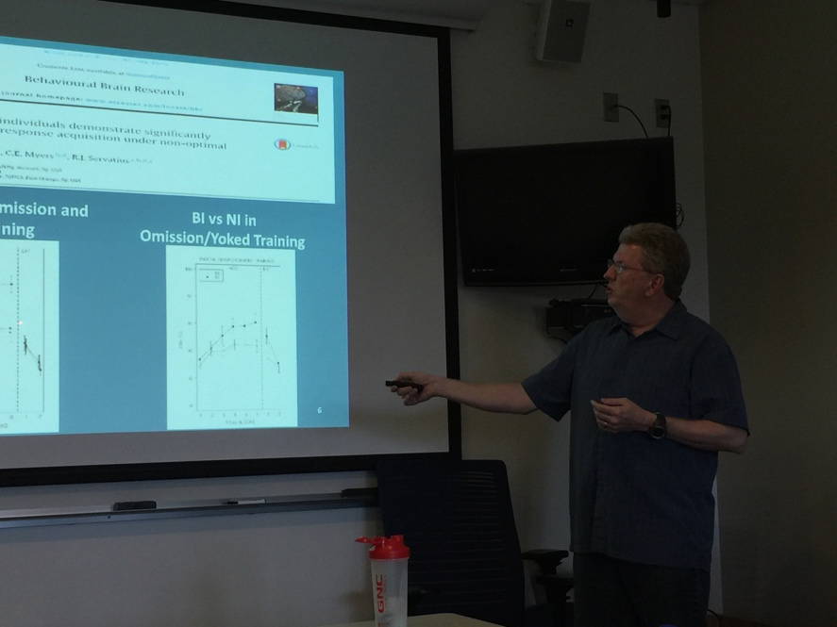
Dr. Allen presented his research on the effects of personality on learning and anxiety vulnerability. Dr. Bergstrom discussed how goal orientation and the need for closure influenced learning and engagement in problem-based learning environment. Akiko explored achievement motivation and academic self-regulation among Japanese elementary school. Thank you to all of our presenters. It was a fascinating and informative hour!

Rocky Mountain Psychological Association 2016

Several students and faculty from UNC were able to attend the 86th Annual Convention of the Rocky Mountain Psychological Associations in Denver this year on April 14th, 15th, and 16th. It was a very successful conference and everyone did a fantastic job presenting their material!
The Ed Psych Department from UNC was well represented at RMPA This year!

Along with Dr. Welsh, Caitlin Rohrbacher, Kathryn LaFary, and David Williams enthralled a standing room only crowd with their presentations about Executive Functions and their relationship to academic dishonesty, procrastination, personality, and the pursuit of a career.

Maha Ben Salem presented her well-constructed poster highlighting a comparison between international students and domestic students’ learning styles, academic adjustment, and achievement.

Maaly Younis gave a solid presentation about her work with Dr. Pulous and the development of a scale to measure college students’ attitude toward dynamic assessment.
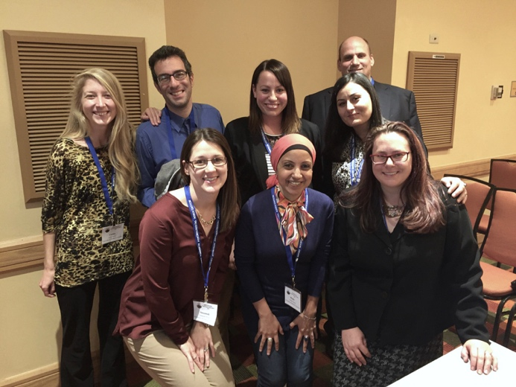
Moshe Machlev and Dr. Nancy Karlin gave a humorous presentation regarding the use of humor in the classroom. Laughing was heard intermittently throughout the talk. Moshe also provided a poster during the poster session regarding the same areas of research.

Susannah Moore confidently presented her poster about the perceptions and attitudes from school faculty regarding the ability to find time for physical activity.

Akiko Watabe, Kerry Duck, David Williams, and Dr. Michael Phillips presented their systematic review on ecological momentary assessment in educational contexts over the past 15 years.

Mr. Duck was very busy at this convention as he presented several times, including turns at marijuana use and psychometric evaluations.

Amanda Jacobs presented her qualitative study regarding the essence of being a full-time classroom teacher while also engaging in online courses for an advanced degree.

Other presenters include Wejdan Felmban, Brynn Michaels, Chris Johnson, and Bryden Spencer.

Several faculty were there also, serving as moderators and RMPA officials, including Dr. Nancy Karlin, Dr. James Kole, Dr. Douglas Woody, Dr. Michael Phillips, Dr. Christina Phillips, and Dr. Marilyn Welsh.

We sincerely apologize if anyone was left out. It was a busy convention and so many presentations were given!

Katy Lafary, a member of Ed Psych Society!
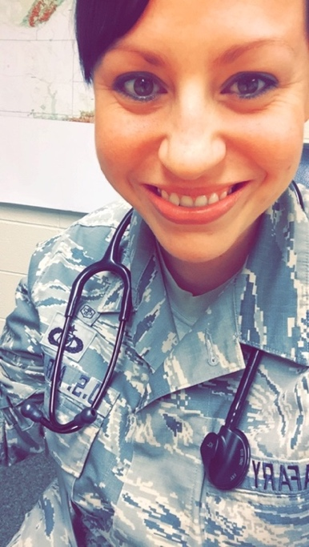
Hi, I’m Katy LaFary. I have been at UNC for 3 years now where I got my undergraduate in Psychology and my master’s degree in Educational Psychology. I am originally from Cincinnati, Ohio. I was active duty Air Force for 12 years and decided to get out so I could continue with my education at a much faster rate than staying active duty would allow. I have been in the Air National Guard as a medic for 3 years now. I currently work at Veterans Services on campus and as a researcher for Dr. Welsh and Dr. Peterson where we focus on hot and cool executive functions in those with previous childhood maltreatment. I love traveling and was lucky enough to live in Italy for 2 years before moving to Colorado. Some of my favorite countries I’ve visited were Japan, Spain, Austria, and France. I also love casually reading which I deeply look forward to once I finish school. I also love yoga, hiking, dancing, and spending time with friends. I love so many of the people in the Ed Psych program and feel very lucky to be a part of it I like this picture because you can see how truly happy I am doing what I love best- helping people in whatever capacity I can.

Elections are now underway!
Elections for next year’s Ed Psych Society officers is now open! The Qualtrics survey will remain open until Tuesday, April 3rd at 5:00 pm. Please be sure to log in and cast your vote for who you would like to see serve you in your Ed Psych Society next year!

VOTE HERE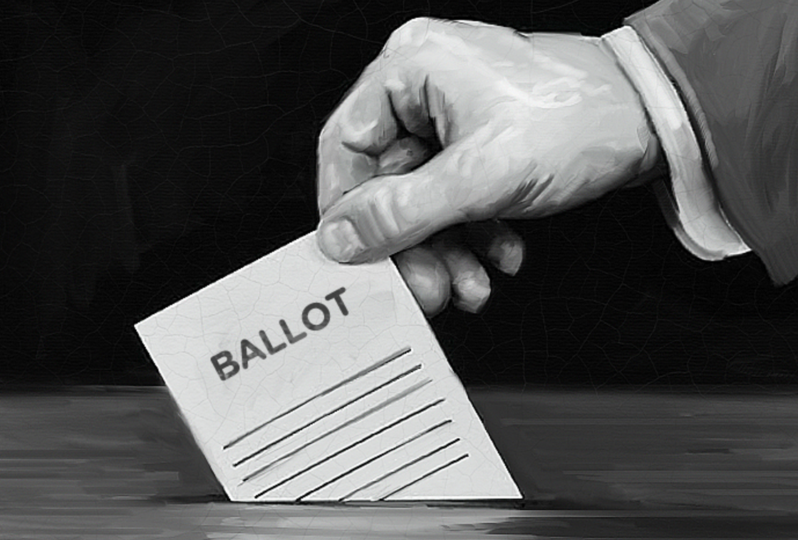

Enjoy your summer! Be on the lookout for announcements regarding next year’s Ed Psych Society! Meetings will resume in the first few weeks of the fall semester!
People take pictures of the Summer, just in case someone thought they had missed it, and to prove it really existed.
- Ray Davies

