**Strategies for Teaching Students who are Blind or Low Vision**

The Disability Support Services Office collaborates with the University in its commitment to recognize disability as a valued aspect of diversity and to embrace access to the University of Northern Colorado community as a matter of social justice. The office provides the University with resources, education, and direct services to design a more welcoming and inclusive environment. These strategies will help you make your classroom and our campus a more equitable and inclusive place for students with disabilities.

**Before the Start of the Semester**

* Provide DSS and the student with advance notice of all reading assignments, all electronic documents, and all library resources/reserved documents to allow ample time for the assignments to be converted to an accessible format. This ensures that the student has access to the material at nearly the same point as all students.
  + If the student recieves the document from the instructor and it was not made availible to be made accessible previously, then deadlines should be adjusted to account for conversion delays.
* Review any tests, quizzes, lessons, worksheets, or handouts that make use of visual information and to make them accessible by implementing:
  + Readable PDFs ,enlarged text, brailed information, or recordings for all important information.
    - For creating readable PDFs follow the instructions below.
  + Refer to the Faculty resource guide, at [www.unco.edu/dss](http://www.unco.edu/dss), or call DSS if you need assistance in making lesson plans accessible.
* Ensure that students are notified of organizational changes in an appropriate way. Students often orient themselves to the classrooms listed on URSA and any change of classroom can be disruptive and confusing.
* For any tests or quizzes that will be administered online be sure to give students their correct amount of testing time on Blackboard by setting a test exception.
  + The Blackboard Test Availability Exceptions instructions are availible below.

**During the Semester**

* Always identify yourself by name.
* Face the class when speaking and speak clearly in a normal voice (e.g. not loudly, slowly or with exaggeration.)
* Convey orally whatever you have written on the board or shown on a projector.
* If you are planning to use a video, inform the student and DSS in advance. Discuss alternative ways, like an observer, to approach the information that the student might miss.
* Doors should be kept completely closed or open, not partially open as this may make navigation diffucult and raises the potential of injury for the student.
* Objects should not be moved from their usual places without letting the student know. (e.g. beakers, flasks, material samples, etc)
* Open book exams can pose a major problem for students who are blind or have low vision. If you are planning to use this format, consult with DSS, in advance, to determine an alternative testing format for the student.
* Allow the student the same anonymity as other students (e.g. avoid pointing out the student or their alternative arrangements to the rest of the class.

If any questions or concerns arise please contact the Disability Support Services office at 970-351-2289, or access our collection of faculty resources at [www.unco.edu/dss](http://www.unco.edu/dss).

Creating a Readable PDF Document for a Screen Reader

1. Open a completed Microsoft Word document.
2. Select ‘Save As’ in the file tab.
3. Select the location you want your file to be saved at, ie: Desktop, Documents folder
4. Select ‘PDF’ from the ‘Save As Type’ Drop down menu.
5. 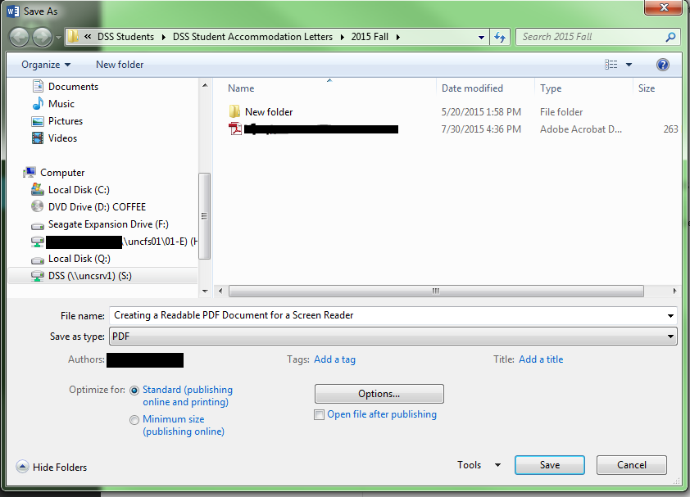Click the Options button below the drop down menu.
6. 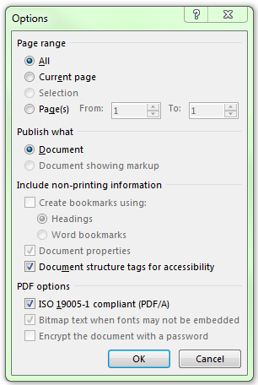Check the box next to the ‘ISO 19005-1 Compliant (PDF/A)’ and press OK.

1. Save your file.

Now your file can be accessed by a screen reader such as Adobe Reader’s Reader fuction.

**Blackboard Test Availability Exceptions**

The test/survey exception feature allows the instructor to select one or more students, or groups of students and make an exception to the test timing and/or date delivery based on the student’s needs. Exceptions are added to the same version of the quiz.

Test Availability Exceptions may be added during the deployment of a test or after a test is deployed and completed. The most permissive settings for the students is granted. For example, students will get the greatest number of attempts, longest availability of time, and so on.

**Applying Exceptions**

• Go to Test Options. Test options are set at the time of deployment or can be edited after deployment.

• Scroll down to the Test Availability Expectations portion of the screen.

• Select the Add User of Group button. Another window with a list of the student’s names will appear.

• Select the appropriate name and select Submit.

The Test Exceptions area of the screen will change to include the names selected. Timer options will mirror the current settings.

Per the students’ needs, changes can be made to the following:

• Attempts

• Timer – number of minutes

• Availability – dates and time

**Remove Exceptions**

Notice the red X and the in the upper portion of the Exception feature. These options can be used to remove exceptions per student or per the test.