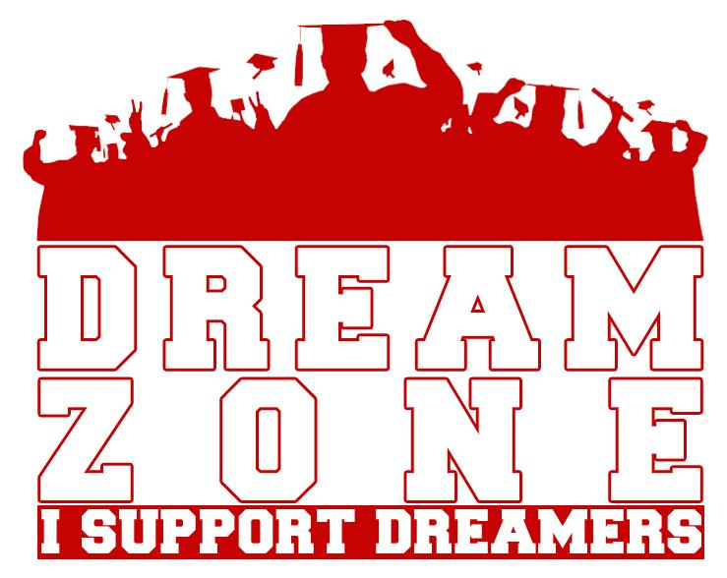

**Undocumented:**

Entered the U.S. without inspection or legal permission or through the use of false papers.

Being undocumented can also refer to a person with expired paperwork or a person in deportation proceedings.

**DREAMER:**

An undocumented young adult or student who would benefit from the passing of the DREAM Act.

**Overstay:**

Visitor who has exceeded their stay in the U.S. after the date indicated on the Arrival-Departure Record, Form I-94.

**USCIS:**

United States Citizenship and Immigration Services, formerly known as Immigration & Naturalization Services (INS).

**ICE:**

U.S. Immigration and Customs Enforcement. Created in 2003 as the principal investigative arm of the Department of Homeland Security.

**BIA:**

Border of Immigration Appeals.

**Intersectionality:**

examines multiple forms of oppression and discrimination that result from biological, social, and cultural categories (race, gender, class, ability, sexual orientation, and other identity markers) that interact on multiple and simultaneous levels.

**Safe space:**

description of a classroom or spaces that allows students to feel secure enough to take risks, honestly express their views, and share and explore their knowledge, attitudes, and behaviors.

**Derogatory terminology not to use**

**Anchor baby:**

Pejorative term used to describe children born in the U.S. to immigrant parents. Because they are U.S. citizens, they can later sponsor other family members for U.S. citizenship.

**Illegal:**

Unlawful or not authorized by law; often used to describe undocumented or unauthorized immigrant.

**Alien:**

Often used to describe a person in a country who is not a citizen of that country (legal and unauthorized noncitizens).