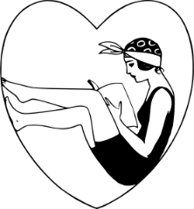
5 Tips for Media Self Care:
(National Eating Disorders Association)

- Choose and use media mindfully. Be selective about your media use and choose media that supports your values and builds self-esteem and body confidence.

- Limit screen time and social networking. Researchers studying body concern issues have found that the more time we spend in the media world, the more we are exposed to body perfect images, and the more vulnerable we are to compare our appearance to unrealistic body standards. Protect your self-image by monitoring the quantity and quality of your mainstream and social media time.
  - Take a break from or delete social apps that don’t make you feel good about yourself or contribute to your happiness.
  - Unfollow people who make you feel bad about yourself!
  - Unfollow people who you find yourself negatively comparing yourself to. You are you, and they are them!
  - Follow people who embrace body diversity and support your body peace journey.

- Test the message for body positivity. Think critically about messages you consume and content you create on social media. Test for body positivity by asking key questions: Are the body depictions realistic or digitally altered? What does the message really mean? Why are they sending it? How might it affect someone’s body acceptance? Who created and profits from the message? Before you text, tweet, post comments, and share photos and videos, ask yourself why you are sending the message, who you want to reach, and analyze its body positivity.

- Talk back to media about body image. Tell people who profit from media and establish policies what you like and don’t like about their body representations, why you feel this way, and what you plan to do about it — take a stand and refuse to read, view or listen to media or buy advertised products until they make changes. (Ex: comment on a company’s Instagram post respectfully pointing out the lack of body diversity you see in their advertisements.)

- Advocate for positive body talk. Use your social media capital to inspire others to use their voices to compliment authentic and diverse body messages, criticize unrealistic body ideals, and report body shaming. Shout out to media outlets, retailers, advertisers, and celebrity product endorsers who celebrate natural looks, healthy body size, and diverse bodies, and call out ones that continue to promote unhealthy and artificial body norms. You can make a difference!

For Amazing Body Positive Instagram Content, follow:
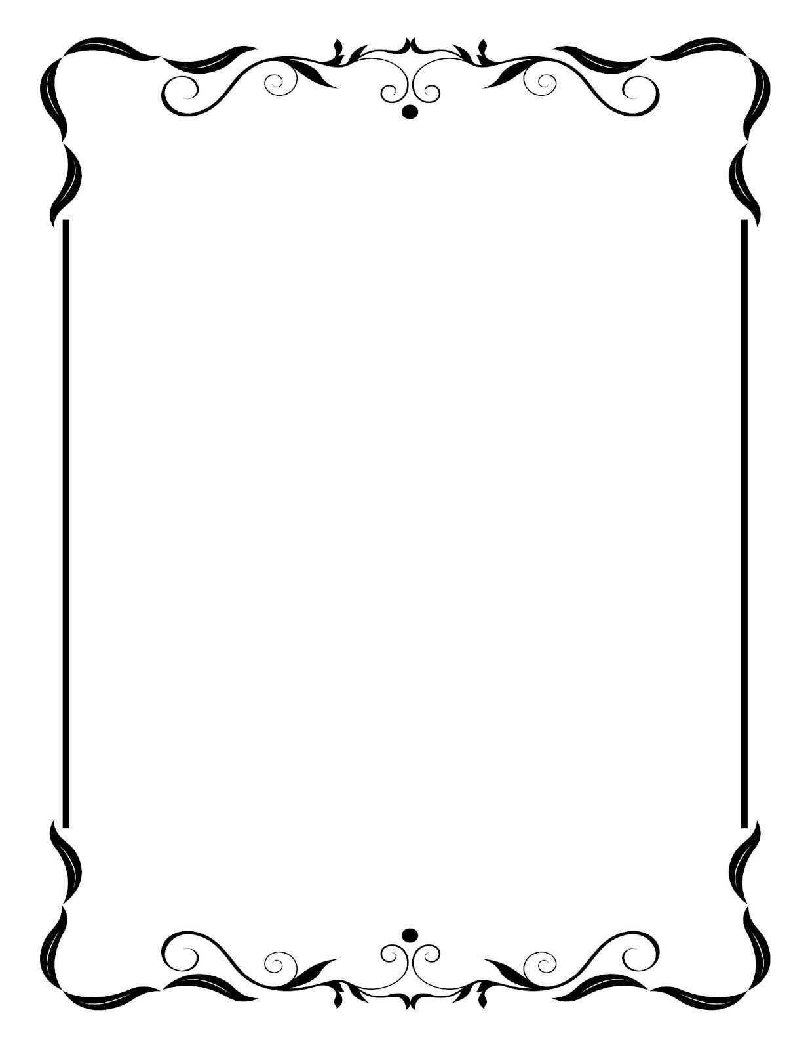
@bodyposipanda | @effyourbeautystandards
@bodyimage_therapist | @antidietriotclub
@jennifer_rollin | @scarrednotscared
@newmoonrd | @laurathomasphd
@selfcareisforeveryone | @yourewelcomeclub
@bodypositivememes | @underneath_we_are_women

From @bodyposipanda:
“If you have to destroy your mental health for it, you’re not supposed to be that size.

If you have to ignore your body’s hunger for it, you’re not supposed to be that size.

If you have to spend every waking minute counting numbers in and numbers out for it, you’re not supposed to be that size.

If you have to sacrifice everything else meaningful in your life for it, you’re not supposed to be that size.

If you have to hurt yourself for it, you’re not supposed to be that size.

And letting go of THAT body, the one we told ourselves we were supposed to have all along? That’s scary. Because we’re not just letting go of that body, we’re letting go of the person we believed we would become once we had it. But maybe we never needed to become that version of ourselves in the ‘after’ picture to be whole, valuable, vibrant humans with all the worth in the world. Maybe we’ve had that all along. And if you’re reading this and feeling something inside yourself shift, maybe it’s time to start the letting go.”

