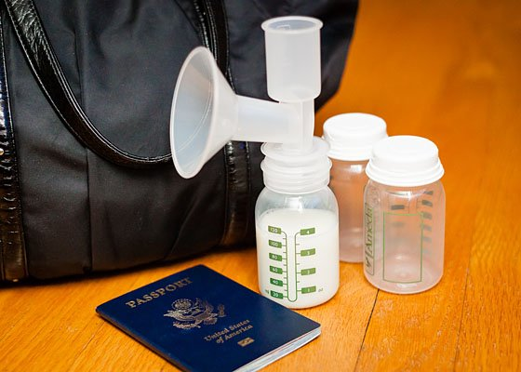
Congratulations on the birth of your little one! Traveling with a new infant and/or child can be an exciting yet stressful time. It can be even more stressful when you are breastfeeding/chestfeeding, but it does not have to be! Check out the information and helpful tips below to help ease your travel stress.

Flying with Human Milk
It is a common misconception that individuals may not fly and are forced to dispose of human milk; however, this is not the case. TSA permits carry-on of human milk and/or pumps. Certain procedures must take place to ensure safety and appropriate handling of these items.

Traveling with Children/Infants
As described on TSA website, children 12 and under can leave their shoes, light jackets, and headwear on during screening. Children will not be separated from their parent(s)/guardian(s). Infants and children must be removed from their carriers and carried by a parent or guardian through screening. To reduce the likelihood of a pat-down, modified screening procedures are in place.

TSA Procedures
According to TSA website formula, human milk, and juice for infants are permitted through the security checkpoint. It is important to inform a TSA officer if quantities exceed 3.4 ounces because they will need to be screened separately. Items are typically screened through x-ray but may need to be tested for explosive or concealed prohibited items if necessary. If you wish for your items to not be x-rayed, additional screening procedures may be taken to clear the items through security. In addition, Food and Drug Administration states there are no known effects from eating food, drinking beverages, and using medicine that has been previously screened by x-ray.

Travel Tips/Information
- A pump does not count as a carry-on item; it is identified as a medical device.
- You may bring a cooler for expressed milk; this will count as a carry-on item.
- Ensure you bring enough ice packs to keep expressed milk frozen.
- In the case of needing to pump while in the airport you may ask if there are any available facilities.
- Although expensive, it is possible to mail or ship human milk via FedEx. This shipment will maintain the temperature of expressed milk on dry ice.
- International travel rules and regulations may vary, contacting your destination country is recommended.

More Information
https://www.tsa.gov/travel/special-procedures/traveling-children
https://www.tsa.gov/travel/travel-tips/strollers-car-seats-breastmilk-oh-my
https://www.tsa.gov/travel/travel-tips/kids-rule-airport
https://www.tsa.gov/travel/travel-tips/5-stressors-every-pregnant-woman-has-airport

