University of Northern Colorado Lactation Accommodation Request

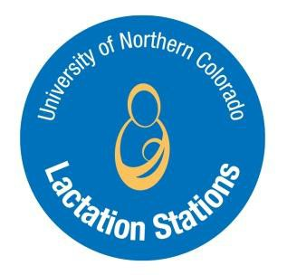

Employee Requesting Accommodation:

Job Title: Department: Extension:

Anticipated Accommodation Duration: _/ _/ until / /

Primary Designated Lactation Station:

Alternate Designated Lactation Station:

Please indicate whether the designated Lactation Stations are University-designated Lactation Stations or temporarily designated for the purpose of this Accommodation Request. For more information on where you can find a University-designated Lactation Station, please go to UNC’s lactation support website: https://www.unco.edu/center-womens-and-gender-equity/what-we-offer/breastfeeding-chestfeeding-support.aspx.
If temporarily designated, please provide a brief description of the Lactation Station:

The requesting employee’s, supervisor’s and Human Resources (HR) representative’s signatures below indicate that all individuals have reviewed and understand the above Lactation Accommodation Request and understand the Colorado Workplace Accommodations for Nursing Mothers Act.
Employee Signature: Date:

Supervisor Signature: Date:

HR Signature: Date:

-------------------------------------------------------------------------------------------------------------------------------

University of Northern Colorado Lactation Accommodation Request

The Colorado Workplace Accommodations for Nursing Mothers Act establishes a standard for an employer to:

- Provide reasonable unpaid break time, or allow an employee to use paid break and/or meal time, to express breast milk for her nursing child for up to 2 years after the child’s birth
- Make reasonable efforts to provide a nursing mother with a private location in close proximity to her work area (other than a toilet stall) in which to express milk
- Not discriminate against women for expressing milk in the workplace

For more information on breastfeeding/chestfeeding/lactating or how to support an employee who is breastfeeding/chestfeeding/lactating, please contact Alena Clark, PhD, RD, CLC at alena.clark@unco.edu or 970-351-2879. Also, encourage your employees to check with their insurance about lactation support and pump coverage.

