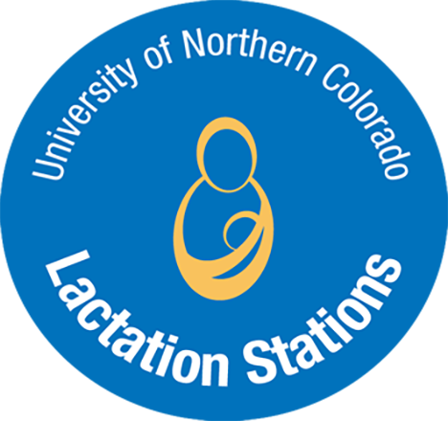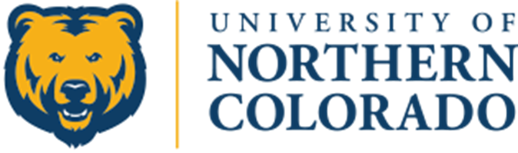

Name

Date

The Center for Women’s and Gender Equity and the Department of Nutrition and Dietetics would like to thank you for your outstanding support of fellow UNC Students, Faculty, and Staff.

University of Northern Colorado’s Breastfeeding, Chestfeeding, and Lactating Individuals

Supporter of: