

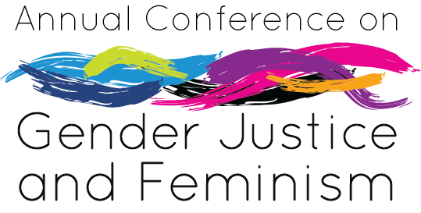

Celebrating 10 Years of

Our Journey, Your Journey

Friday, November 8, 2019

8am – 5pm, University Center Ballrooms

*Presented by:*

*The Center for Women’s and Gender Equity*

*Co-Sponsored by:*

*The Stryker Institute for Leadership Development*

*Student Senate*

Celebrating 10 Years of Our Journey, Your Journey

##### CALL FOR PROPOSALS

Submission Deadline: 11:59 p.m., Friday, October 18th, 2019

### Notification of Acceptance will be October 25th, 2019

The Annual Conference on Gender Justice and Feminism is an all-day experience designed to explore women’s and gender issues and gender oppression through an intersectional lens. This conference provides an opportunity to bring awareness, celebrate, and connect with others while creating community and empowering oneself and others to promote gender equity at UNC and beyond.

This conference experience, to attend and to present, is open to all UNC students, faculty, staff, and community members as a way to engage contemporary and historical women’s and gender issues.

To honor a decade of hosting our conference on the UNC campus, the Center for Women’s & Gender Equity (CWGE) has chosen the theme “**Celebrating 10 Years of Our Journey**, **Your Journey.”** As our Center continues to embrace growth and change within our community, we reflect on how our conference has grown over time. We want this year’s conference to be an opportunity to reflect on our individual and collective growth within our social justice journeys. As we delve into conversation about *where we come from, where we are, and where we are going,* we invite you to contribute to this year’s conference by submitting a proposal. We welcome a variety of topics.

We recognize that our own personal identities are shaped through our journeys and growth, and by gathering together, we can continue to become more aware of how we can create the change we desire to see in our society.

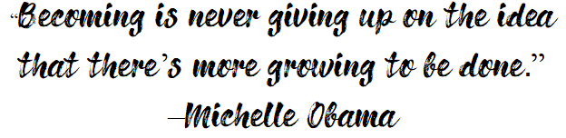

**PROGRAM GUIDELINES**

The following guidelines are suggested as you plan program submissions:

* Participants will include undergraduate and graduate students, faculty, staff, and community members who represent diversity in various identities.
* Creativity is important in presentation, style, format, title and description of workshop.
* Participants may have varied levels of knowledge and experience with the topics presented.
* Highly participatory formats are generally most well received, as participants will have a wide variety of learning styles.

Presentations should be multi- and cross- culturally inclusive (i.e. intersections of gender, race, ethnicity, age, sexual orientation, ability, etc.).

***TOPIC SUGGESTIONS***

Listed below are some topics to consider as you develop your program. This list is not comprehensive. We encourage you to share your journey by incorporating your interest(s) and passion(s) to explore current or historical issues impacting underrepresented identities in the context of gender, both within the University setting and the larger community.

* Activism (e.g. blogging)
* Belief System
* Coalition/Collective Building
* Feminism
* Gender and Academics
* Gender Identity
* Gender Violence
* Global Issues/Globalization of Women
* Health Care   
  (access to/health care system implications)
* Human Trafficking
* Immigration
* Intersections of Identity   
   (e.g. race, class, gender, etc.)
* Lactation
* Masculinity/Men & Feminism
* Motherhood/Parenthood
* Personal Development   
  (goals and aspirations)
* Politics (International, National or Local)
* Reproductive Rights
* Sexuality
* Sexual and Romantic Orientations
* Underrepresented Identities
* Voting
* Wage Gap
* Wellness
* Women of Color
* Women with Disabilities
* Women’s Rights Movement History

***Each program session is approximately 70 minutes***



*Annual Conference on Gender Justice and Feminism*

# Conference Session Proposal

***CONTACT INFORMATION:***

Primary Contact:

Name:

E-mail:

Address:

Phone:

Presentation Title:

Presenter(s):

Please include pronouns

Have you registered for the Conference:

**ABSTRACT**:

Brief description of content and format **approximately 3-5 sentences in length** (to be used in the Conference Program Booklet):

How is your presentation relevant to the Conference on Gender Justice and Feminism? **How will your session include, reference or address activism, intersecting identities and/or feminism within a social justice framework**?

**OUTLINE**:

Please provide a description of the format of your program, including resources used in planning. Be specific and include enough information for the program committee to get a good picture of how your session will be facilitated.

**PRESENTER INFORMATION:**

Please include a brief (**2 sentences**) bio for each presenter.

**PLEASE IDENTIFY THE LEVEL OF YOUR PRESENTATION:**

We offer an assortment of presentation options for you to consider in yoru proposal. Participants enter the Annual Conference on Gender Justice and Feminism with varied knowledge of, and familiarity with, feminism, intersecting identities , activism and women’s and gender issues. In an effort to create a valuable conference experience, we will be identifying presentation levels to meet the unique needs of participants. Presentations can be delivered in any format (e.g. poster session,lecture/content, discussion, interaction, etc.). The options below provide a guide for level of depth of presentation. ***Please choose the option(s) that best match your presentation content:***

 **Poster Session**: Sessions in this category will provide the presenter an opportunity to display a poster with their topic throughout the conference for all participants to see. In addition, the presentor will have the opportunity to engage with participants who attend the open poster forum.

**OR (chose one of the following if you are proposing to do a breakout session)**

**Building Foundations**: Sessions in this category will provide foundational knowledge about, and introductions to, conference content including feminism, women’s and gender issues and intersectionality. These sessions will begin to define core concepts in these areas.

**Making Connections**: Sessions in this category will provide an opportunity to build upon foundational knowledge in content areas including feminism, women’s and gender issues and intersectionality. These sessions will offer an opportunity to increase awareness in content areas while connecting and applying knowledge to everyday experiences.

**Advanced Dialogue, Content and/or Critical Thinking**: Sessions in this category will provide an opportunity to engage in critical thinking about content areas, including feminism, women’s and gender issues and intersectionality. These sessions will also offer a space to engage in consciousness raising around more complex scenarios and experiences and engage in critical thinking about content, concepts, terms and theory.

If my session is **not** chosen for a breakout session, I would like to be considered for a poster session.

***PLEASE IDENTIFY THE PREFERRED SETUP OF YOUR PRESENTATION*:**

**Preferred Room Set-up** (no guarantees on final set-up):

Circle Style

Lecture Style (Chair set up in rows)

**Audio/Visual Requirements** (check as many as apply):

Flip Chart & Markers

LCD Projector (**You Must Provide Your Own Laptop)**

PowerPoint will require sound capability

Other:

Check here if the laptop you are bringing is a

Mac

Power Source

*Please list AV equipment you will provide:*

PLEASE RETURN PROGRAM PROPOSALS **NO LATER** THAN

**11:59 p.m.** **Friday, OCTOBER 18th, 2019.**

Please submit proposals via one of these methods:

**Email attachment** to: [cwge@unco.edu](mailto:cwge@unco.edu)

**Drop Off** to: Scott-Willcoxon Hall, 1915 10th Ave., Greeley, CO 80639

**Mail** to: Center for Women’s and Gender Equity, 501 20th St., Campus Box 97, Greeley, CO 80639

**Questions**: 970.351.1492 (M-F, 8a – 5p)