



MAKING THE MOST OF HANDSHAKE
& HIRING BEST PRACTICS
University of Northern Colorado

Overview
This Handshake overview provides comprehensive guidance on how to post student employee jobs on Handshake, best practices for interviewing student employees, and details of the UNC hiring process. By following this guide, employers can create equitable and efficient hiring practices while enhancing the student employee experience.
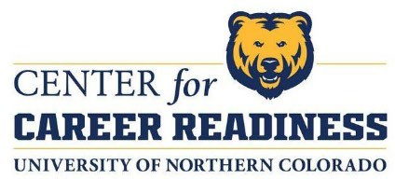

Center for Career Readiness
Career.readiness@unco.edu

Table of Contents

Overview of Handshake
Handshake is UNC’s oﬃcial job platform where employers can connect with students for job and internship opportunities. This tool allows employers to reach a targeted audience of UNC students and simplify the hiring process.
Creating an On-Campus Employer Account in Handshake 3
Access Handshake Complete Your Proﬁle Posting Job Opportunities
Utilizing Handshake to Post a Job 4
Access the Job Posting Tool Fill out Job Details
Setting Job Preferences Preview and Submit
Monitoring and Managing Applications
Managing Applicants on a Job Posting 5
Access the Job Posting Filter Applicants Export Applicant Data
Take Action on Applicants View Applicant Details
Messaging Applicants 6-7
How to Contact Applicants
How to Send Direct Messages to Applicants Troubleshooting Tips

Best Practices for Interviewing Student Employees 8
Develop Consistent Questions
Focusing on Strengths and Learning Potential Sample Interview Questions
1

Hiring Process at UNC 9

2
Initial Hiring Steps Employment Forms Orientation Training

Building a Positive Work Environment 10
Setting Clear Expectations Regular Check-Ins Encouraging Development
Discussing Professional Development Goals Performance Reviews

Employer Engagement at UNC 11
Center for Career Readiness Services On-Campus Recruiting Options Employer Fairs and Events

Additional Resources for Student Employers 12
Center for Career Readiness Contant Information
Payroll Oﬃce Information
Student Employment Handbook

Center for Career Readiness Career Competencies 13-14

Creating an On-Campus Employer Account in Handshake

Welcome to Handshake, the University of Northern Colorado’s on-campus job platform for students! We are excited to have you as an on-campus employer and look forward to helping you connect with our students through Handshake. Below are the steps to create and manage your employer account on Handshake:

Step 1: Access Handshake
- Use the link below to navigate to Handshake:
-Handshake Link: https://unco.joinhandshake.com/edu
- Create your account using your UNC email address (ﬁrst.last@unco.edu).
-When prompted, select “log in with email address” rather than the single sign-on option. This ensures proper access to your department’s Handshake account.

Step 2: Complete Your Proﬁle
- Fill out your proﬁle details as prompted.
- Ensure that your information is accurate to help students easily identify your department and job postings.

Step 3: Posting Job Opportunities
- Once your proﬁle is created, you will have the permissions to post on-campus job opportunities.
-If you do not automatically receive posting permissions, please reach out to Center for Career Readiness at career.readiness@unco.edu to have them manually granted.
- Begin posting jobs by navigating to the “Post a Job” section within your employer dashboard.

Additional Resources
For more detailed guidance on posting and managing jobs, please refer to the following resources:
Handshake Support on Posting and Managing Jobs: https://support.joinhandshake.com/hc/en-us/sections/204202038-Post-Manage-Jobs

Need Help?
If you encounter any issues or need further assistance, please feel free to contact the Center for Career Readiness at career.readiness@unco.edu. We’re happy to schedule a meeting to assist with troubleshooting or any other questions you may have.
3

Utilizing Handshake to Post a Job

Access the Job Posting Tool
- Once logged in, click on the “Jobs” tab.
- Select “Create Job” to start a new posting.

Fill Out Job Details
- Job Title: Make it specific and appealing (e.g., “Student Office Assistant – UNC Housing”).

Description:
  - Key Responsibilities
  - Required Qualifications (e.g., work-study eligibility, proficiency in tools/software).
  - Desired Skills (e.g., customer service experience, teamwork).
  - Consider Career Competencies adapted by Center for Career Readiness
- Employment Type: Clearly label as Work-Study or Non-Work-Study.
- Job Duration: Specify if it is academic year-long, semester-based, or temporary.
- Compensation: Clearly indicate hourly pay (e.g., “16.00/hour”).

Job Preferences
- Indicate target student demographics:
  - Year in School (e.g. freshman through graduate students).
  - Major preferences (optional).
- List application materials required (e.g., resume, cover letter, references).

Preview and Submit
- Review the job post carefully.
- Submit for approval. Allow 24-48 hours for the Center for Career Readiness to review.

Monitoring and Managing Applications
- Log in to frequently to review applications
- Communicate with applicants through Handshake’s messaging system.
- Mark Candidates as Reviewed, Considered, or Declined for tracking purposes.

4

Managing Applicants on a Job Posting

Your job posting has been approved at the University of Northern Colorado and has started receiving applications. Great! Now what? This guide will show you how to manage your applicants for your job postings in Handshake.
Note: To learn how to speciﬁcally manage your students for an interview schedule, read
Managing Interview Schedule Applicants.

Step 1: Access the Job Posting
- Click 'Jobs' in the left-hand navigation bar.
- Click directly on the person icon with a number next to it (indicating the number of
applicants on this job) under 'Applicants' on the job you wish to manage.
- You will then be taken to the applicant’s page for that job.

Step 2: Filter and Manage Applicants
- On the applicant’s page, you can ﬁlter your candidates in a variety of ways, such as by their applicant status, labels, school, and more, using the ﬁlters on the left of the page.
- Use the checkboxes at the top of the page to exclude students who do not match all or
some of your speciﬁc job preferences.

Step 3: Export Applicant Data
- You can export all your applicant data to a .CSV ﬁle.

Step 4: Take Action on Applicants
- Check the boxes next to an applicant to select them and populate the toolbar with additional actions, such as Messaging Applicants, Downloading Applicant Packages, and exporting to CSV Files.
Note: Checking the topmost checkbox will highlight all applicants.
- Use the drop-down menu under an applicant's status to set them as 'hired', 'declined', 'reviewed', or reset them back to 'pending'.

Step 5: View Applicant Details
- Click directly on an applicant's name to bring up a snapshot view of their proﬁle.
- In the snapshot view, you can see details about their education, email address, and any documents they submitted in a PDF preview.
5
- You may also leave notes on the applicant in the last tab.

Messaging Applicants

On Handshake, you can reach out to an applicant directly in-app, or via your personal email. Note: You do not need a Trust Score of 80 to message any applicants. This restriction only applies to the Search and Messaging Students feature.

How to Contact Applicants to Your Job
- Choose the Job or Interview you're interested in to access the direct list of students that have applied.
- Click the checkboxes next to the applicants you'd like to contact or select the topmost checkbox to highlight all applicants.
- Once selected, you can choose to Message Applicants, Download Applicant Packages, or Download Applicant Data to CSV. You can also download Applicant Data into a Zip ﬁle in the 'More Actions' section.

How to Send a Direct Message to Applicants in Handshake
- After selecting the applicants you want to contact, click on 'Message Applicants' in the top toolbar.
- The recipients of the message will be listed at the top of the message box. Applicants will not see other recipients.
- Craft your message and click 'Send' to send your message to the selected applicants.
- After clicking 'Send', a popup box will appear, prompting you to conﬁrm your message.
Click 'Conﬁrm' to send your message.
- You will receive conﬁrmation of the sent message towards the lower right of your screen.

How to Contact Applicants Outside of Handshake
- Select the applicants you'd like to contact, then click on the 'Export CSV' button towards the top right of the page. This will download a spreadsheet of the applicants' information.
Tip: Not selecting any applicants will download all applicants' information from that job into the CSV.
You can also perform this action by clicking 'More' in the top toolbar and selecting 'Download Applicant Data to CSV' from the dropdown menu.
- Conﬁrm this action by clicking 'Conﬁrm'. You will be alerted that your download is
building. This may take longer if there are many applicants.
- Once the CSV ﬁle is ready, you will receive an email with a link to download the ﬁle. You can also click directly on the hyperlink in the notiﬁcation that states 'Your download is
ready. Click here to retrieve the ﬁle.' 6

- If you don't want to review the download immediately, you can access it later from the email sent to you by clicking on the Bulk Download link.
7

Troubleshooting Tips
- We recommend using Google Chrome or Firefox as your web browser, not Internet Explorer.
- If you're already using Chrome or Firefox and encounter issues, try clearing your cache before logging back into Handshake and attempting the download again.

Best Practices for Interviewing Student Employees

Develop Consistent Questions
  - Use competency-based questions tailored to the role (e.g., “Describe a time when you managed multiple tasks at one”).
  - Ensure all candidates are asked the same core questions to maintain fairness.

Create a Comfortable Environment
  - Hold interviews in a quiet, distraction-free space.
  - Consider virtual interviews for accessibility.

Focus on Strengths and Learning Potential
  - Students may lack formal experience but can bring transferable skills (e.g.,
leadership roles in clubs, volunteer work).
  - Ask about their career goals and how the role aligns with their academic interests.

Sample Interview Questions

- How would you handle balancing this job with your academic commitments?
- What skills do you hope to develop in this role?
- Tell me about a time when you solved a problem creatively.
- How would you approach a task you’re familiar with?
- What are your long-term career goals, and how do you think this position will help you achieve them?
- How do you prioritize your tasks and manage your time, especially during busy periods?
- What do you believe are your top two strengths that apply to this position?
- What are two weaknesses of yours that relate to this position and how would other people experience these? What have you done or are you currently doing to work on these?
- Can you provide an example of a time when you had to work as part of a team to achieve a goal?

Closing the Interview

- Provide a brief overview of the next steps (e.g., decision timeline).
- Encourage candidates to ask questions.
- Thank them for their time and interest.

8

Hiring Process at UNC

9

Initial Hiring Steps
- Verify Eligibility
  - Check that the candidate is enrolled at UNC.
  - Conﬁrm if the position requires work-study eligibility.
- Employment Forms
  - Form I-9: Verify identity and eligibility to work.
  - Form W-4: Determine tax withholding preferences.
  - Direct Deposit Form: Set up a payroll deposit.

EPAF Submission
- The hiring supervisor submits the Electronic Personnel Action Form (EPAF).
- Wait for approval before the student begins work.

Onboarding
- Orientation:
  - Introduce the student to department procedures.
  - Explain workplace policies, including time tracking and conﬁdentiality.

Training
- Provide detailed instruction on job responsibilities.
- Use checklists to ensure all training topics are covered.

Building a Positive Work Environment

10

Set Clear Expectations
  - Provide a detailed job description and go over expectations for the ﬁrst day.

Regular Check-Ins
  - Schedule weekly or bi-weekly meetings to provide feedback and answer questions.

Encourage Development
  - Assign tasks that help students build skills and gain conﬁdence.

Create a Supportive Culture
  - Recognize student achievements and contributions.

Performance Reviews

- Conduct periodic reviews (mid-semester and end-of-semester).
- Provide both positive feedback and constructive suggestions.
- Use the opportunity to discuss professional development goals.

Employer Engagement at UNC

Services We Oﬀer at the Center for Career Readiness
- You can post job/internship opportunities at no cost through our online system Handshake, accessible by students and alumni.
- Meet with our staﬀ to strategically discuss your recruitment needs.
- Reserve a table on campus to recruit employees.
- Participate in career events, employer panels, and more.

On-Campus Interviewing/Recruiting
- On-campus Interviews: Reserve one of our interview rooms for conveniently interviewing students on campus. We assist in scheduling students and managing the interview process during your time here.
- Employer in Residence: We can schedule speciﬁc employer(s) to be on campus for a few
hours to answer student questions about their organization and industry.
- Table Marketing: Hallway tables are available in the University Center for employers to speak with students about employment opportunities.
- Mock Interviews: Opportunities to participate in mock interviews on campus may be available.
- Classroom Presentation: Opportunities to present in classrooms may be available, subject to faculty approval.

Employer Fairs and Events Information
Please visit our website for more information: https://www.unco.edu/career/employers/fairs- events.aspx
- Student Employment Fair: Held in August in the ﬁrst week of classes. This fair is for on- campus employers seeking to hire part-time UNC positions.
- Job, Internship, Graduate School Fair: Held in October and February in the University Center. This fair provides a venue for job seekers to meet and/or interview with a variety of diﬀerent companies about employment opportunities and/or graduate school programs.
- K-12 Educator Employment Days: Typically held in October or November in the University Center and a two-day fair in April. This event provides a venue for School Districts and Teachers to meet concerning K-12 opportunities.
- Career Events: Opportunities to connect your organization to career events during the school year may be available, based on collaborations with academic departments or
student services. 11

Resources for Student Employers

12

Center for Career Readiness
Oﬃce: 970-351-2127
Email: career.readiness@unco.edu

Payroll Oﬃce
  - Access forms and payroll guidelines at UNC Payroll Forms.

Student Employment Handbook
  - A detailed guide available at UNC Financial Aid.

Center for Career Readiness Career Competencies
  - Great resource to use when creating your job postings.

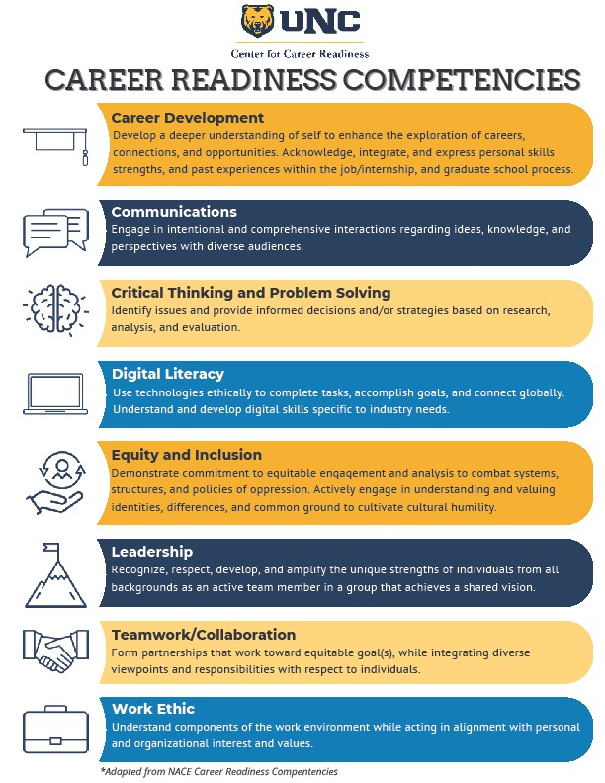

13

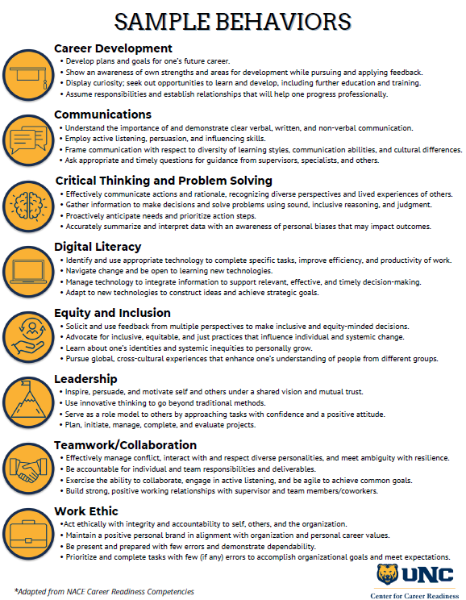

14

