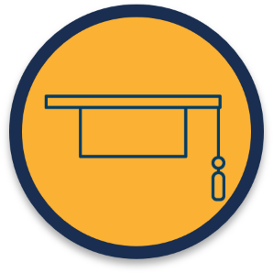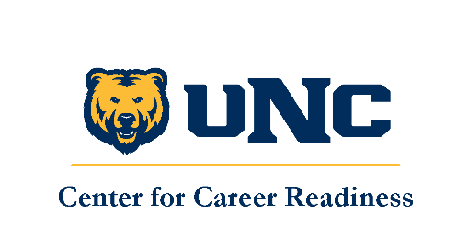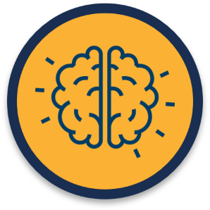

Career Readiness Student Employment Toolkit
Developing Learning Outcomes

It is important to align the learning outcomes of your student employees with those of your unit, the division you belong to, and UNC’s Institutional Learning Outcomes. By doing so, you ensure that student employees are intentional in their learning and training and the experience of working in your unit contributes to their long-term success.
Below are some examples of general student learning outcomes that you can start with. Be sure to further elaborate the SLOs once they are developed, particularly regarding how you plan to assess them. It will be difficult, if not impossible, to properly identify whether the intended learning outcomes are being met without a proper assessment plan in place.

- Articulate and recognize strengths in active listening and positive communication with others
- Engage in connecting to others and team building
- Provide inclusive support to a diverse campus community while building on communication skills
- Collaborate with various audiences to convey data, ideas, reports and to provide resources
- Demonstrate skills in time management, dependability, responsibility, and work-life balance
- Engage in comprehensive interactions regarding ideas, knowledge, and perspectives
- Establish collaboration with team members and students while integrating diverse perspectives with respect to individuals
- Evaluate career development and build skills to utilize in possible career path

It is also important to try and map learning outcomes you are developing to the career readiness competencies outlined in the toolkit and adapted by UNC from NACE. Again, they are:

Career Readiness Competencies (top to bottom, left to right): Communication, Technology, Equity & Inclusion, Leadership, Teamwork, Critical Thinking, Work Ethic, and Career Development
