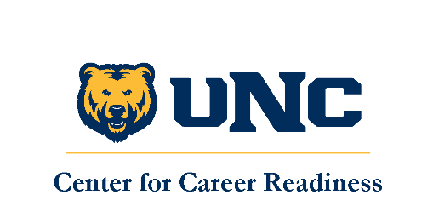
Career Readiness Student Employment Toolkit
Document 1: Getting Started & The “Why”

Intro
First off, we want to thank you for investing your time in increasing your competency and understanding around student employment. By integrating important career readiness core competencies (in alignment with National Association of Colleges and Employers, NACE), you will be well-equipped to hire, train, supervise and develop your student employees.
Furthermore, we would like to thank the tireless efforts of the Career Readiness Committee and Dr. Chris Marston for their tireless efforts on this project.
This toolkit is designed to both increase your student employment competency as well as provide resources and templates for developing standard operating procedures (SOPs) for your own unit around student employment practices . If at any point you would like to meet with the staff in the Center for Career Readiness to workshop topics or troubleshoot anything, please do not hesitate to contact us at career.readiness@unco.edu.
The toolkit is comprised of several templates, which you can use as a starting point to tailor to your specific course content. They are:

- CCR NACE Competencies and Sample Behaviors
- Developing Student Employment Learning Outcomes
- Supervisor Development Guide
- Types of Student Employment
- EPAFS/How to Hire Student Employees
- Using Handshake at UNC
- Cornerstone Tutorial
- Onboarding/Orientation Guideline/Template
- Payroll
- Identity-Based Approaches to Student Employment
Where should I start?
While the toolkit can be utilized in any given order, it is our recommendation that you start by reviewing the CCR NACE Competencies and Sample Behaviors. This will give you a framework with which to help build the curriculum, going off of nationally-recognized competencies that can be woven into specific learning outcomes for the course. Determine which NACE competencies you wish to integrate into student employment learning outcomes. That will give you a roadmap from which to work from for the rest of the toolkit. While the toolkit has several resources you can utilize, we do not anticipate every employee will have the space in their schedule to integrate every item. For example, you may just be focusing on developing learning outcomes at this point, and are not ready to post student employment positions on Handshake yet.
A Note about the Icons
Throughout the toolkit, you will see several gold icons. These match the relevant NACE competencies that are applicable to the assignment or template provided. These icons are also downloadable through the toolkit and can be added to any assignments you may create that connect to the appropriate career readiness competencies.
They are (top to bottom, left to right): Communication, Technology, Equity & Inclusion, Leadership, Teamwork, Critical Thinking, Work Ethic, and Career Development
