Step 1

To start your application to become a Student Teacher with Aurora Public Schools and click on: Student Teacher Application

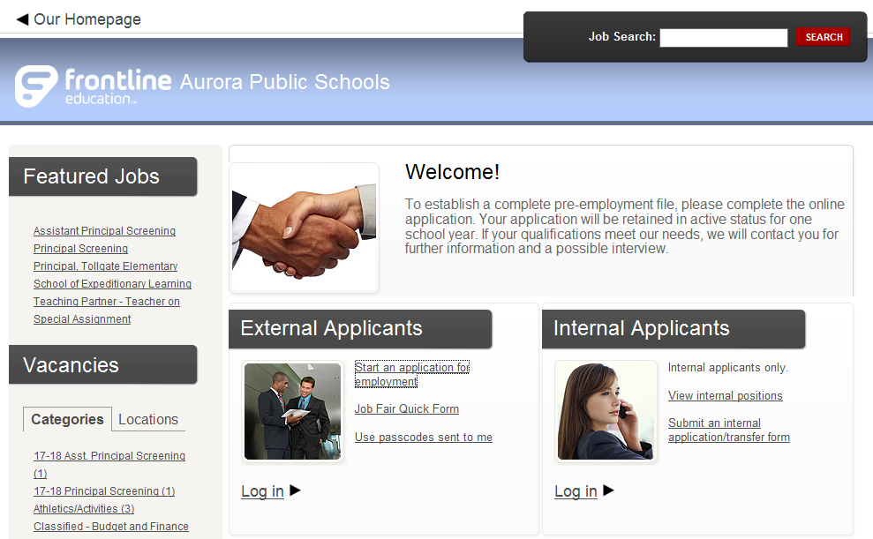

Step 2

Click on START

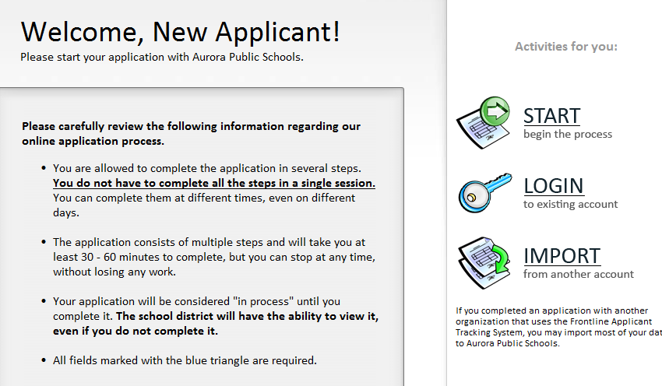

Step 3

Complete all required necessary information

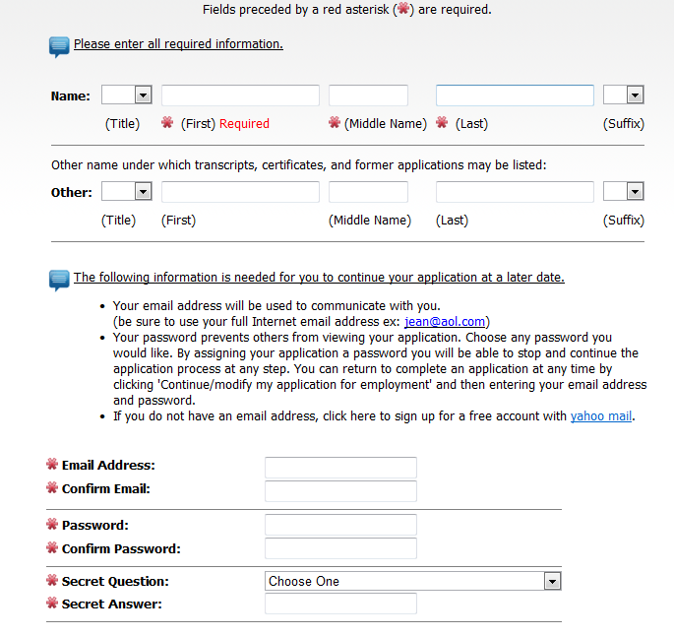

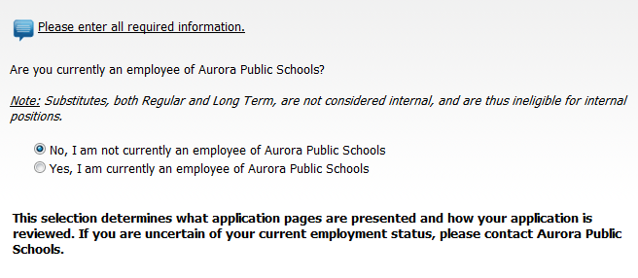

Step 4

Complete address information

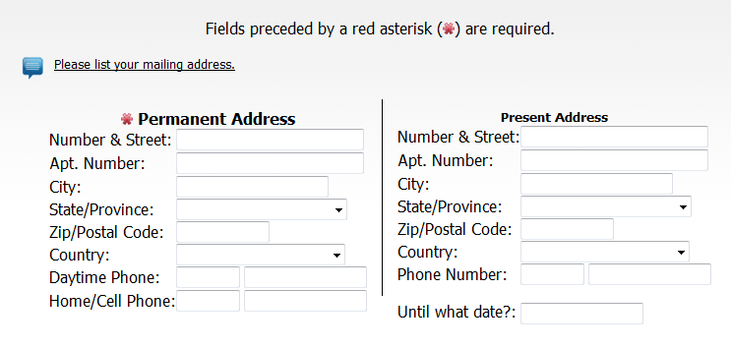

Step 5

Type in STUDENT TEACHER in Title Contains and click on Search

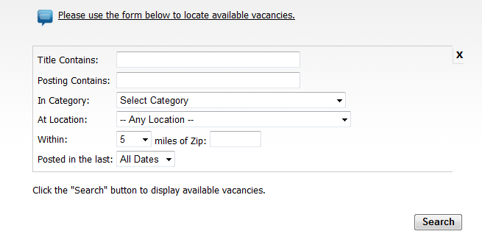

Step 6

Click on box for Job ID 5427:
(If you are seeking an intern or observation placement go to Step 6.1)

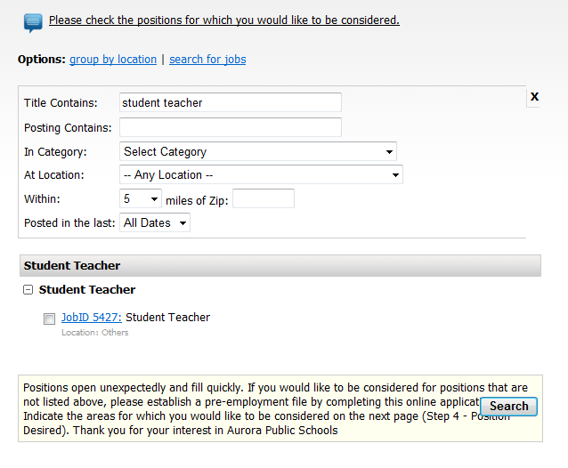

Step 6.1

Interns/Observations: type intern and click search

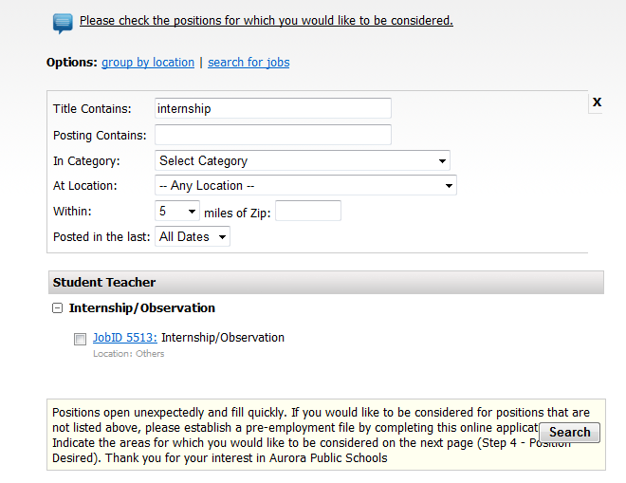

Step 7

Under Position Desired, only select either Internship/Observation or Student Teacher under the Student Teacher heading. If you select anything other than that in this area it will prompt you to complete the FULL application and upload documents.

Step 8 (For Student Teacher submissions only-NOT intern/observer students)

For the remainder of the application you will be asked to complete the Teacher Match test, provide Language Information as well as Legal information and then Confirm and Submit.

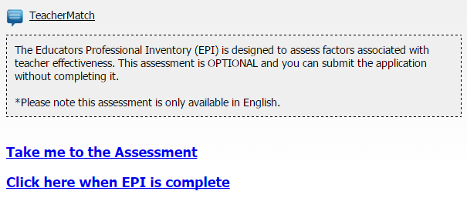

*** Please Note: This test is not OPTIONAL and must be completed in order to submit your application ***

