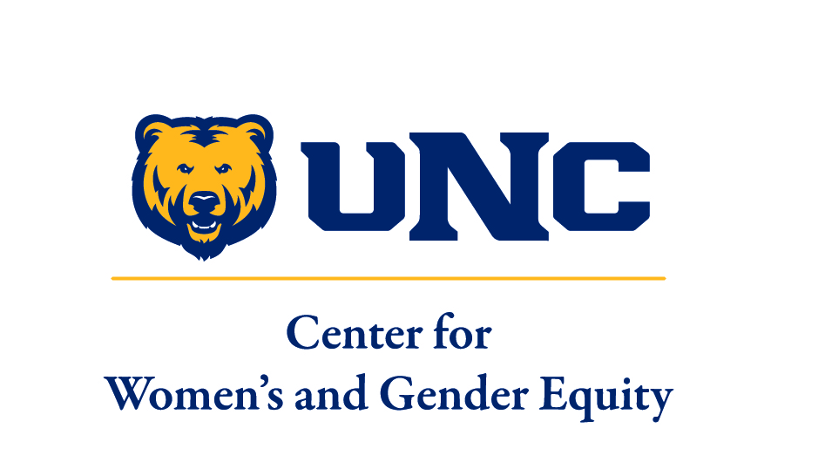

Accepting Applications Until Filled

Position Title: Graduate Assistant; Center for Women’s and Gender Equity

Mission of the Center for Women’s and Gender Equity:

The Center for Women’s and Gender Equity (CWGE) honors gender as a central identity and engages critical women's and gender issues, while challenging systems of inequity and advocating for change at the University of Northern Colorado.

The CWGE accomplishes this mission by doing the following:
  - Educating our campus community
  - Providing a space that celebrates diversity and the unique self
  - Engaging in conversations about gender and the relevance of feminism
  - Empowering student voices to create gender equity at UNC
The CWGE is a support resource for students specific to women's and gender issues and serves as a referral site for additional resources on campus and in the community.

The CWGE is dedicated to offering an inclusive environment and is committed to social justice and equity for all. We value people of all genders coming together to end sexism and all other forms of oppression.

Job Duties and Responsibilities include (but not limited to):

The Center for Women’s and Gender Equity is looking for a Graduate student who demonstrates passion and commitment to women’s and gender issues and who seeks an opportunity to grow both personally and professionally through the mentorship offered by CWGE staff in the Graduate Associate(GA) position.

- Support Associate Director with the programming aspect of the CWGE, including planning programs and events that address women’s and gender issues, assessing campus needs, providing staffing support at events and activities, and provide support in the development of innovative strategies to address women’s and gender issues.
- Mentor student staff and provide support to students with programming responsibilities such as interns and volunteers (when applicable)
- Represent the CWGE, it’s goals, and activities to various other organizations across campus
- Possess the desire and ability to provide services to UNC community and others accessing the CWGE
- Be available to respond to walk-in students and phone concerns
- Managing publicity and public relations for programs and events
- Assume responsibility for other tasks within the office
- Must be available for some evening and weekend hours
- Provides support for Stryker Institute program including event organizing

Compensation:

- This is an Academic Year appointment beginning August 1, 2019 and ending May 15, 2020. It is an 18-hour per week position and includes some evening hours and weekends. Included is tuition remission up to 10 credits and a monthly Master’s level Graduate Assistant stipend. Stipend amounts can be found on the GAA/GTA/GRA Stipend Chart at http://www.unco.edu/grad/forms/index.html

Qualifications:

- Required:
- Must be enrolled as a graduate student at the University of Northern Colorado
- Awareness of women’s and gender issues and concerns
- Knowledge and awareness of social justice and a desire to engage social justice within this position
- Demonstrate excellent verbal and written communication skills, a high level of self-direction, organization, initiative, and reliability
- Must be available to attend GA and Department trainings in August.

- Preferred:
- Previous leadership or other experience working with students
- Ability to engage an audience during group presentations or committee meetings
- Experience with program development and implementation

To Apply:

The Application for Administrative Graduate Assistantship can be found through the Graduate School and International Admissions website: www.unco.edu/grad/funding/gaVacancies.html.

Please submit the following materials to Sarah.Rodriquez@unco.edu:
- Completed GA application (found on Graduate School website)
- Resume (including references)
- Cover letter that speaks to your interest in the position and how you meet the qualifications (see qualification list)

For more information about this position, please email Yvette Lucero-Nguyen, Director of Center for Women’s and Gender Equity at Yvette.LuceroNguyen@unco.edu or call: 970-351-1492.

