Streamlyne IRB & Committee Module Tip Sheet

How to Create & Submit an Amendment

The PI or the protocol creator can amend a protocol any time after initial approval. The review process for amendments is like the review process for initial submissions. This section will only cover the differentiators specific to creating and submitting an amendment.
The recommended way to initiate an amendment is from within the existing, active protocol: IRB Actions > Amend or Renew IRB Protocol. Clicking this menu option will display all protocols available to the user that currently qualify for an amendment or renewal.
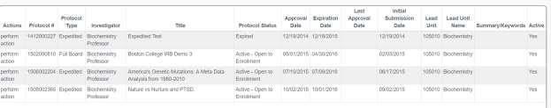
Navigation
Main Menu > IRB > IRB Actions > Amend or Renew IRB Protocol

- Locate the protocol that you would like to amend.

- Click the corresponding perform action hyperlink.

Result: Streamlyne will open the protocol to Protocol Actions > Request an Action
panel. The Available Actions will display multiple options for you.

- Click the Show button next to Create Amendment.
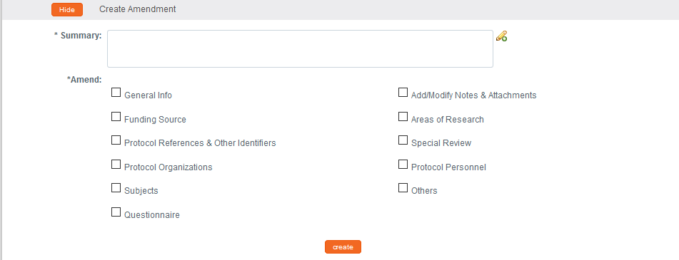

- Describe the purpose and content of the amendment in the Summary field. If necessary, click on the edit button to access a text editor with character count.

- In the Amend section, check all boxes for sections you wish to amend. Protocol sections with checked boxes will be opened for editing. Those not selected will remain read-only.
If you are requesting an amendment to your procedures, please be sure to check the box next to Questionnaire.

- Click the Create button.

Result: Streamlyne will open a new Amendment document. You will be able to make edits in the areas you selected in Step 5.


- If you selected Questionnaire, click on the tab header to access the Questionnaire tab.
you will now see an IRB Protocol Amendment questionnaire under the
Questionnaire tab. Click the > next to IRB Protocol Amendment.

- You will now see an additional amendment questionnaire. Click on the section header to expand the Questionnaire section.

- Read each item carefully and provide a response. Enter detailed descriptions or explanations where prompted. You may be
directed to upload an attachment.

Click on the pencil to the right of the text box to expand the text box, creating a large field to type into.

Note: New questions may appear based on your answers.

Note: If you choose to type into a Word document and then paste your responses into the text box, please note that smart quotes from Word are not an accepted character.

- Click the Save button at any time to save your work.

- The Questionnaire status will change to Complete once all questions are answered.
You MUST complete this questionnaire before submitting the document.

- If you would like to edit further sections in addition to those previously selected, navigate back to Protocol Actions > Request an Action > Available Actions.

- Click the Show button next to Modify Amendment Sections.
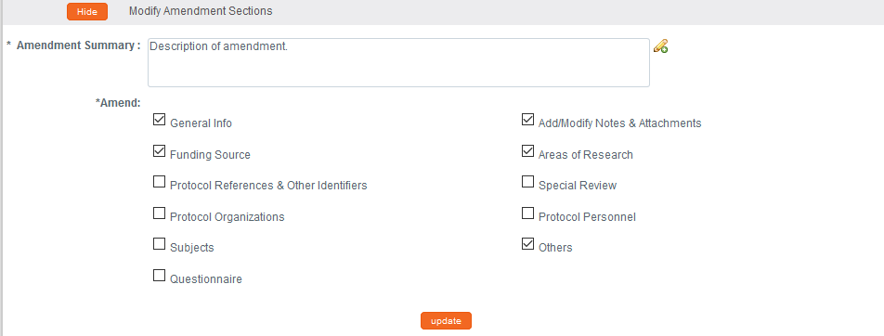

- Select the applicable sections and click the Update button.

- Make all applicable changes to the information displayed on the protocol document as needed.

- When ready to submit, navigate back to Protocol Actions > Request an Action> Submit for Review.

- Click the Show button next to Submit for Review.

- Complete the required fields of Submission Type (e.g., Amendment) and
Submission Review Type (e.g., Full Board).

Notes: For Exempt and Expedited protocols, a Checklist will display. Select all categories that apply to your amendment.

- Click the Submit button to submit your amended protocol for the required workflow approvals.

Result: The delivered Data Validation routine will display any errors or warnings that pertain to this document. Be sure to complete the Questionnaire. If necessary, fix the errors and click the Submit button again to revalidate and submit.
Otherwise, the system will change the Document Status to Submitted to IRB.

See Understanding Streamlyne Amendments & Renewals for what Amendment details will be made available in the Summary & History section.

