Streamlyne IRB & Committee Module Tip Sheet
How do I clear my Action List of FYI notifications?
FYI Notifications are sent to your Action List by Streamlyne for a variety of reasons: reminder of a due date, change in status of your application, action taken on your protocol, etc. FYIs are for notification only and are not the item that requires your attention, however, the FYI Content may at times include a hyperlink to the protocol you need to access to complete the request.
Once you have addressed the item needing your attention, or you no longer need the reminder, as in the case of Annual Disclosures, you are welcome to remove the FYI Notifications from your Action List. This can be done individually or an entire page at a time.

To remove FYI Notifications one at a time from your Action List:
- Within your Action List, locate the second column from the right labeled Actions. Under Actions, you will see a drop-down menu that currently has “None” selected. Click on the drop-down menu and select “FYI”. 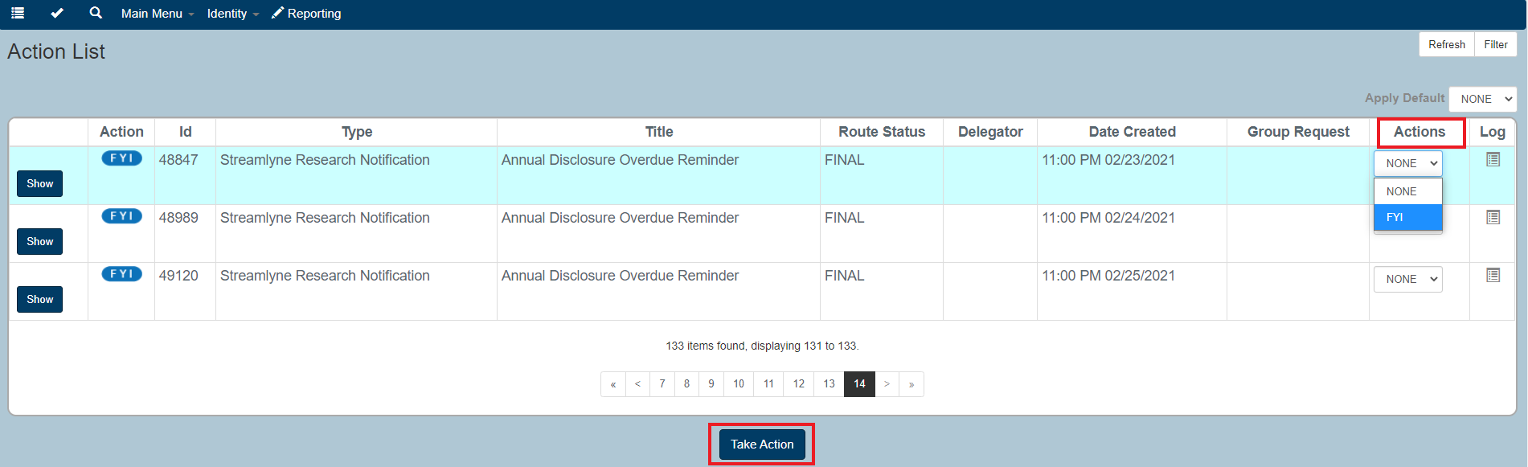

- Scroll down to the bottom of the page and click on .

- Since you have taken action on the FYI, it has now been deleted from your Action List.
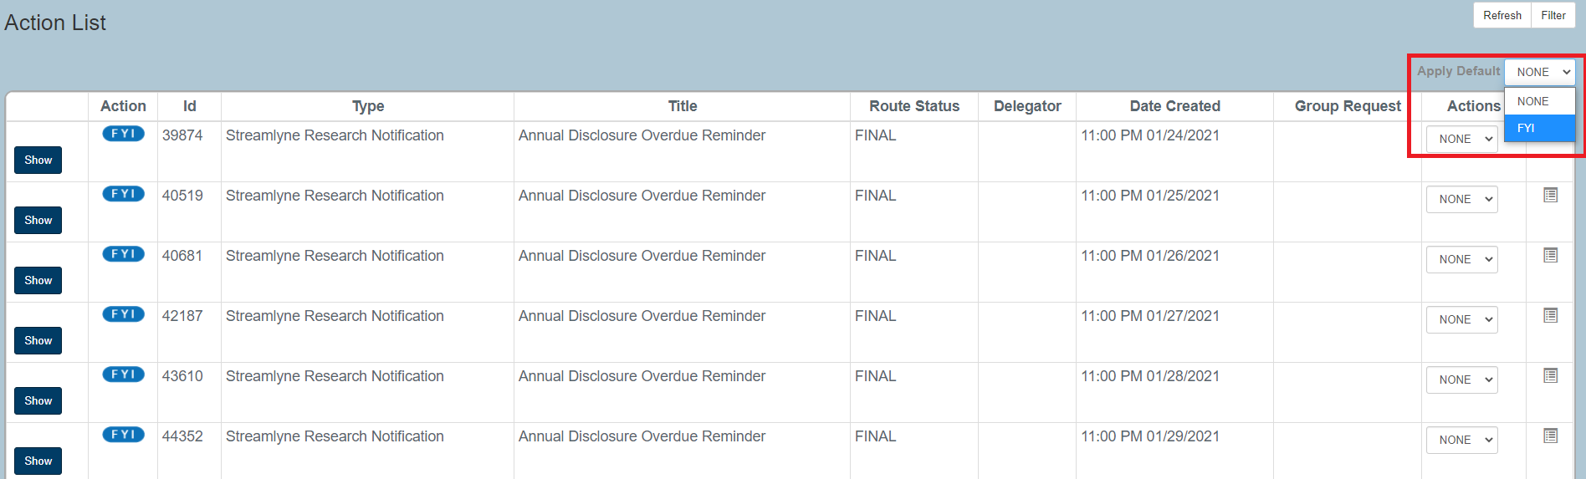
To remove all FYI Notifications on a page at the same time:
- Towards the top right corner of your Action List, there is a drop-down menu with Apply Default to the left of it. Click on the drop-down menu and select “FYI”.

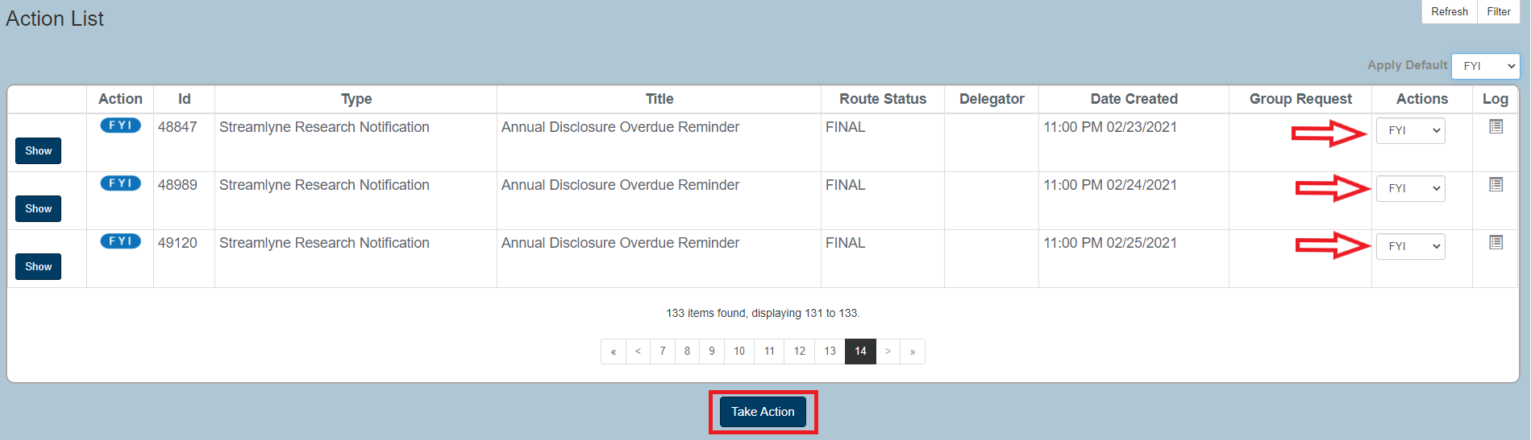
- You will notice that all of the drop-down menus under the Actions column have now changed to “FYI”. Scroll down to the bottom of the page and click on .
- Since you have taken action on all the FYIs on that page, they have now been deleted from your Action List. You can repeat these steps as many times as needed.

