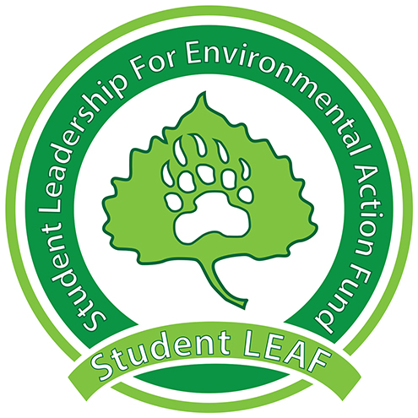
Board Minutes
Student LEAF
Date|9/10/2018 4:00 PM | Meeting called by Z. King
Z. King, President | M. Wike, Vice President | E. Scott, Grant Coordinator | T. Rapport , Treasurer | L. Van Es, Secretary | T. Boen, Public Relations| J. Jenkins, Green Team | K. Leichliter , Advisor | C. Romulo, Advisor
Time | Item | Owner
4:00pm | Call to Order | Z. King
4:00 | Presidential Updates:  - AASHE Conference Proposal to send two people  - Apply for reimbursement through student senate  - October 2-5  - Changing Bylaws  - Updating and changing positional requirements  - Trying to get funding to pay all Board Members  - Send Time commitments to Zak | Z. King
[Time] | Vice President:  - Creative ways to reach students  - Weekly podcast/video blast  - A memorable slogan (#WWND, etc)  - Solid colored wrist bands (similar to LIVESTRONG – iconic) | M. Wike
[Time] | Grant Coordinator:  - Frolf baskets- lights for nighttime  - Sun blocked by trees or tops of baskets  - For bottom of baskets  - For top of basket  - Tee pad lights (1) (2)  - PVA lights – updating tech  - Housing lights – retrofit more expensive  - Staging lights – retrofitting without gels to be more sustainable  - Get in contact with whoever will submit a proposal  - Single trash Can Conversion  - Reuse bins or buy something for outside the bins to connect them  - Split existing bins | E. Scott
[Time] | Green Team:  - Attending Dining Services meetings Tuesdays at 12:05 in Holmes  - Holly Wainscott is the replacement for Robin  - Waterbottle fillers at Holmes  - Write a proposal  - Center for Women’s and Gender Equity needs one as well  - Needs access to Bishop Lehr for storage | J. Jenkins
[Time] | Treasurer:  - Send receipts when ordering online  - Colorado Switch Energy Alliance – starting to develop clubs in Universities  - Understanding the future of energy and social justice aspect of energy  - Byron Straw – contact for more information | T. Rapport
[Time] | Public Relations:  - Schedule volunteering at a table in the UC  - Nametags needed for Zak and Joelle  - Earth Week  - Increase attendance  - RHA and Greek Life  - Student Senate | T. Boen
[Time] | Secretary:  - Still need pronouns for website  - Sending follow up emails after meetings with tasks for the next week | L. Van Es
[Time] | Vote: Allocate $2500 to send two people to go to AASHE Conference October 2-5  Called to a vote by: Z. King  Seconded by: M. Wike  For: E. Scott, J. Jenkins, T. Rapport, L. Van Es, T. Boen  Against:  Unsure:  Notes:
4:55pm | Adjournment | Z. King
General Notes:

