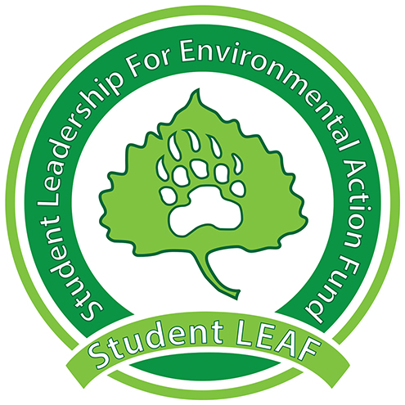
Board Minutes
Student LEAF
Date|10/8/2018 4:00 PM | Meeting called by Z. King
Z. King, President | M. Wike, Vice President | E. Scott, Grant Coordinator | T. Rapport , Treasurer | L. Van Es, Secretary | T. Boen, Public Relations| J. Jenkins, Green Team | K. Leichliter , Advisor | C. Romulo, Advisor
Time | Item | Owner
4:05 | Call to Order
4:05 | Public Comment:  - goal to offer recycling to off campus students – mainly greek life  - Emmy contact with Greek Life (Michelle Harvey)  - Kirk – LEAF and others have attempted in the past  - Momentum – get info from Stephanie  - Awareness raising? - competitions | Jacob McMillen
4:15 | Presidential Updates:  - AASHE Conference updates next week | Z. King
4:18 | Vice President:  - Film Video  - Big Banner/Poster in UC  - “Contribute to Campus Sustainability” – marketing? | M. Wike
4:23 | Grant Coordinator:  - Signing notice of awards – Zak  - Future rating forms – google survey?  - Solar Flower – about $22k buying and $2 or 4 k install  - Cesar Chavez still interested | E. Scott
4:30 | Green Team:  - Student contacted about project with nutrition class  - More info next week | J. Jenkins
4:36 | Public Relations:  - Paint a leaf, take a leaf –October 15 from 11-1  - LEAF sticker – working on  - Individual interested in shadowing for position next year  - LEAF info on tables – maybe cycling TV in dining hall?  - “Lights by LEAF” – including information  - AASHE notes Green/Sustainability Ambassador within departments | T. Boen
4:43 | Treasurer:  - Student Senate  - Announced projects – will continue | T. Rapport
4:46 | Secretary: N/A | L. Van Es
4:46 | Parking Lot:  - RHA – recycling and to go boxes guest speaking  - Marketing – McKinstry  - E-waste event  - Donating swipes to Bear Pantry  - Bear in Mind Podcast  - TV in Ross  - Project Plaques  - Advertising for positions next year
 | Adjournment | Z. King
General Notes:

