Contract Management System Requestor Training Guide
Version 2.0
November 2, 2016

This document contains detailed instructions on how to request a contract, check the status of that contract, and retrieve copies of existing active contracts using the OnBase Contract Management System.

Requesting a Contract

To request that a contract be either reviewed or created, you must complete a Contract Request Form. The Contract Request Form is found within the Hyland OnBase Unity Client (which must be installed on your computer). The icon for the system is pictured below.

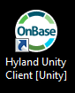

You will be required to log into the Unity Client. When the login screen opens, select “OnBase PROD” in the first field. Once you select OnBase PROD, the second box will populate with UNCO1 automatically. Your user name will also populate after the first time you log on. If you are using someone else’s computer, you can type your FIRST.LAST name in the third field. In the last field, next to the padlock icon, type in the same password you have to log into your computer.

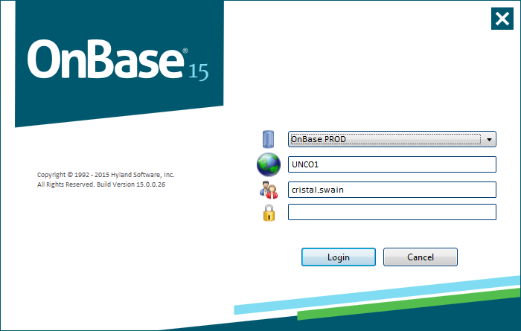

Once you have logged into the OnBase Unity Client, the following screen will appear.

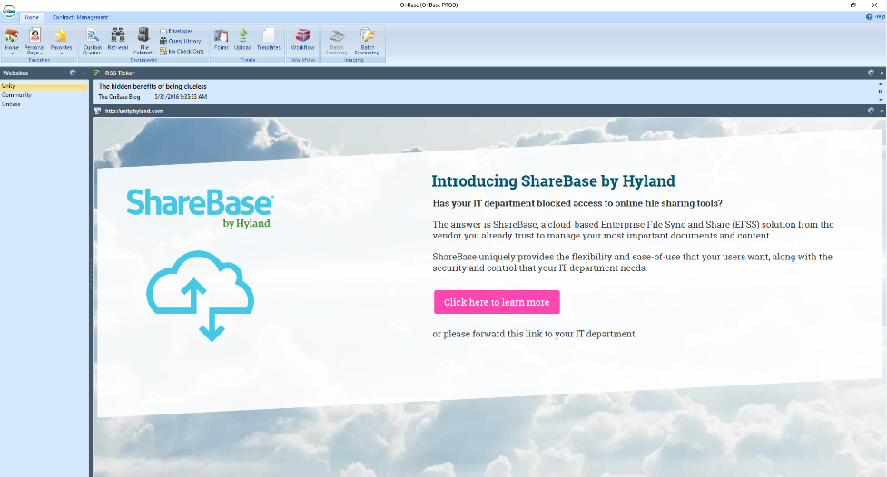

On this screen you will select Forms in Ribbon at the top of the screen.

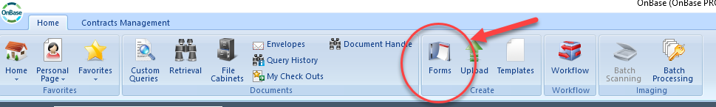

Once you select forms, you will select CM Contract Request in the left column on your screen.

Once CM Contract Request is selected, the following screen will appear.

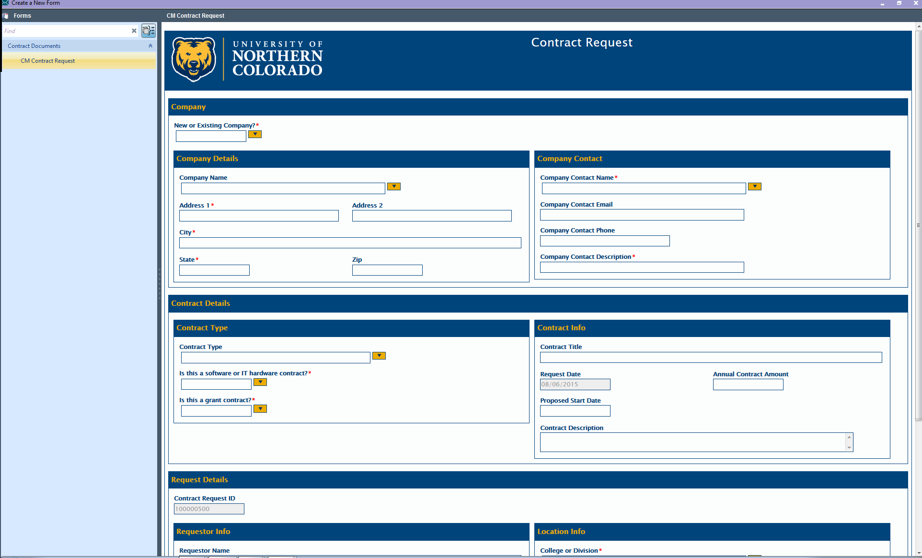

You must complete all sections of this form to submit your request. Details for each section are below. Note: All fields marked with an asterisk * are required fields.

Company:

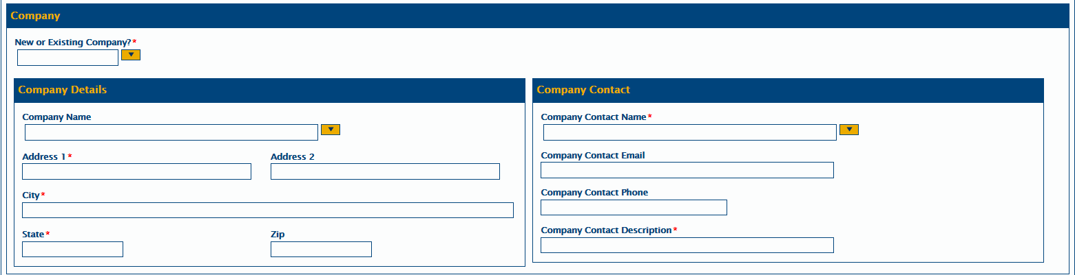

In the Company Section, first select existing and search to see if the Company Name exists.

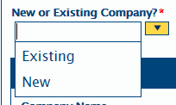

If the Company does exist in the system, select the Company from the drop down box. You can search for the company name by typing the start of the Company’s name in the Company Name field. If the company exists, the address information will automatically populate.

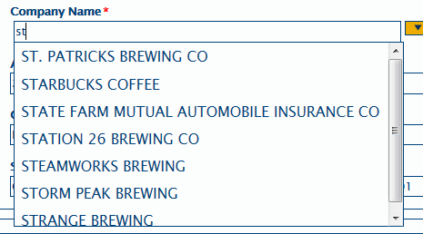

If the Company does not appear in the drop down box, select New in the top box and type in the Company information in the Company Details section of the screen.

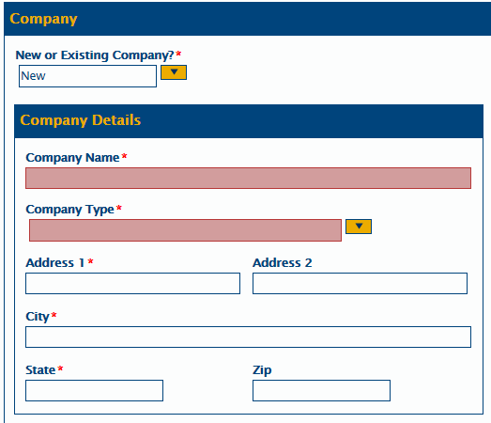

After entering the Company details section, you will need to complete the Company Contact section.

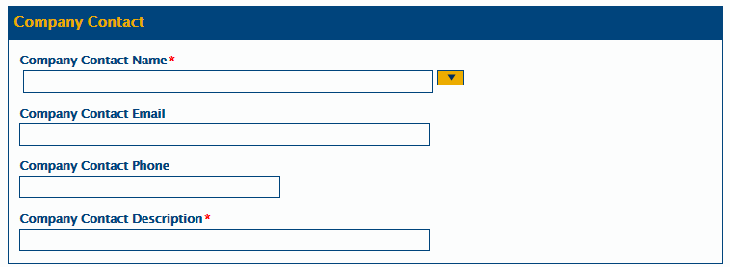

You can search for a company contact either by his/her name or by entering the company name. If you type in the company name, all contacts associated with that company will appear in the drop down box.

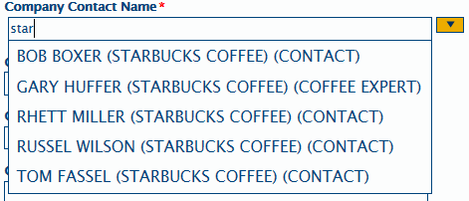

Once you select the Company Contact, all contact information will automatically fill in the Company Contact box. If any information is incorrect in this box, you must note that in the Requestor Comment box (discussed on page 8, below). Any changes you make to the Company Contact Name do not update in the Contract Management System.

If the contact person you are working with does not appear in the drop down menu, you can add him/her by typing the person’s information in each field. The Company Contact Description field is used to remind you or your colleagues in the future what that contact person’s role is in the company. As you can see in the Company Contact Name field, above, when someone searches for that contact person in the future, the drop down menu will provide the contact name, the company he/she is associated with and his/her role in the company.

Contract Details:

After completing the Company section in the Company Details and Company Contact boxes, you will complete the Contract Details section.

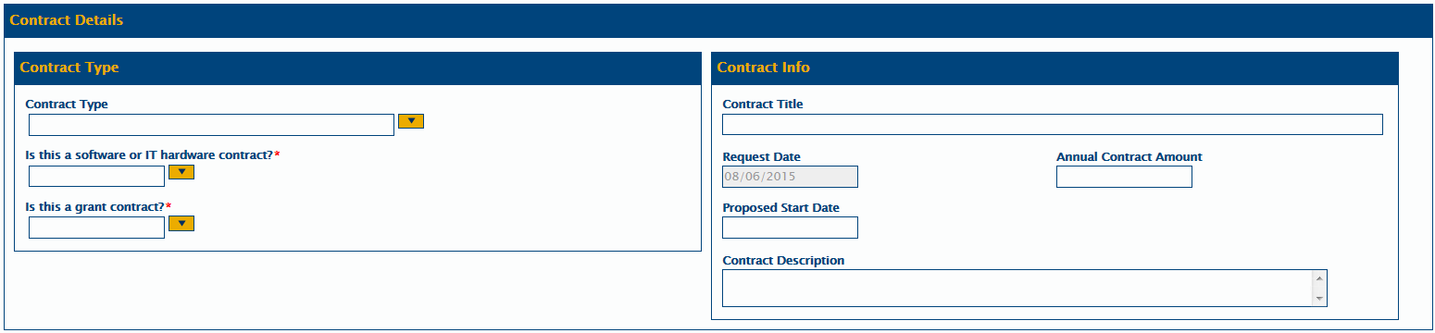

In this section, you will first select the Contract Type from the drop down menu. If you are unsure of your Contract Type, please contact the Purchasing & Contracts Office for assistance.

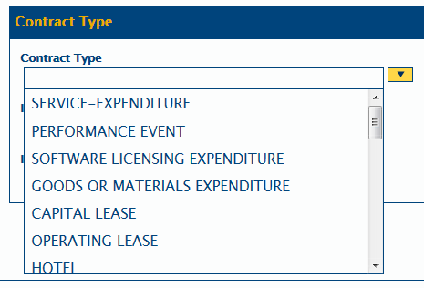

Next you will identify if the contract is for software or IT hardware. If “Yes” is selected from the drop down menu, the Contract will be automatically routed to IM&T for approval. Note: If “No” is selected and the Contract is actually for software or IT hardware, the Contract Lead will change this on the Request Form, and send it to IM&T for approval. This will delay the contracting process, so it is important that you answer this question correctly.

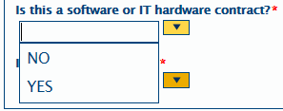

Next you will identify if this is a Grant contract. Most requestors on campus will answer this question “No.” The answer to this question will determine if the contract is routed to the Office of Sponsored Programs (those who answered “Yes”) or the Purchasing & Contracts Office (those who answered “No”). Note: Answering this question incorrectly will cause a delay in the processing of your contract so it is important that you answer this question correctly.

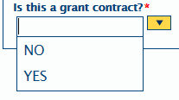
The last step in this section is to complete the Contract Info box. Although this information is not required, it provides important information to the Contract Lead, Legal, IM&T and the Fund Approver.

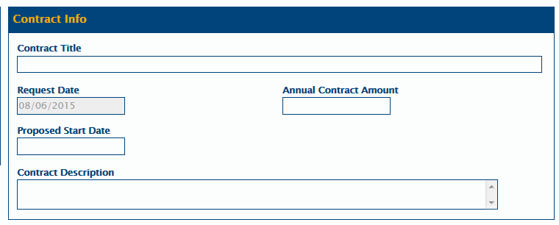

Contract Title: This is a brief statement of the work to be completed (for example, Consulting Services or Software License). Note: This title may be changed by the Contract Lead as appropriate.

Request Date: This field is automatically populated with today’s date and cannot be changed. This field is only used to determine when the request was submitted.

Annual Contract Amount: This field is the total annual value of the contract. This information will be used to determine if, by UNC Fiscal Rule, the contract requires legal review. This information will also be used as the compensation value in the contract document itself. Note: This field cannot contain any commas, so, by way of example, $5,000 should be entered as follows – 5000.00

Proposed Start Date: This is the date you would like to have the contract start. Note: The actual start date is dependent upon completion of all contract negotiations and the receipt of signatures from both the Company and UNC.

Contract Description: The information entered in this field is very useful for the Contract Lead, IM&T and Legal in the review and negotiation of the contract. The information provided in this field will also be communicated to the Fund Approver when they are asked to Approve or Deny the contract document. (See the Notifications section on page 21, below, for further details.)
Below is an example of a fully completed Contract Details section.

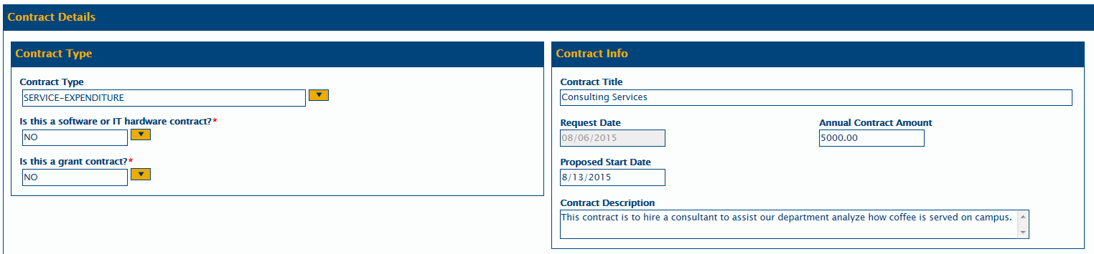

Request Details:

After completing the Contract Details section in the Contract Type and Contract Info boxes, you will complete the Request Details section.

The Contract Request ID is a unique number given to each Contract Request. Note: This is not your contract number.

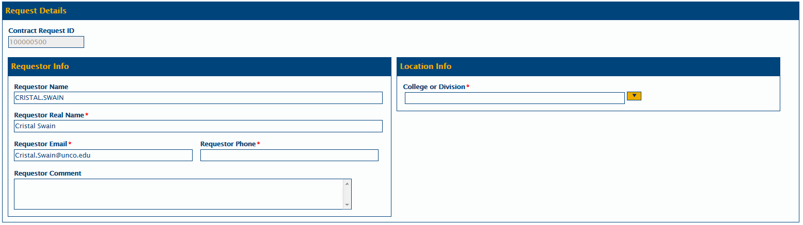

In the Requestor Info box, most of the Requestor information will be filled in automatically based on your login. The only required field that is not automatically filled in is your phone number. You will need to enter your complete phone number in this field. Note: You can change the Requestor information if you are not the appropriate Requestor.

The Requestor Comment field is a place where you can make notes for the Contract Lead to review. These notes are not part of the contract document itself, but provide a place for you to communicate any information regarding this contract that is not captured in any other field. Note: This is the field that you will use to notify the Contract Lead of any changes that need to be made to the Company Contact information.

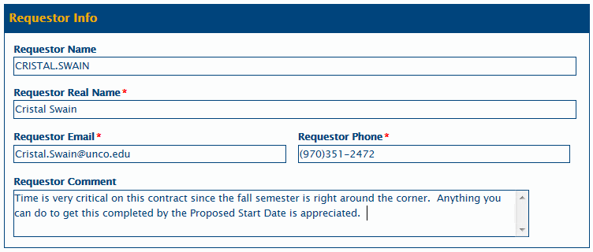

After completing the Requestor Info box, you will complete the Location Info box.

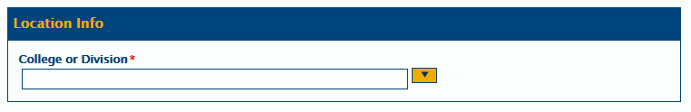

This box contains what is known as a “cascading data set.” That means that the available options in each field in this box is dependent upon what you selected in the prior field.

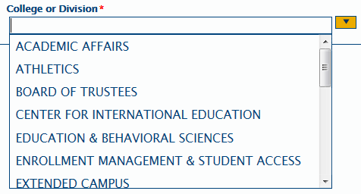

Once you select your College or Division, you will then select your Department Name.

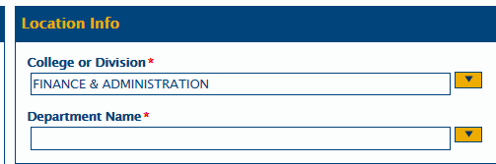

This drop down menu is limited to those Department Names associated with the selected College or Division.

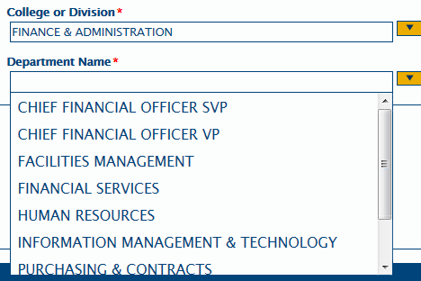

Once you select your Department Name, you will select your Primary Approver Name. This is the person who is responsible for approving the Contract before it can be signed by UNC or the Company.
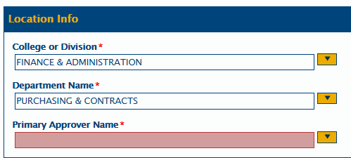
As with the Department Name field on page 9, the drop down menu for the Primary Approver Name is limited to those Approvers associated with the selected College or Division and Department Name.

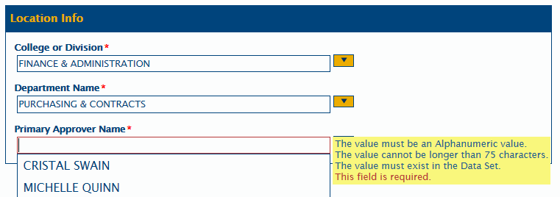

Attach Third Party Agreement:

This section is only used if you have a contact that has been provided by the Company. If you do not have a contract from the Company, you will skip this step and select “Submit” at the bottom of the page.

To attach a company provided contract, click on the blue ribbon that is shown above. You will then get the following screen.

To attach the contract, select Attach CM Contract.

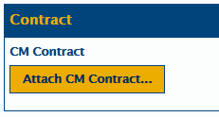

This will open the following screen.

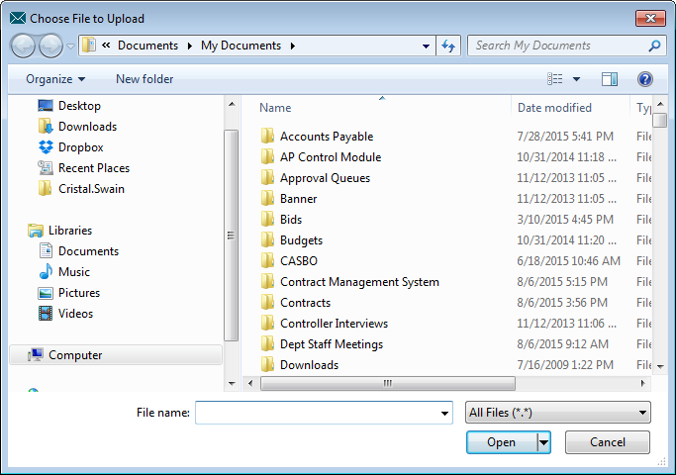

You can then attach any document saved to your computer by highlighting the contract and clicking open.

Once the contract has been attached, the following screen will appear.

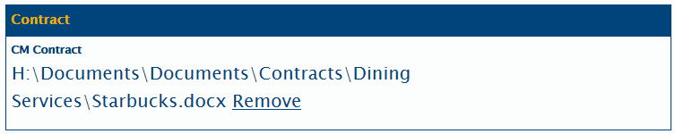

If you have selected the wrong contract document, you can select Remove and start over.

Once all above information is completed, select Submit on the bottom of the screen.

Once you click Submit, you will get a screen that says the request is being saved. Once it has successfully saved the following message will appear.

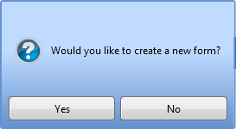

If you click Yes, you will be given a blank form. If you click no, the screen will be blank and you can close OnBase by selecting the “X” in the top right hand corner of the screen.

Tracking a Contract and Retrieving an Existing Contract

You can track the status of your contract through the Hyland OnBase Unity Client. To track your contracts, you will log into the system using the same process as identified on page 1 of this document.

Once on the login screen, you will select Contracts Management Tab above the ribbon bar.

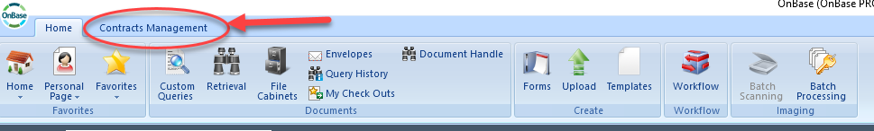

Once you select Contracts Management, you will select Filters from the Ribbon bar.

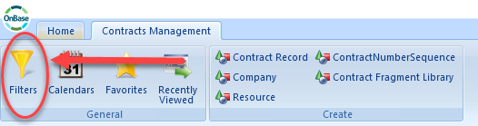

Once you are on the Filters page, select My Contracts from the Filters list on the left side of the screen.

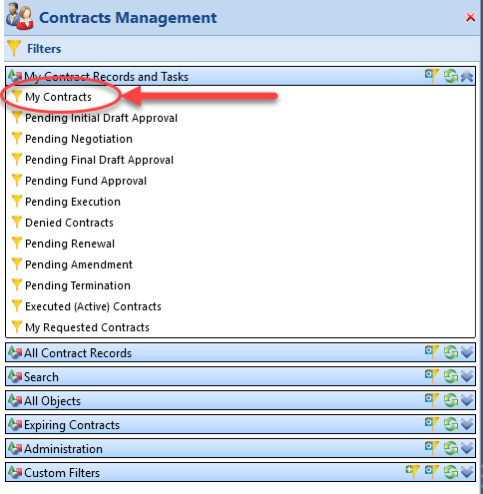

Once you select this filter, all of your requested contracts will populate on the right side of the screen.

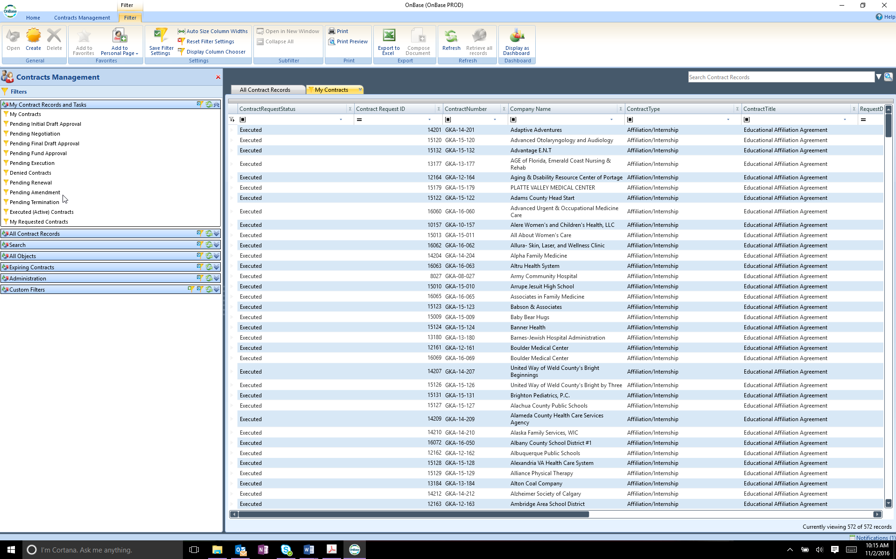

This filter will show you every contract associated with a Contract Request that you have entered in the system.

On this filter, you will see the Contract Status, Contract Request ID, Contract Number, Contract Type, Contract Title, Request Date, in addition to many other fields.

The Contract Request Status will inform you of exactly where the contract is in the contracting process. Please see the attached Contract Management System Status document for further details on each status.

Searching for a Contract:

If you have a long list of contracts and need to search for a contract, you can search by any of the fields that are contained in the filer.

If you would just like to sort the contracts by value, you can do so by clicking on the field name at the top of the page. If you double click on that value it will do a reverse sort.

You can also search for a specific value in each of the fields. In order to conduct this search, you will click in the bar just below the contract field name and start typing your value.

If the search box contains a box [] then you can type any part of the word or phrase you are looking for and the search will display any record that contains what you have typed (see above).

If the search box contains an equal symbol [] then the value must match exactly in order for the record to be returned in the search.

Retrieving a Copy of a Contract:

A copy of the fully executed contract will be sent to you, as the Requestor, once both the Company and UNC have signed the contract. The contract will be an attachment to an email that can be saved as any other document can be (see attached notifications for an example). Should you ever lose that email or file or just want to more easily pull a copy of the contract, you can access it by searching for the document as discussed above.

Once you have found the contract record you are trying to retrieve, double click anywhere on the line that contains the contract to open the contract record.

Once you have double clicked on the contract line, the following screen will appear:

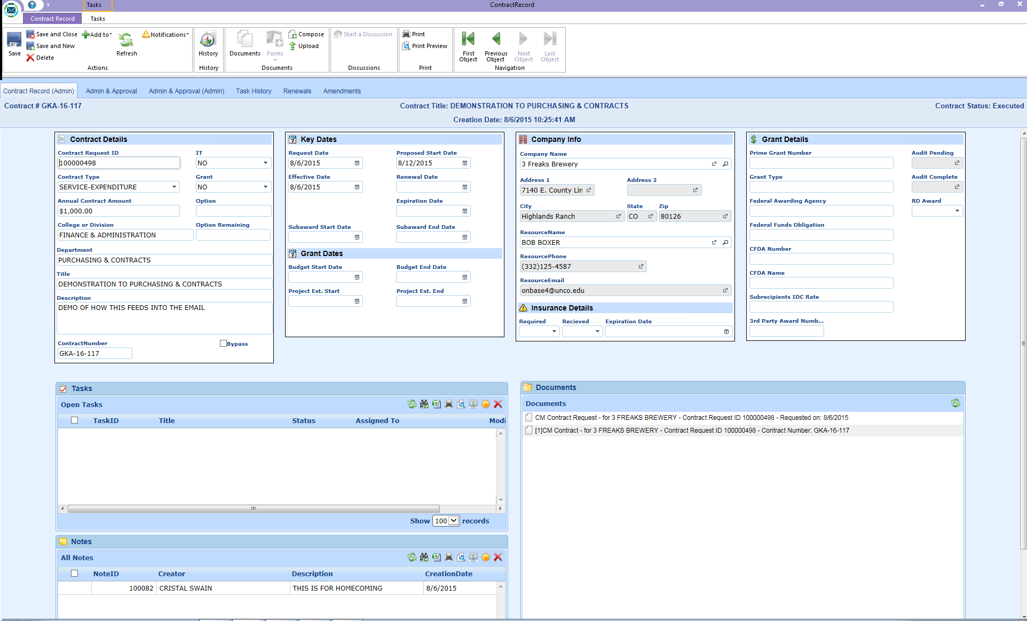

Navigate to the Documents section of the page.

You can now retrieve the contract document by double clicking on the record that says CM Contract in the Documents Box (lower right hand corner of the screen immediately above). Note: This document will usually be the second document in the document list.

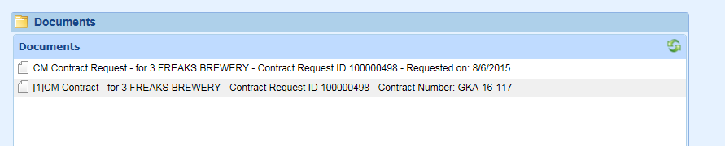

Once you double click on the contract document, it will open in either Word or PDF, depending on the file type.

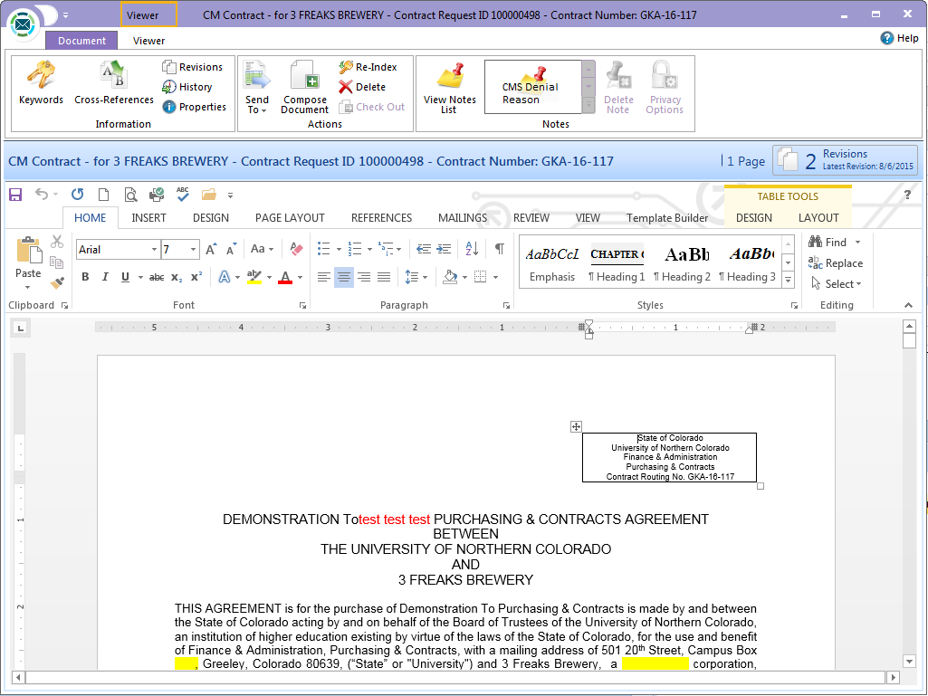

Notifications:

OnBase contains a workflow component that automatically sends email notifications to the appropriate individuals depending on the status of the contract.

There are two notifications of which you should be aware as a Requestor. The first is the Fund Approval email that is sent to the person that was selected as the Fund Approver on the Contract Request Form. As the Requestor you will not see this email, but it is important that you understand what it contains and how it impacts the contracting process.

Below is a sample email notification that the Fund Approver will see.

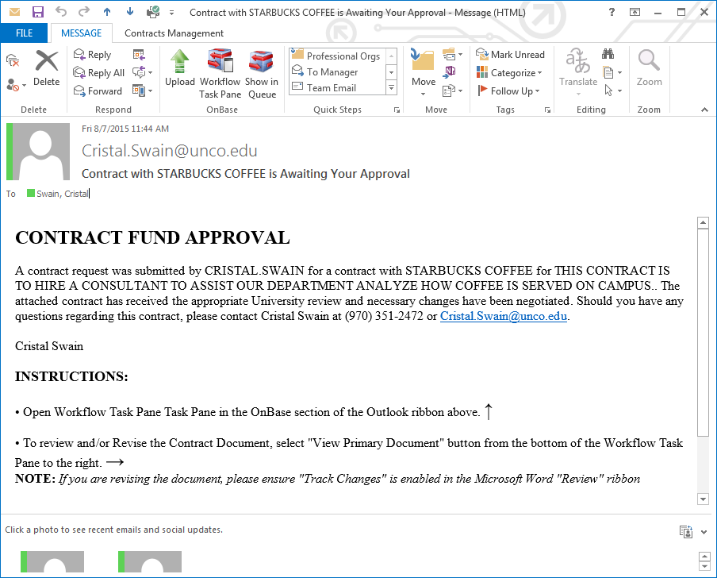

As you can see, this email notification informs the Fund Approver who requested the contract, the Company with whom the University has contracted with, and the Contract Description that you entered on the Contract Request Form. The email also contains instructions for approving the contract and provides contact information for the Contract Lead should the Approver have any questions regarding the contract or how to approve it.

The second notification of which you should be aware is the one you will receive as the Requestor. Once a contract has been fully executed, you will receive a copy of that contract via email at the same time the contract is being emailed to the Company.

Below is a sample email notification that you will receive as the Requestor.

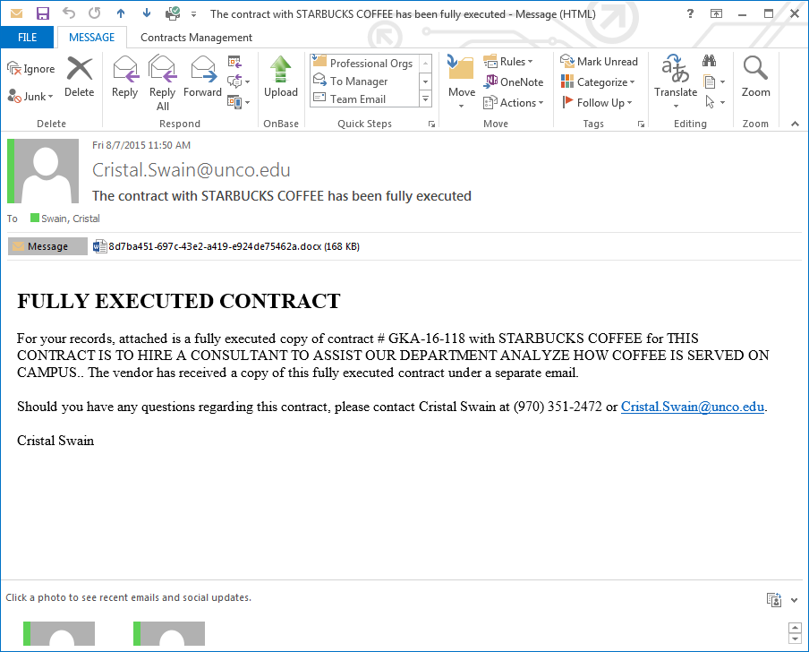

As you can see, this email contains the Contract Number, Company Name, and the Contract Description you entered on the Contract Request Form. The Contract document itself is attached to the email and can be downloaded and saved as you would save any other document. The email will also contain contact information for the contract lead that handled this contract on behalf of the University.

