MED Comprehensive Examination
2016

Nature of the MED Comprehensive Examination
The purpose of the Mathematics Education (MED) Written Comprehensive Exam is to determine whether doctoral students have made sufficient progress in the program, demonstrating the necessary knowledge of theory and research methods in mathematics education and writing skills that form a foundation for successfully engaging in a dissertation study.

The questions for the take-home examination draw from content related to MED 610, MED 700, MED 701, and MED 702. The questions primarily focus on the MED Comp Reading List 2016 (see appendix), but exam prompt and response expectations include a broader familiarity of literature involving educational research, theory, and practice.

There are two parts to the MED Comprehensive Examination 2016.
Part I. Provide responses to both prompts related to research methods. These items primarily focus on coursework in MED 701 and MED 702, although drawing on educational theory and practice might be appropriate.
Part II. Provide responses to one of two prompts related to theory and practice. These items primarily focus on coursework in MED 700 and MED 610, although drawing on research methods might be appropriate.

Scheduling and Evaluation of the MED Written Exam:
MED Comp Exam takers will receive this exam at 12 p.m. on Wednesday, August 10, 2016. Responses are due to Dr. Robert Powers (robert.powers@unco.edu), Chair of the 2016 MED Comp Exam Committee, within 72 hours (by 12 p.m. on Saturday, August 13, 2016). MED Comp Exam takers may submit responses via email, access to shared files (e.g., documents on Dropbox or Google Docs), or flash drive delivered to the UNC mailbox.

Guidelines for Students
Below are guidelines for students as they craft their responses.
- Your goal is to write high quality essays, both in terms of substance and writing style. The essays should demonstrate your understanding of a variety of theoretical perspectives on learning and cognition, as well as central issues in mathematics education research. It is expected that your responses will consist of more than a literature review and should entail synthesizing the literature.
- While you should focus on the reading list, it is appropriate and important to draw upon additional resources, such as reading from your other MED courses, statistics courses, scholarly papers, and your teaching and learning experiences.
- The essay questions are designed to align with the reading list. However, this does not mean that you have to mention every paper on the reading list that might have bearing on the question. Support your argument by citing papers appropriately.
- You may contact the chair of the MED Comprehensive Exam to clarify questions. This question and response will be shared with everyone taking the written exam. On the other hand, you may NOT consult with anyone else during the written examination. All university plagiarism policies will be enforced.
- It is important that your essay has a thesis. In other words, your essay should have a stance and “your voice” by integrating existing literature, logical arguments, supporting evidence, and so forth. Your response will be evaluated on the strength of your argument, not on whether the evaluators agree with you.
- Each response should be no longer than 5-7 pages (not including references, tables and figures). It is important to pace yourself and decide in advance which subset of ideas you think you can tackle well in the time and page-space available.
- Formatting instructions: Type your response on a computer using Microsoft Word and following these guidelines:
- Use APA style on all responses.
- Each response is contained within a unique file, named as LastName.QuestionNumber (e.g., Hernandez.Q1)
- Each file has a header with your name on the left margin, and question number and page number on the right margin (so that this information appears on every page).
- Each file begins with a statement of the question to which the response is given.
- Responses will be in 12 point Times New Roman, double spaced, with 1-inch margins all around.
- Use clear headings (in bold font) to label each section of your essay.

Part I

Items 1 and 2: Respond to BOTH of the following prompts.

1. As a researcher at the National Institute of Educational Research your job includes analyzing quantitative data and writing executive summaries of ongoing research projects. One such project is a comparison of how high-school students in the United States are performing on calculus procedural and conceptual skills against students from Germany. The PI of the project presents you with preliminary data from a U.S. class and three sections of a calculus class taught by the same instructor in Germany. The data for this study are on the provided Excel spreadsheet. The PI provides the following information regarding this study.
- All students completed an exam consisting of two parts. Part A consisted of tasks used to measure conceptual understanding and required minimal computation. Part B required strong procedural skills as well as conceptual understanding. Both parts of the exam are shown below.
- The U.S. students were enrolled in calculus BC and thus, you also have access to their AP score. These data are on the Excel spreadsheet.
- The German students do not study differential equations or Taylor series as part of their calculus curriculum. Other than that, the two curricula are very similar.
- Class 1 from Germany consisted of students of highest ability, according to standards set forth by the country.

Your task is to write an executive summary that compares how high-school students in the U.S. are performing on calculus procedural and conceptual skills against students from another country. As part of this summary, you should provide:
- Specific research question(s) addressed
- Criteria used to compare student scores
- Appropriate tabular and/or graphical displays of the data
- Appropriate results of statistical tests with a rationale explaining your selection of these statistical tests (include any statistical output in an appendix)
- Effect size
- Discussion regarding reliability and validity
- Interpretation of the results
- Recommendations for improving the next stage of the study with a rationale for these suggestions

Part A Questions
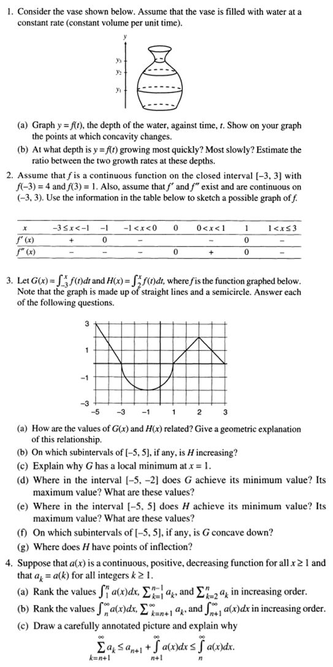
Part B Questions
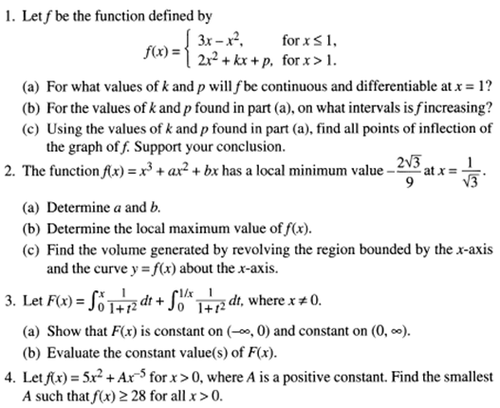

2. What a teacher knows is a critical component of high quality instruction in mathematics classrooms (Ball, Thames, & Phelps, 2008). Mathematics education researchers have examined various aspects of teacher knowledge. Wilhelm (2014) explored how teacher knowledge influenced the enactment of cognitively demanding tasks (Stein & Smith, 1998). Kersting et al. (2012) investigated the relationship among teacher knowledge, teacher practice, and student learning. Additionally, mathematics education researchers have examined how teachers can develop the kinds of specialized knowledge teachers need to teach mathematics (e.g., Bell et al., 2010).
Using these sources among others as a basis, propose a qualitative study involving one or more of the following methods: clinical interviews (Ginsburg, 1997), design experiment (Cobb et al., 2003), and grounded theory (Strauss & Corbin, 1994). Your proposed study should have the potential to contribute to the mathematics education community’s understanding of the role of teacher knowledge in mathematics classrooms. In addition to addressing (even briefly) the important considerations of a research proposal, provide a justification of the validity (Maxwell, 2005) for using the qualitative methods to answer your proposed research question(s).

References
Ball, D. L., Thames, M. H., & Phelps, G. (2008). Content knowledge for teaching: What makes it special? Journal of Teacher Education, 59(5), 389-407.
Bell, C. A., Wilson, S. M., Higgins, T., & McCoach, D. B. (2010). Measuring the effects of professional development on teacher knowledge: The case of developing mathematical ideas. Journal for Research in Mathematics Education, 41(5), 479-512.
Cobb, P., Confrey, J., diSessa, A., Lehrer, R., & Schauble, L. (2003). Design experiments in educational research. Educational Researcher, 32(1), 9-13.
Ginsburg, H. (1997). Entering the child’s mind. Cambridge, UK; Cambridge University Press.
Kersting, N. B., Givvin, K. B., Thompson, B. J., Santagata, R., & Stigler, J. W. (2012). Measuring usable knowledge teachers’ analyses of mathematics classroom videos predict teaching quality and student learning. American Educational Research Journal, 49(3), 568-589.
Maxwell, J. A. (2005). Qualitative research design: An interactive approach. [2nd Edition.] Thousand Oaks, CA: Sage Publications.
Stein, M. K., & Smith, M. S. (1998). Mathematical tasks as a framework for reflection: From research to practice. Mathematics Teaching in the Middle School, 3(4), 268–275.
Strauss, A., & Corbin, J. (1994). Grounded theory methodology: An overview. In N. K. Denzin & Y. S. Lincoln (Eds.), Handbook of qualitative research (pp. 273 – 285). Thousand Oaks: Sage Publications.
Wilhelm, A. G. (2014). Mathematics teachers' enactment of cognitively demanding tasks: Investigating links to teachers' knowledge and conceptions. Journal for Research in Mathematics Education, 45(5), 636-674.

Part II

Item 3: Respond to ONE of the following prompts.

A. The theory of Vygotsky (1987) is pervasive across educational research. Select three of the following articles: (a) Perry (2011), (b) Lobato, Rhodehamel, & Hohensee, (2012), (c) Harkness, (2009), (d) Goos (2004), (e) Ginsburg, (1997), and (f) Foster et al. (2016). Discuss the influence of Vygotsky (1987) on your selected manuscripts. Specifically, compare and contrast how these authors adopt Vygotsky’s work and how they extend it. Additionally, be sure to discuss any ways in which these authors’ work may contradict Vygotsky. Thus, your selection of articles should provide you the opportunity to discuss interesting parallels and contrasts. Your response should tend to answer questions regarding:
- What does it mean to know?
- How does one learn?
- What is the teacher’s role in helping students to learn/know?
- What is the student’s role in learning and coming to know?

References
Foster, M. E., Anthony, J. L., Clements, D. H., Sarama, J., & Williams, J. M. (2016). Improving mathematics learning of kindergarten students through computer-assisted instruction. Journal of Research in Mathematics Education, 47(3), 206-232.
Ginsburg, H. (1997). Entering the child’s mind. Cambridge, UK; Cambridge University Press.
Goos, M. (2004). Learning mathematics in a classroom community of inquiry. Journal for Research in Mathematics Education, 35(4), 258-291.
Harkness, S. S. (2009). Social constructivism and the believing game: A mathematics teacher’s practice and its implications. Educational Studies in Mathematics, 70(3), 243-258.
Lobato, J., Rhodehamel, B., & Hohensee, C. (2012). “Noticing” as an alternative transfer of learning process, Journal of the Learning Sciences, 21(3), 433-482.
Perry, C. A. (2011), Motivation and attitude of preservice elementary teachers toward mathematics. School Science and Mathematics, 111(1), 2–10.
Vygotsky, L. (1987). The development of scientific concepts in childhood. In R. W. Rieber and A. S. Carton (Eds.) The collected works of L.S. Vygotsky (Vol. 1, 167-241). (Original work published in 1934).

B. Compare and contrast social constructivism and socioculturalism. Provide an overview of the major features and theoretical assumptions of the two perspectives (e.g., ideas about knowing and learning; the nature of mathematics; the role of the teacher, the student, and the community). Then discuss the implications of the perspectives, first, for researchers (e.g., how are research design, research questions, and methods influenced by the theoretical perspective) and, second, for instructors in mathematics and/or science education. Illustrate your response with examples from empirical studies conducted from the selected perspectives.

MED Comp Reading List
2016

Bell, C. A., Wilson, S. M., Higgins, T., & McCoach, D. B. (2010). Measuring the effects of professional development on teacher knowledge: The case of developing mathematical ideas. Journal for Research in Mathematics Education, 41(5), 479-512.
Cobb, P., Confrey, J., diSessa, A., Lehrer, R., & Schauble, L. (2003). Design experiments in educational research. Educational Researcher, 32(1), 9-13.
Foster, M. E., Anthony, J. L., Clements, D. H., Sarama, J., & Williams, J. M. (2016). Improving mathematics learning of kindergarten students through computer-assisted instruction. Journal of Research in Mathematics Education, 47(3), 206-232.
Ginsburg, H. (1997). Entering the child’s mind. Cambridge, UK; Cambridge University Press.
Goos, M. (2004). Learning mathematics in a classroom community of inquiry. Journal for Research in Mathematics Education, 35(4), 258-291.
Harkness, S. S. (2009). Social constructivism and the believing game: A mathematics teacher’s practice and its implications. Educational Studies in Mathematics, 70(3), 243-258.
Kersting, N. B., Givvin, K. B., Thompson, B. J., Santagata, R., & Stigler, J. W. (2012). Measuring usable knowledge teachers’ analyses of mathematics classroom videos predict teaching quality and student learning. American Educational Research Journal, 49(3), 568-589.
Lobato, J., Rhodehamel, B., & Hohensee, C. (2012). “Noticing” as an alternative transfer of learning process, Journal of the Learning Sciences, 21(3), 433-482
Ma, X. (1997) Reciprocal relationships between attitude toward mathematics and achievement in mathematics, The Journal of Educational Research, 90(4), 221-229.
Maxwell, J. A. (2005). Qualitative research design: An interactive approach. [2nd Edition.] Thousand Oaks, CA: Sage Publications.
Perry, C. A. (2011), Motivation and attitude of preservice elementary teachers toward mathematics. School Science and Mathematics, 111(1), 2–10.
Phillips, D. C. (1995). The good, the bad, and the ugly: The many faces of constructivism. Educational Researcher, 24(7), 5-12.
Silver, E. & Herbst, P. (2007). The role of theory in mathematics education scholarship. In F. Lester (Ed.), Second handbook of research in mathematics teaching and learning (pp. 39-67). New York: Information Age.
Strauss, A., & Corbin, J. (1994). Grounded theory methodology: An overview. In N. K. Denzin & Y. S. Lincoln (Eds.), Handbook of qualitative research (pp. 273 – 285). Thousand Oaks: Sage Publications.
Vygotsky, L. (1987). The development of scientific concepts in childhood. In R. W. Rieber and A. S. Carton (Eds.) The collected works of L.S. Vygotsky (Vol. 1, 167-241). (Original work published in 1934).
Wilhelm, A. G. (2014). Mathematics teachers' enactment of cognitively demanding tasks: Investigating links to teachers' knowledge and conceptions. Journal for Research in Mathematics Education, 45(5), 636-674.

