If you have not used Ursa or the university’s e-mail system before, you will need to contact the Technical Support Center at 351-4357 (351-HELP) to set up your account before you can view your paystub.

1. Go online to <http://ursa.unco.edu> using an Internet browser.
2. For Username enter your Ursa user name.
3. Enter your password and click on Sign In (If you don’t remember it, click on Password reset/ account activation).
4. Once you are in Ursa, click on the yellow Employee tab.
5. Click on the Pay Stub link under Employee Information.
6. From the Pay Stub Year drop-down menu, select the year for the pay period you want to view and click the Display button.

**Pay Stubs**

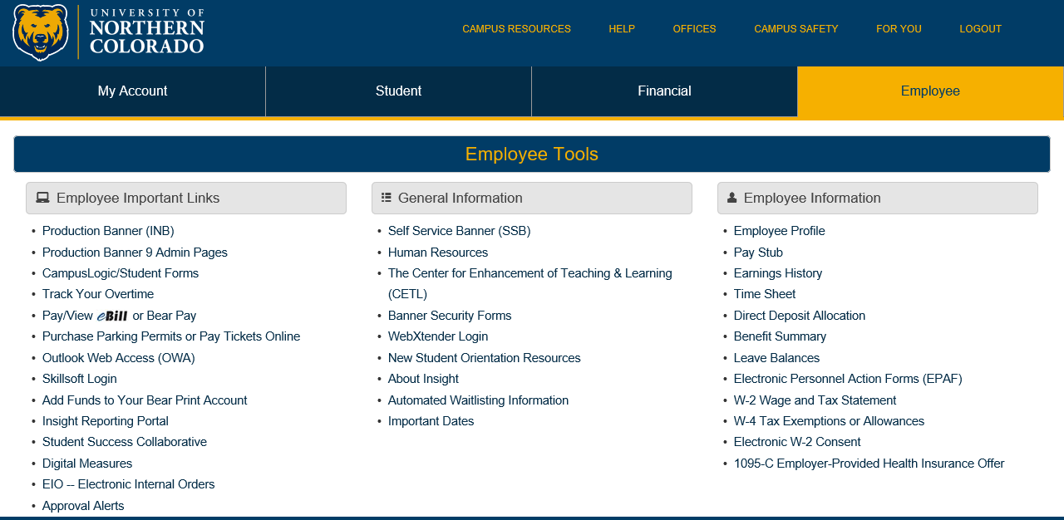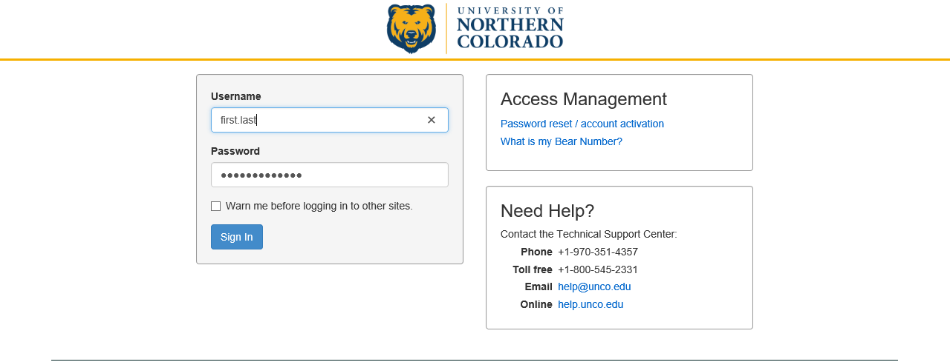

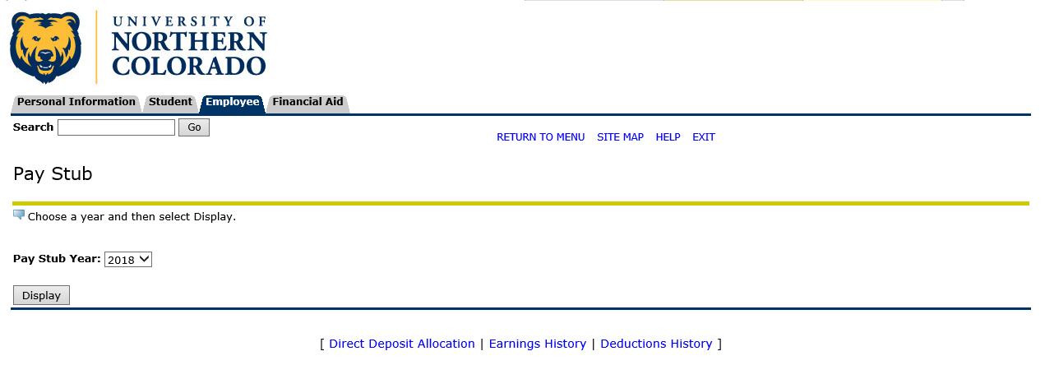

1. On the Pay Stubs screen, click on the date of the pay stub you wish to view.
2. The information for the pay date selected will be displayed. Depending on your computer monitor and browser settings, you may need to scroll down to see all of your information.

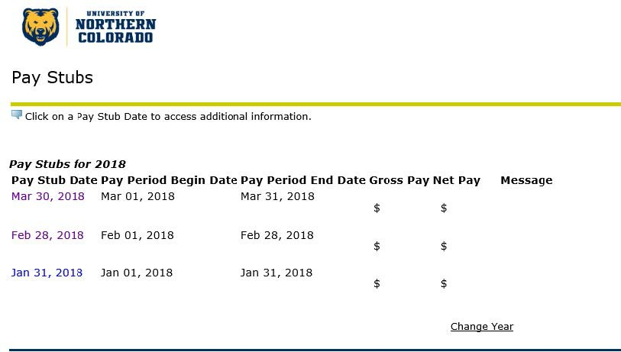

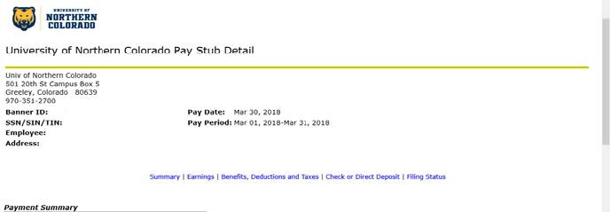

Once you are done, **DON’T FORGET TO LOG OUT** so that the next person to use the computer can’t access your personal information.

For questions or concerns about pay stubs contact Payroll Services at 351-2700.

