Physical Geography - Activity 1 (PG-1)

Open Activity 4: Map Measurement (web map for Activities PG-1, PG-2, PG-3, and PG-4). You should see a map of the major rivers in Colorado with a few of the major cities in the state. In this activity you will be using the map measurement tools.

Step 1 | Your Task
Click on Ruler to open measurement tools.  Then click on the second (middle) icon to measure distance in miles. | Estimate the distance between Grand Junction and Denver.  Click on Grand Junction to open your first point. Then click on Denver to measure the distance from Grand Junction to Denver.  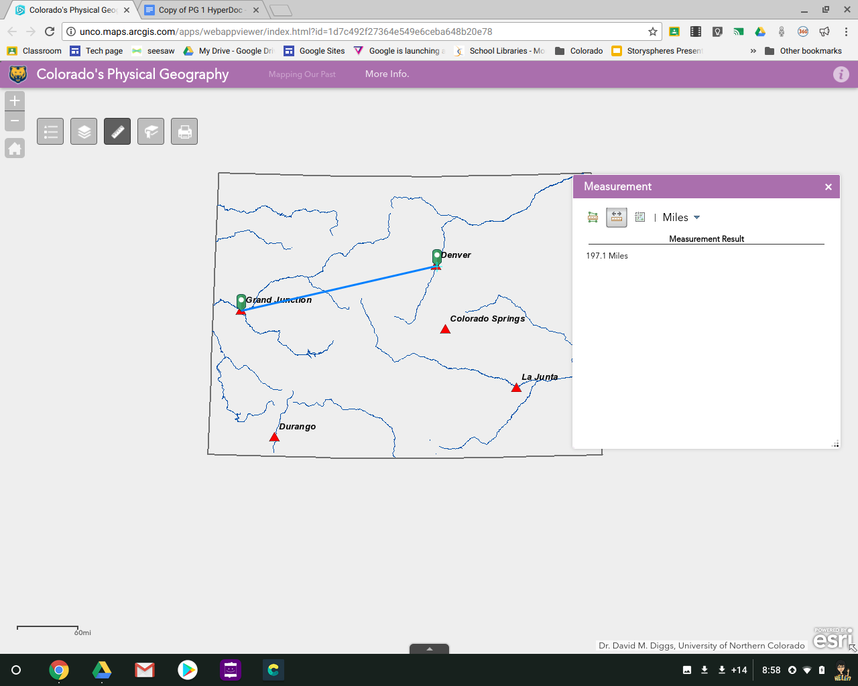  What is the approximate distance between Grand Junction and Denver?  How close was your estimate?
Step 2 | Your Task
Click Clear or the second icon again to reset the measurement tool. | Estimate the distance between La Junta and Durango.  Now use the measurement tool to find the actual distance. What is the approximate distance between La Junta and Durango?  Measure distance of La Junta and Durango to Continental Divide. Which city is farther?
Step 3 | Your Task
Click Clear or the second icon again to reset the measurement tool.  Check on Continental Divide Layer. | Estimate the distance between Colorado Springs and Denver.  Use measurement tool to calculate the actual distance. What is the approximate distance between Colorado Springs and Denver?  Estimate which city, Colorado Springs or Grand Junction, is closer to the Continental Divide. Use measure tool to check your guess.
Step 4 | Your Task
Click on first icon (far left) to measure area. Note that you can change the units by clicking on the unit name. Switch between square miles and square kilometers. Make sure to hit the CLEAR button when done measuring.  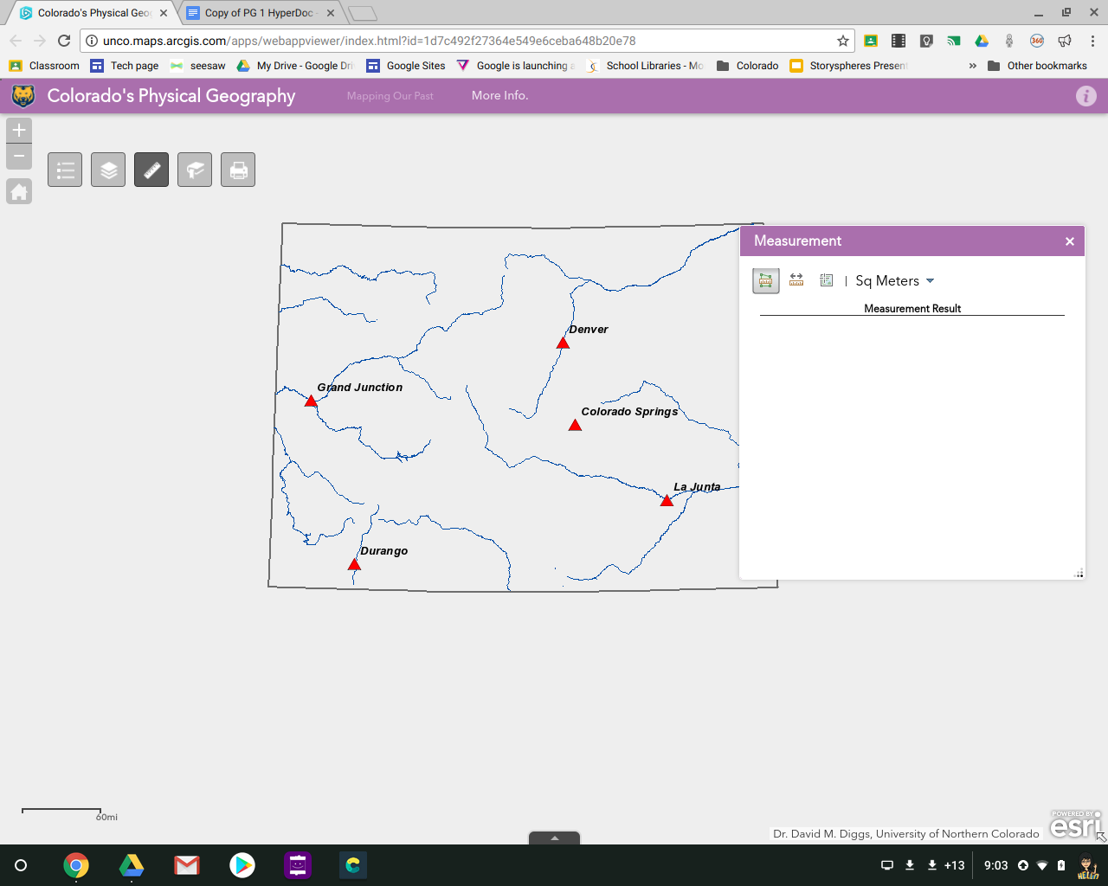 | Measure the area of Colorado by clicking on each corner of the state. As you do so, the area being measured will increase until you cover the whole state. Double-click on the fourth corner to finish.  What is the approximate area of Colorado in square kilometers?  What is the approximate area of Colorado in square miles?
Step 5 | Your Task
You can also measure the distance rivers travel, by clicking several times to follow the river’s path. As you do so, the total distance will keep adding up. | Find the Gunnison River in western Colorado. It flows into the Colorado River at Grand Junction.  What is the approximate distance from there to the point in the mountains where the Gunnison River begins?
Step 6 | Your Task
Check ON the Communities layer and find the community you live or go to school in. | What is the closest major city to your community?  What is the distance between your community and that major city?

